Project Report

|  |  |
| --- | --- |
| Product Name | Advanced Certificate in Web Development |
| Qualification Name (NICF) | NICF-Advanced Certificate in Infocomm Technology (Software & Applications) |
| Product Name | Web Development Foundations |
| Module Name (NICF) | NICF -Web Development Foundations |

|  |  |  |  |
| --- | --- | --- | --- |
| Student name | | Assessor name | |
| **Chathushi Jayarathna** | | **Ms. Arvinder Kaur** | |
| Date issued | Completion date | | Submitted on |
| **12/09/2022** | **25/09/2022** | | **02/11/2022** |
|  | |  | |
| Project title | Design, Develop, Implement & Document Community Portal Website | | |

|  |
| --- |
| Learner declaration |
| I certify that the work submitted for this assignment is my own and research sources are fully acknowledged.  Student signature: **Chathushi**  Date: 25/09/2022 |

Table of Contents

**1.** **Project Background** 5

**2.** **Project Objectives** 5

3. Block diagram of the system 10

4. Case Diagram 11

5. Architecture of the system 16

5.1 Explanation of Architecture of the application 16

6. Developed Modules 17

6.1 Private Module - Administrator - Manage user Data and Bulk Emailing. 17

6.2 Public Module - Software Programmers 17

7. All the pages in each of the modules and Description 17

8. Create, Edit & View pages. 18

9. Sitemap of Public & Private Site 19

10. Technical Environment Requirements 19

10.1 Hardware Requirements 19

10.2 Software Requirements 19

10.3 System Integration Requirements 20

10.4 Portability Requirements 20

10.5 Maintainability Requirements 20

10.6 Performance Requirements 20

10.7 Security Requirements 20

12. Login & Logout mechanism 21

12.1 Login 21

12.2 Log out 21

13. Eclipse Installation 21

14. Features in IDE 26

14.1 Smart Code Completion 26

14.2 Quick Fixes 26

14.3 Getter and Setter 27

15. Coding & Documentation Standards 28

15.1 Comments 28

15.2 Naming Convention 28

15.3 File and Folder Organization 29

16. Documentation tool and its configuration. 30

17. HTML Pages Source Code 34

17.1 Registration Page (register.jsp) 34

17.2 Login Page (login.js) 36

17.9 Check Mail (checkMail.jsp) 45

45

18. Java Classes 53

12. Implemented pages 72

✓ Home Page 72

**13.** **Debug the application in Eclipse** 83

**14.** **Errors you encountered while developing the application.** 87

**15.** **New feature to the application** 88

16. Unit Testing code 89

Figure 1:Screenshot of Eclipse 5

Figure 2;Screenshot of MySQL Workbench 6

Figure 3:Screenshot of XAAMP Server 6

Figure 4:Screenshot of Flow Drawio 7

Figure 5:Screenshot of Microsoft Word 7

Figure 6;Screenshot of Microsoft PowerPoint 8

Figure 7:Block Diagram of System 9

Figure 8;Login Process 10

Figure 9:Registration Flow 10

Figure 10: Architecture of the system 11

Figure 11:Sitemap of Public and Private Site 13

Figure 12:Screenshot of address bar in browser 16

Figure 13:Screenshot of Eclipse installation step 3 16

Figure 14:Screenshot of Eclipse installation step 4 17

Figure 15:Screenshot of eclipse installation step 5 17

Figure 16:Screenshot of eclipse installation step 6 17

Figure 17:Screenshot of eclipse installation step 7 18

Figure 18:Screenshot of eclipse installation step 8 18

Figure 19:Screenshot of eclipse installation step 9 19

Figure 20:Screenshot of eclipse installation step 10 19

Figure 21:Screenshot of eclipse installation step 11 20

Figure 22:Screenshot of of smart code completion in eclipse 21

Figure 23:Screenshot of quick fixes in eclipse 22

Figure 24:Screenshot of coding & documentation Standards in eclipse (getters and setters) 22

Figure 25:Screenshot of coding & documentation Standards in eclipse (comments) 23

Figure 26:Screenshot of coding & documentation Standards in eclipse (Naming Conventions) 23

Figure 27:Screenshot of coding & documentation Standards in eclipse (File and Folder Organization) 24

Figure 28:Javadoc configuration step 2 25

Figure 29:Screenshot of Javadoc configuration step 7 26

Figure 30:Screenshot of Javadoc configuration step 3,4,5,6 26

Figure 31:Javadoc configuration step 8 27

Figure 32:Javadoc configuration step 9 27

Figure 33:Screenshot of Javadoc 28

Figure 34:Screenshot of source code of registration 30

Figure 35:Screenshot of source code of login 32

Figure 36:Screenshot of source code of thank you page 33

Figure 37:Screenshot of source code of registration forgot password 34

Figure 38:Screenshot of source code of forgot password confirmation 35

Figure 39:Screenshot of source code of user profile 37

Figure 40:Screenshot of source code of edit profile 40

Figure 41:Screenshot of source code of search user 43

Figure 42:Screenshot of source code of update profile 44

Figure 43:Screenshot of source code of MvcController.java 46

Figure 44:Screenshot of source code of userDao.java 47

Figure 45:Screenshot of source code of User.java 48

Figure 46:Screenshot of Registration Page 49

Figure 47:Screenshot of Thank you page 49

Figure 48:Screenshot of login 50

Figure 49:Screenshot of forgot password validations 50

Figure 50:Screenshot of forgot password page 50

Figure 51:Screenshot of forgot password confirmation 51

Figure 52:Screenshot of user profile page 51

Figure 53:Screenshot of edit profile page 52

Figure 54:Screenshot of search user page 52

Figure 55:Screenshot of debugging in eclipse step 1 53

Figure 56:Screenshot of debugging in eclipse step 2 53

Figure 57:Screenshot of debugging in eclipse step 3 54

Figure 58:Screenshot of debugging in eclipse step 4 54

Figure 59:Screenshot of debugging in eclipse step 5 55

Figure 60:Screenshot of debugging in eclipse step 6 55

Figure 61:Screenshot of debugging in eclipse step 7 55

Figure 62:Screenshot of debugging in eclipse step 8 56

Figure 63:Screenshot of debugging in eclipse step 9 56

1. **Project Background**

ABC Jobs Pte Ltd is a career guidance organization that gives tasks to individuals. That organization needs to foster a community portal to spread its name to additional clients.

ABC Jobs Pte Ltd suggests occupations and recruits’ programmers. With this community portal, clients can enlist for themselves and quest the most prominent positions in their occupations. Likewise, clients can make networks with other clients by interfacing with them in their local area. Likewise, the gateway is principally utilized for proficient collaborating and vocational development

The primary motivation behind this task is to design and develop the community portal as they wish. Locally community portal clients will actually want to enroll and look for another client. After they can log in, reset their password, and update their profile. User details are stored in a database. This ABC Community portal entryway is very valuable to the client side since clients do not have to go to ABC Jobs organization to look through positions, they can look online with the local area gateway. Likewise, clients should need to safeguard a client profile to acquaint themselves. This people group entryway has private and public modules. Confidential modules approach for the administrators and public modules approach programming software engineers.

For this local community portal, we have carried out a java-based web application with a spring MVC structure for the client necessities, business needs, and cycles. Likewise, we want to design, make, plan and execute the tests for this undertaking. As a component of this task, we really want to recognize this problem and oversee it across its lifecycle

Here, the software developer connects the database to get the data of those who register. Then the details of everyone who registers will be mentioned in the database. After that you need to generate data from database and login to the job portal. The user profile will be displayed according to the user login. The user should be able to login to the user profile and the admin to the admin profile through the same login form. It should also be possible to updated the user profile. In case of security reasons, ABC JOBS reserve the right to prohibit/restrict any users accessibility and can remove any user’s data from the portal. To provide a safe net browsing for the users of ABC JOBS it provides 24/7 hours administrator support. There, admin can view all users details and can edit and delete them. These are implements as grants and in addition, search user page, forgot password page, forgot password confirmation page, thank you page also have been implemented.

The main functions are,

* Once the programmers register can view confirmation after displacing thank you page
* Providing the login page
* Provide password retrieval functionality.
* After logging they can update their profile.

1. **Project Objectives**

We need to design, develop, implement, test and document for ABC Jobs community portal using spring frameworks

* Gathering and identifying requirements and specifications for

the system

* Design wireframes and prototypes.
* Conduct usability testing.
* Design the database.
* Develop and implement the application using Eclipse IDE.
* Maintenance and document the application developed.
  1. **Tools and Platforms used**
* 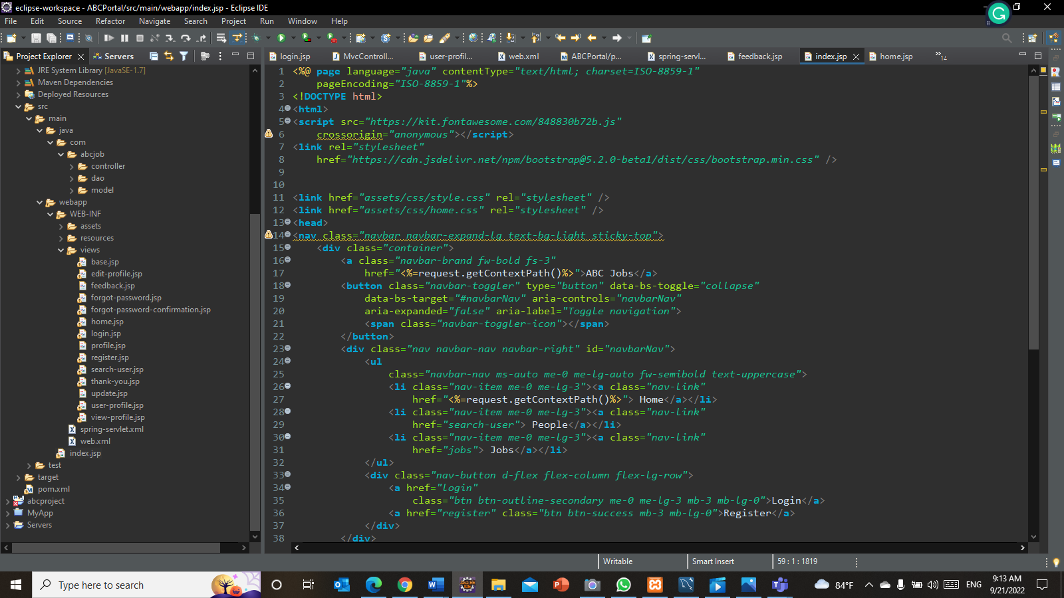Eclipse IDE for Enterprise Java and Web Developers - 2022- 03 – To implement application

Figure :Screenshot of Eclipse

* MySQL Workbench 8.0 CE – To create ate database

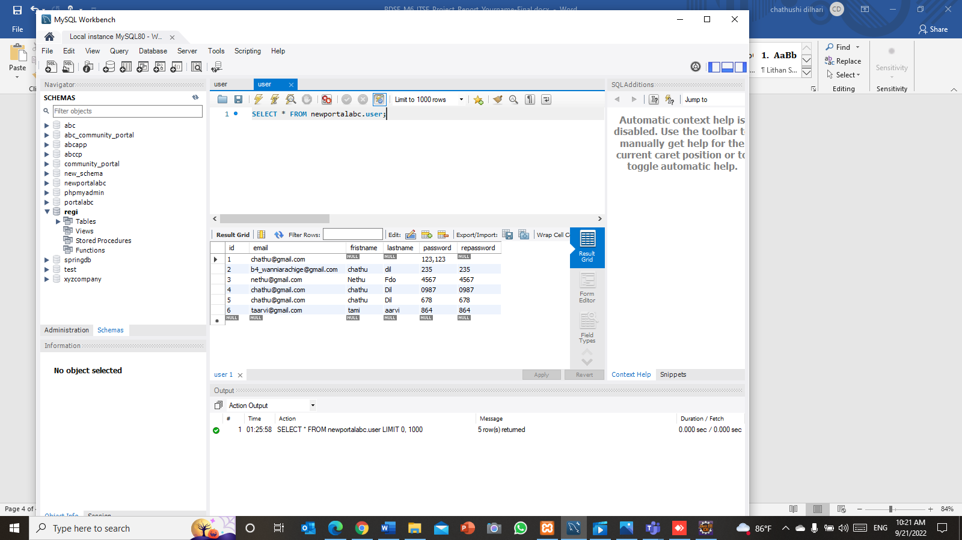

Figure ;Screenshot of MySQL Workbench

* 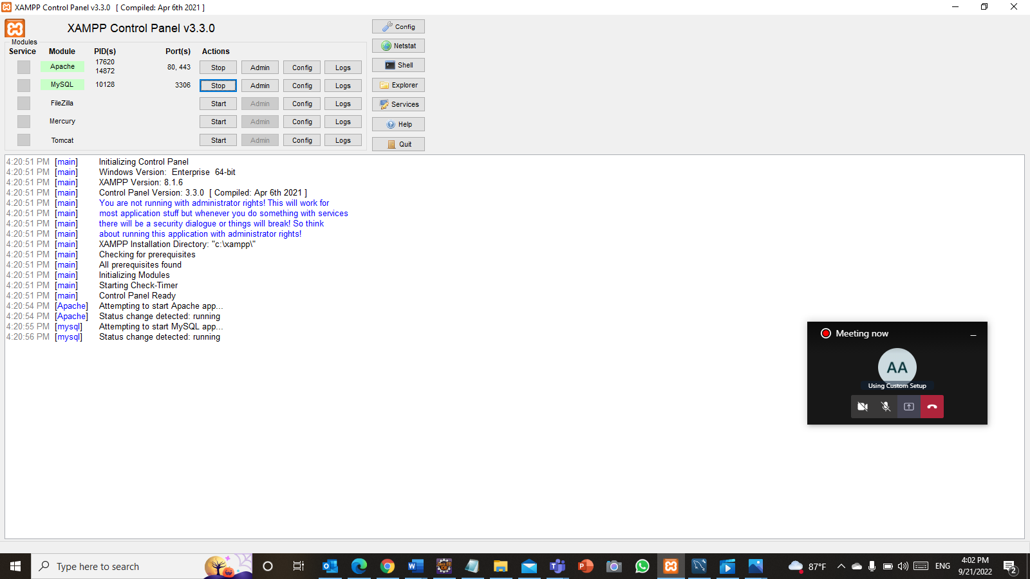XAAMP Control Panel v3.3.0

Figure :Screenshot of XAAMP Server

* Flow Drawio – To create a flow chart

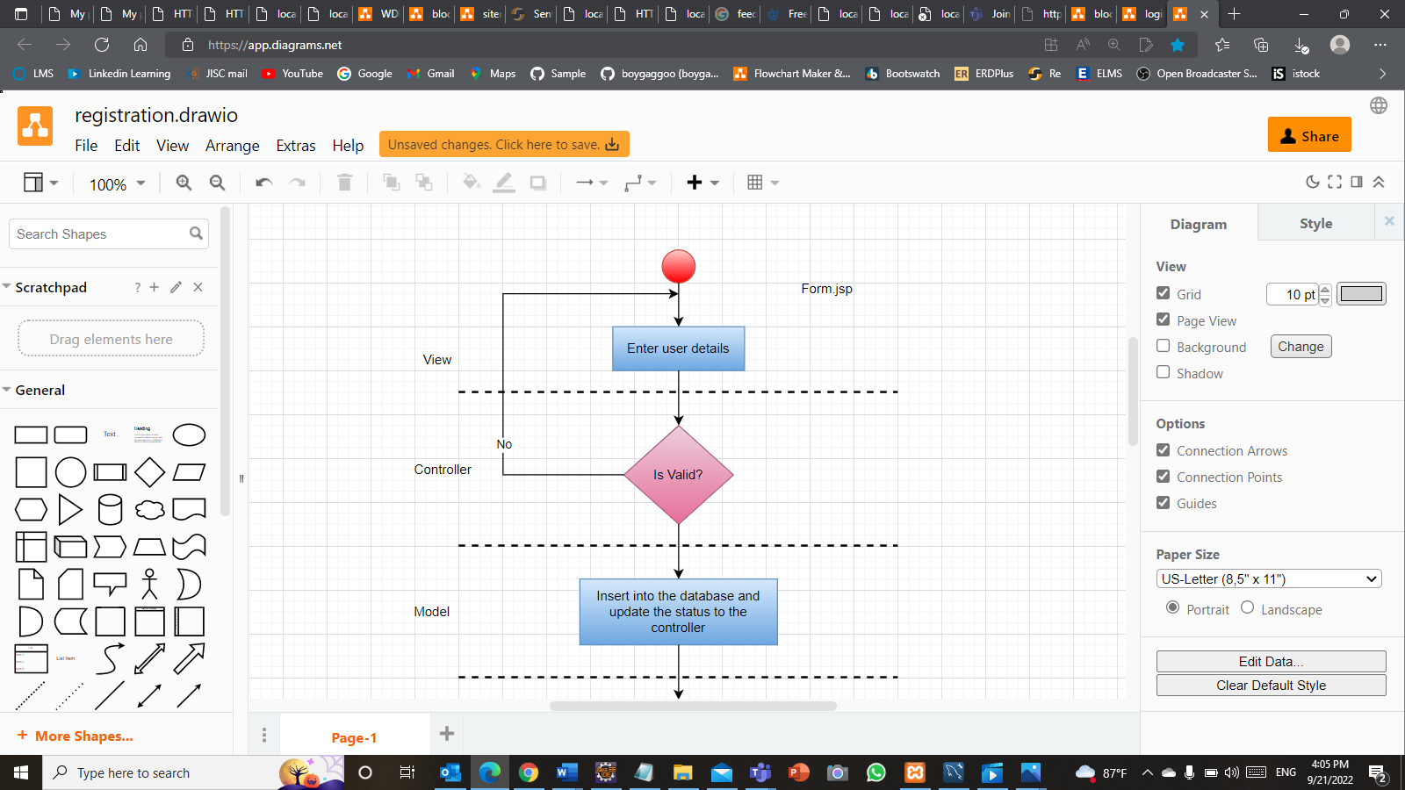

Figure :Screenshot of Flow Drawio

* 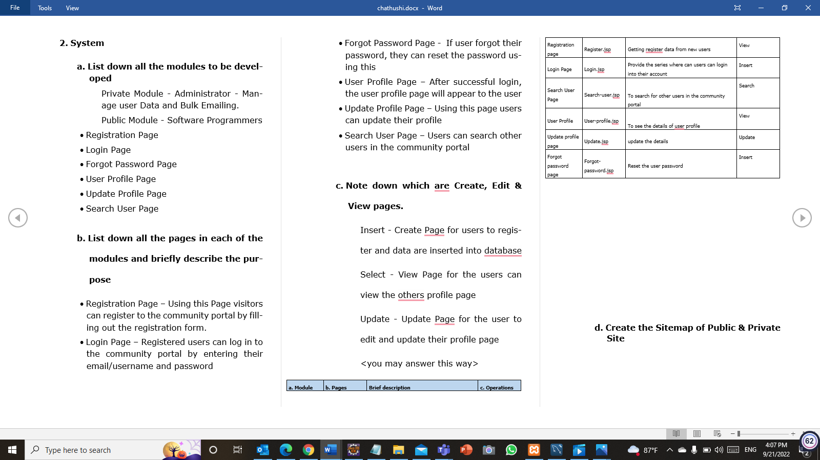Microsoft Word – To create project report

Figure :Screenshot of Microsoft Word

* 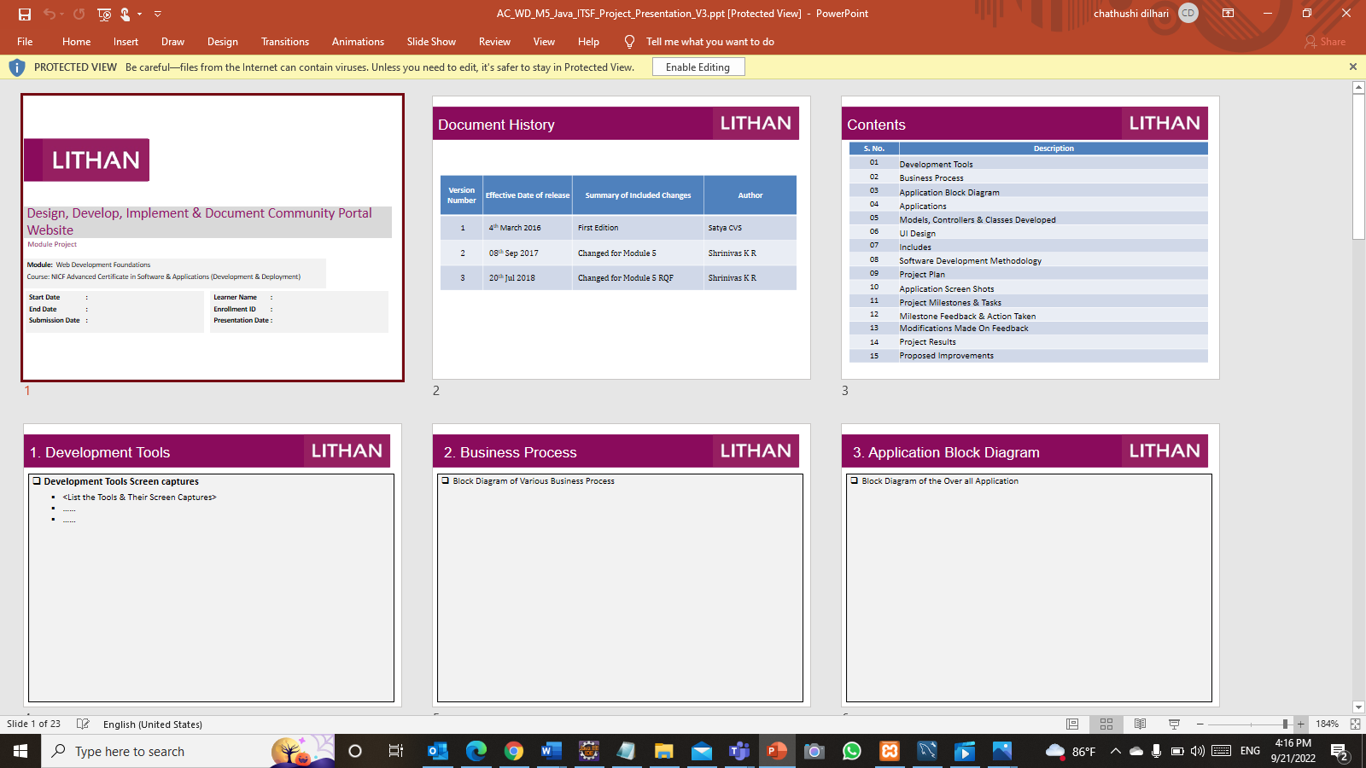Microsoft PowerPoint – To create project Presentation

Figure ;Screenshot of Microsoft PowerPoint

Task 1

3. Block diagram of the system

Figure :Block Diagram of System

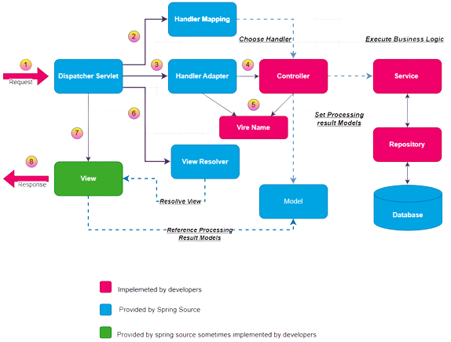

4. Case Diagram

* Login

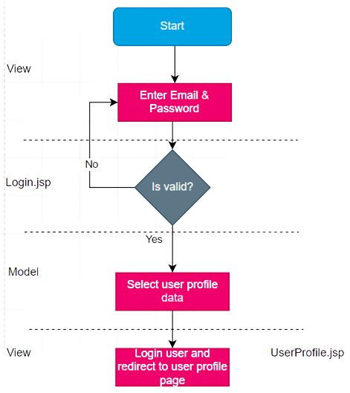

Figure ;Activity diagram of Login

* Registration

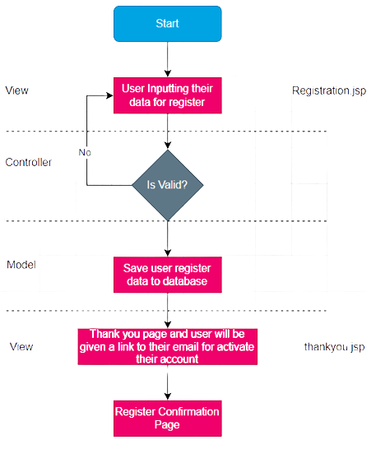

Yes

Figure :Activity diagram of Registration

* Forgot Password

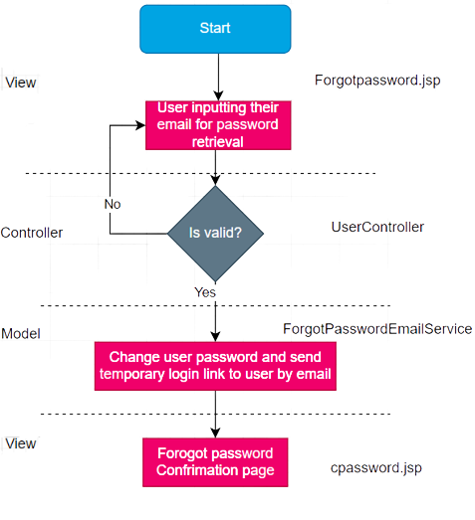

Figure :Activity Diagram of Forgot Password

* Search User

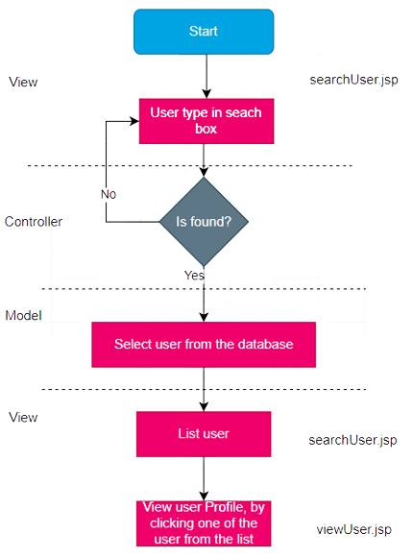

Figure :Activity Diagram of Search User

* 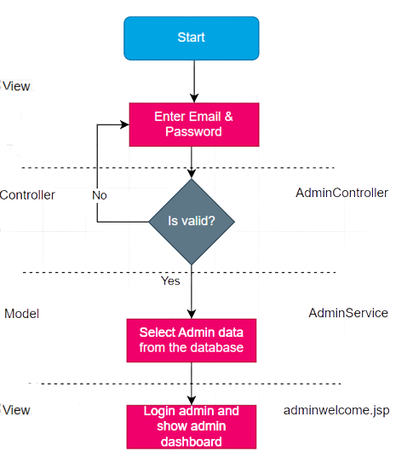Admin Login

Figure :Activity diagram of Admin Login

1. 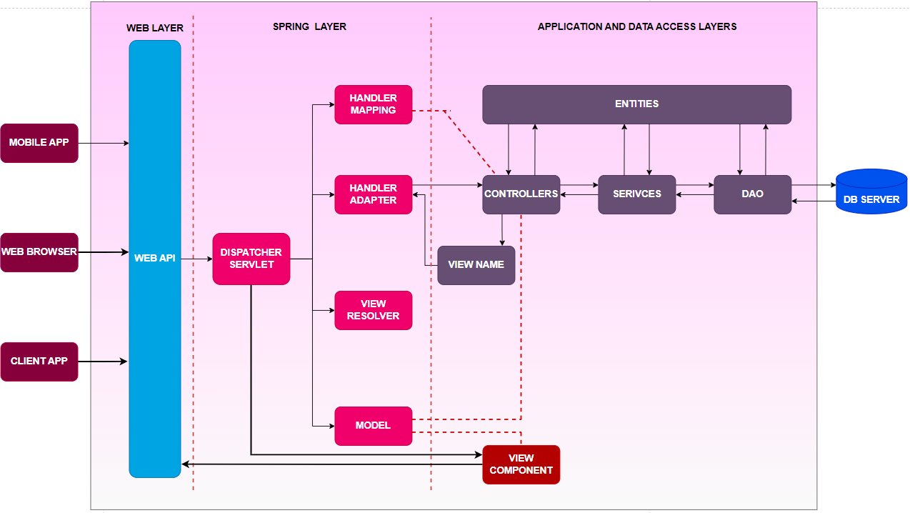Architecture of the system

Figure : Architecture of the system

* 1. Explanation of Architecture of the application

All the jsp pages of this ABC community portal is handled by the controller. The controller requests a response from the service and after receiving the response from the service it calls the dao layer which is the data access layer. Then Dao layer takes data from Database. After this whole process application will work properly

1. Developed Modules
   1. Private Module - Administrator - Manage user Data and Bulk Emailing.
   2. Public Module - Software Programmers

* Registration Page
* Login Page
* Forgot Password Page
* Forgot Password Reset
* User Profile Page
* User Home Page
* Edit User Profile
* Search User Page

1. All the pages in each of the modules and Description

* Public Modules
* Index Page – Landing Page of community portal
* Registration Page – Using this Page visitors can register to the community portal by filling out the registration form.
* Login Page – Registered users can log in to the community portal by entering their email/username and password
* Forgot Password Page - If user forgot their password, they can reset the password using this
* Forgot Password Confirmation
* User Home page – After successful login, the user home page will appear to the user
* User Profile Page – User profile page which include edit profile, search user
* Update Profile Page – Using this page users can update their profile
* Search User Page – Users can search other users in the community portal

Private Module

* Admin Home Page
* Admin View User page – Using this page admin can view, edit, and delete users
* Bulk Email – Using this page admin can send mails to users

1. Create, Edit & View pages.

Insert - Create a Page for users to register and data are inserted into the database

Select - View Page for the users can view the other’s profile page

Update - Update Page for the user to edit and update their profile page

|  |  |  |  |
| --- | --- | --- | --- |
| a. Module | b. Pages | Brief description | c. Operations |
| Registration page | Registeration.jsp | Getting register data from new users | Insert |
| Login Page | Login.jsp | Provide the series where can users can login into their account | Insert |
| Search User Page | Searchuser.jsp | To search for other users in the community portal | Search/Select |
| User Profile | UserProfile.jsp | To see the details of user profile | View |
| Update profile page | Update.jsp | update the details | Update |
| Forgot password page | Forgot-password.jsp | Reset the user password | Insert |
| Bulk Email | Emailform.jsp | Send emails to users | Insert |
|  |  |  |  |

1. 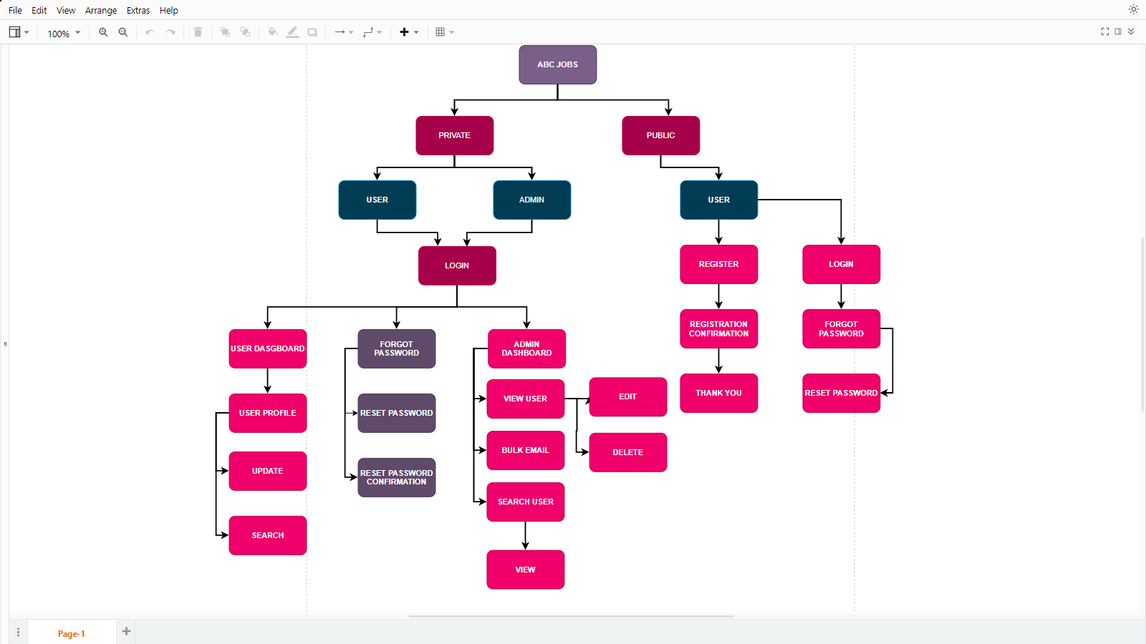Sitemap of Public & Private Site

Figure :Sitemap of Public and Private Site

1. Technical Environment Requirements
   1. Hardware Requirements

* Processor: Inter(R) Core(TM) i5
* RAM: 12GB
* 1TB Disk Space
* MySQL Server 8.0.30
* Apache Tomcat 9
  1. Software Requirements
* Development Environment - JDK 8.1
* Framework - Spring MVC
* Database Server - MySQL Server 8.0.30
* Firewall Settings - Port 9001-Http,Port 3306 - Database
  1. System Integration Requirements
* JDBC-JDBC Connector 8.0.11
* Spring security Dependency
  1. Portability Requirements
* Multi OS- Windows, Linux, and Mac
* Multiple Browsers - Chrome, Safari, Microsoft Edge
* Multiple Devices - Desktop, Tablet, Mobile
  1. Maintainability Requirements
     + - Back up the database every 6 hours.
       - Vulnerability check – periodical scanning.
       - Each request should be processed within 10 seconds.
  2. Performance Requirements

Concurrent number of users- 100

Loading time – 15secs

* 1. Security Requirements

|  |  |  |  |
| --- | --- | --- | --- |
| **.permit All()** | **.hasAnyRole** | **.hasRole(“ABC Adminstators”)** | **.hasRole(“Software Programmers”)** |
| home.jsp | Home.jsp | Admin.jsp | Profile.jsp |
| Update.jsp | Update.jsp | Login.jsp | Forgot-password.jsp |
|  | Login.jsp |  |  |

1. Login & Logout mechanism
   1. Login

Using the Spring security login process is accomplished. user.java has the data variables in store in the database. when user input their username and password it gets the information from the base of the records and select if a user is an admin or software programmer. After that, it shows the perfect pages for the user

* 1. Log out

A simple disconnection lets in you to leave the portal. this indicates terminating access to a computer system or internet site and notifying the pc or internet site that the user needs to end the login session.

Task 2

1. Eclipse Installation

Step 1 - Install JDK

To use Eclipse for Java programming, developers need to install Java Development KIT.

* Step 1 - Download JDK
* Step 2 - Install JDK
* Step 3 Include JDK's "bin" Directory in the path
* Step 4 - Verify the JDK Installation

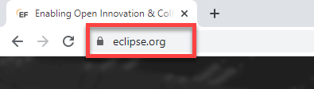Step 2 - Open Browser and go to <https://www.eclipse.org/>

Figure :Screenshot of address bar in browser

Step 3 - Click on download

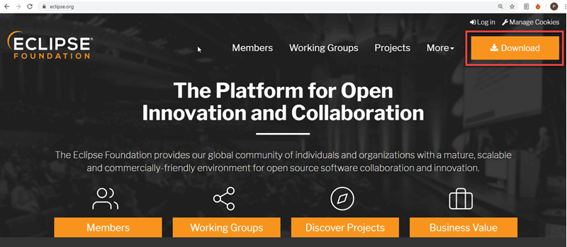

Figure :Screenshot of Eclipse installation step 3

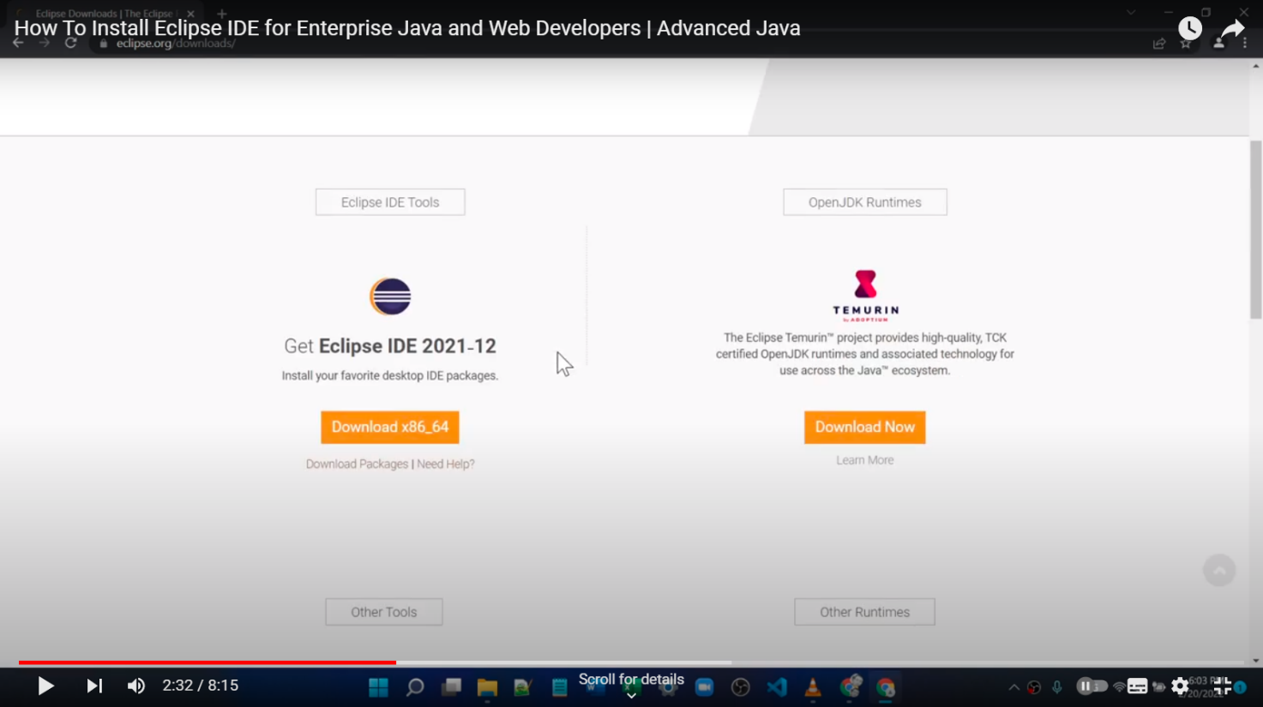Step 4 - Then click on download 64bit button

Figure :Screenshot of Eclipse installation step 4

Step 5 - Click on download button

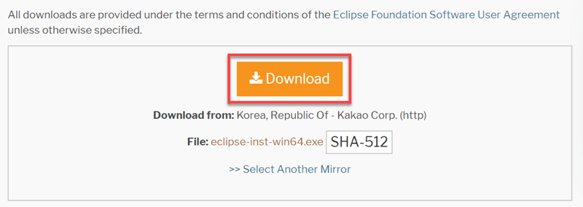

Figure :Screenshot of eclipse installation step 5

Step 6 - Install Eclipse

Click on “downloads” in Windows file explorer.

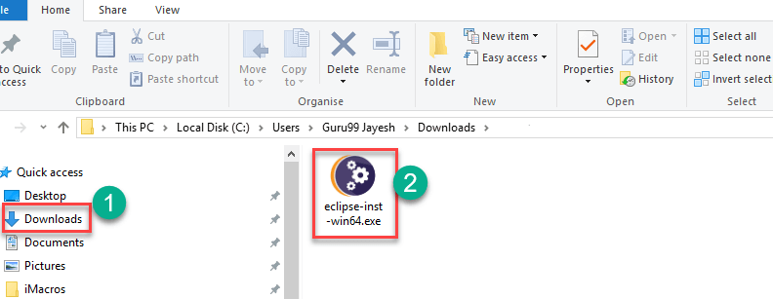Click on “eclipse-inst-win64.exe” file.

Figure :Screenshot of eclipse installation step 6

Step 7 - Run Application

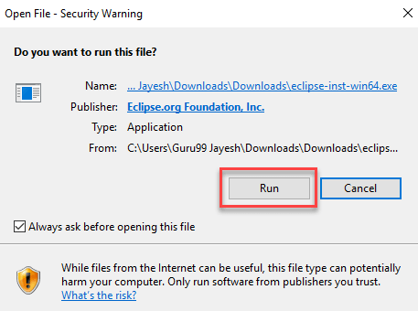

Figure :Screenshot of eclipse installation step 7

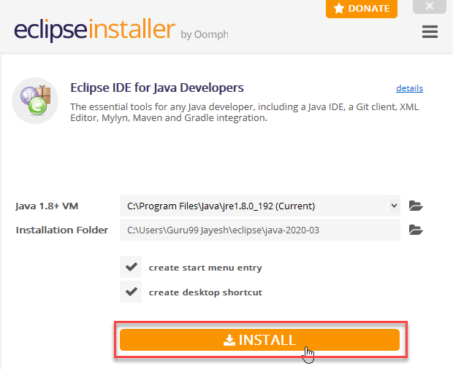Step 8 - Click on the install button

Figure :Screenshot of eclipse installation step 8

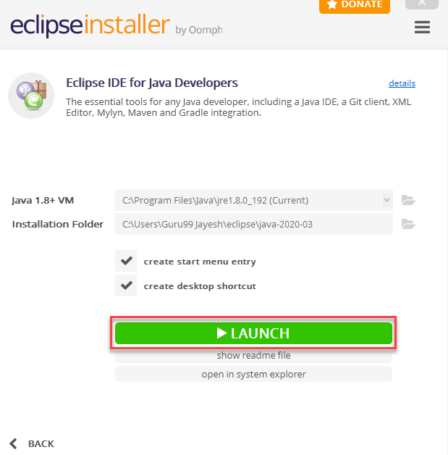Step 9 - Click on the launch button.

Figure :Screenshot of eclipse installation step 9

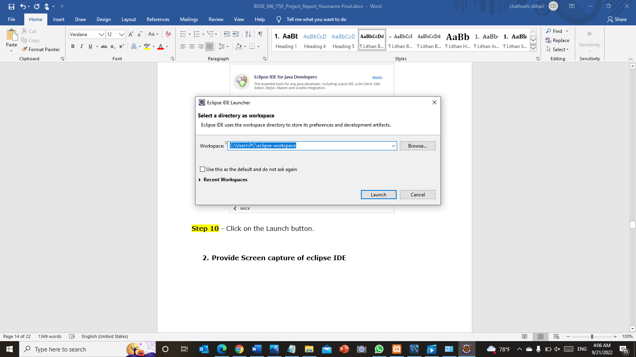 Step 10 - Click on the Launch button.

Figure :Screenshot of eclipse installation step 10

Step 11 –

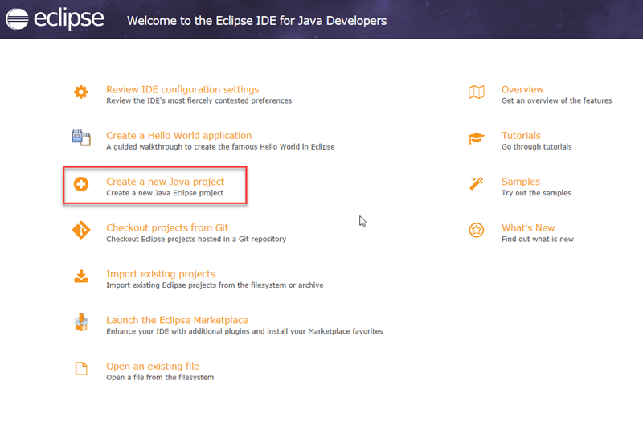

Figure :Screenshot of eclipse installation step 11

Task 3

1. Features in IDE
   1. Smart Code Completion

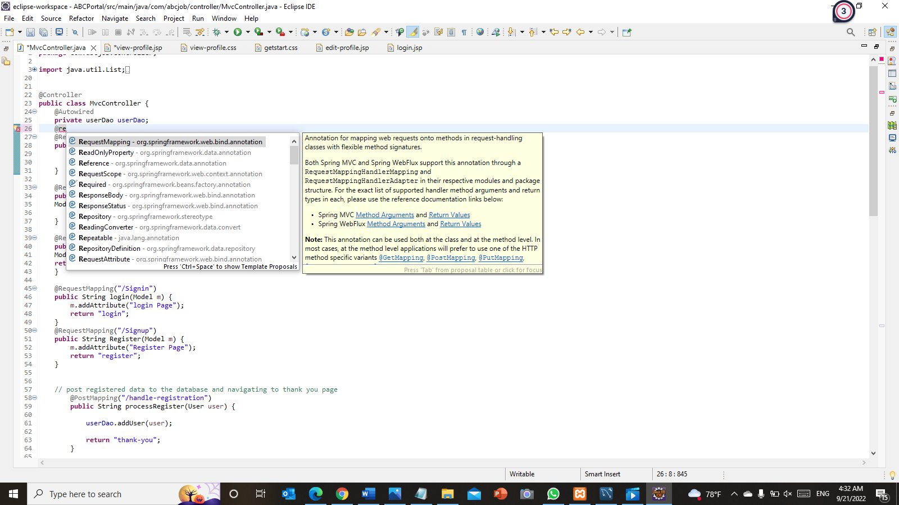We get code of completion as quickly as we start typing in eclipse, we don’t always need to apply a keyboard shortcut to deliver the suggestions. suggestions are also context sensitive so that they must make feel for the current place we’re typing

Figure :Screenshot of of smart code completion in eclipse

* 1. Quick Fixes

Each time Ide detects an error, the eclipse highlights the error the use of a wavy red line underneath the offending code and a marker in the left editor margin. moving the mouse over the underlined code or the marker will indicate the error. The marker may be selected with the left mouse to set off the quick restoration pop-up, indicating moves that may be undertaken to repair the error. rather, pressing Ctrl+1 will activate brief restore from the keyboard.

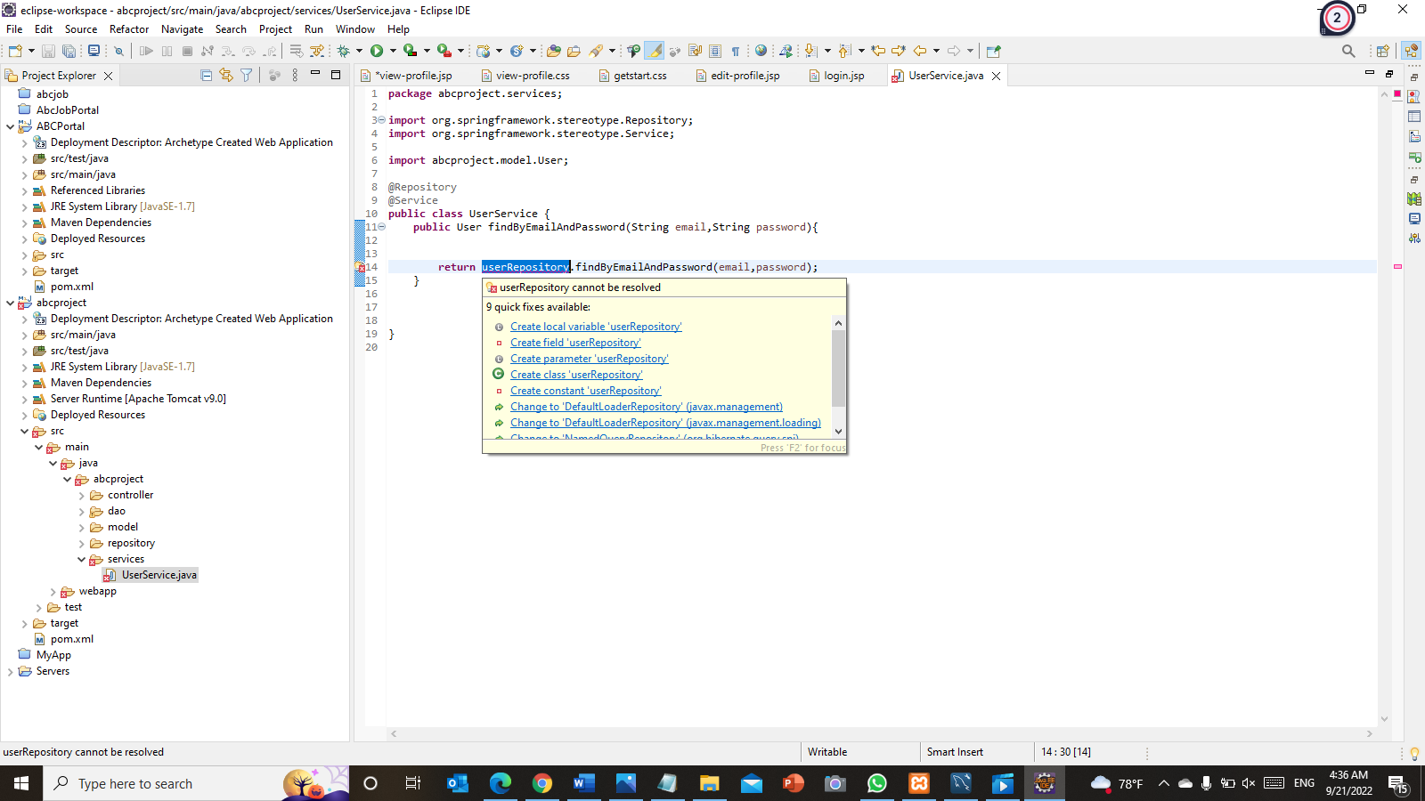

Figure :Screenshot of quick fixes in eclipse

* 1. Getter and Setter

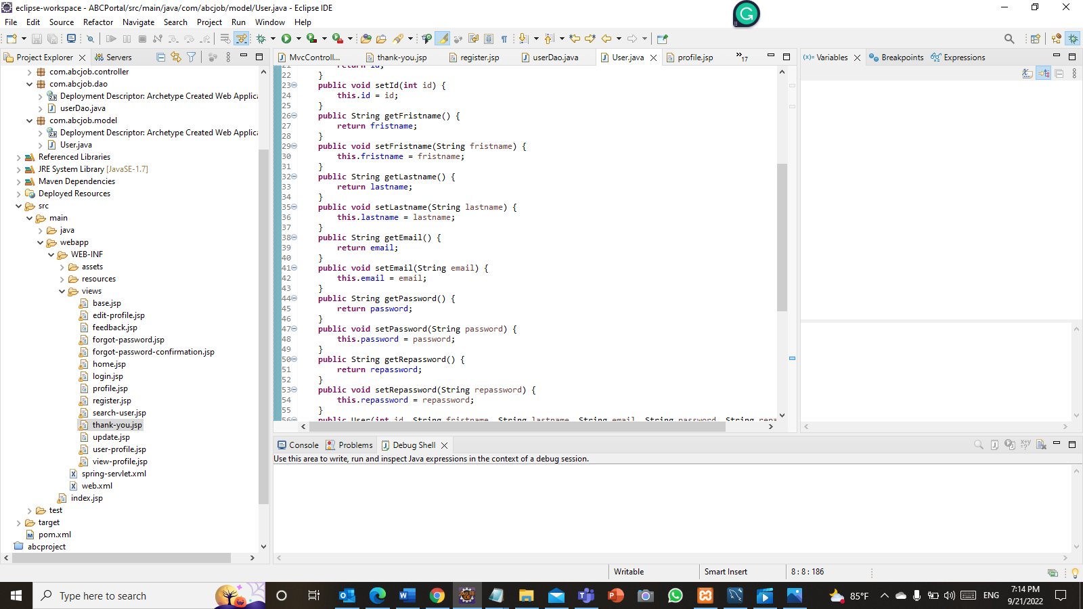Getters and setters are used to shield your data, in particular when developing classes. For each example variable, a getter method returns its value while a setter method sets or updates its value. Given this, getters and setters are also called accessors and mutators, respectively

Figure :Screenshot of coding & documentation Standards in eclipse (getters and setters)

**Task 4**

1. Coding & Documentation Standards
   1. Comments

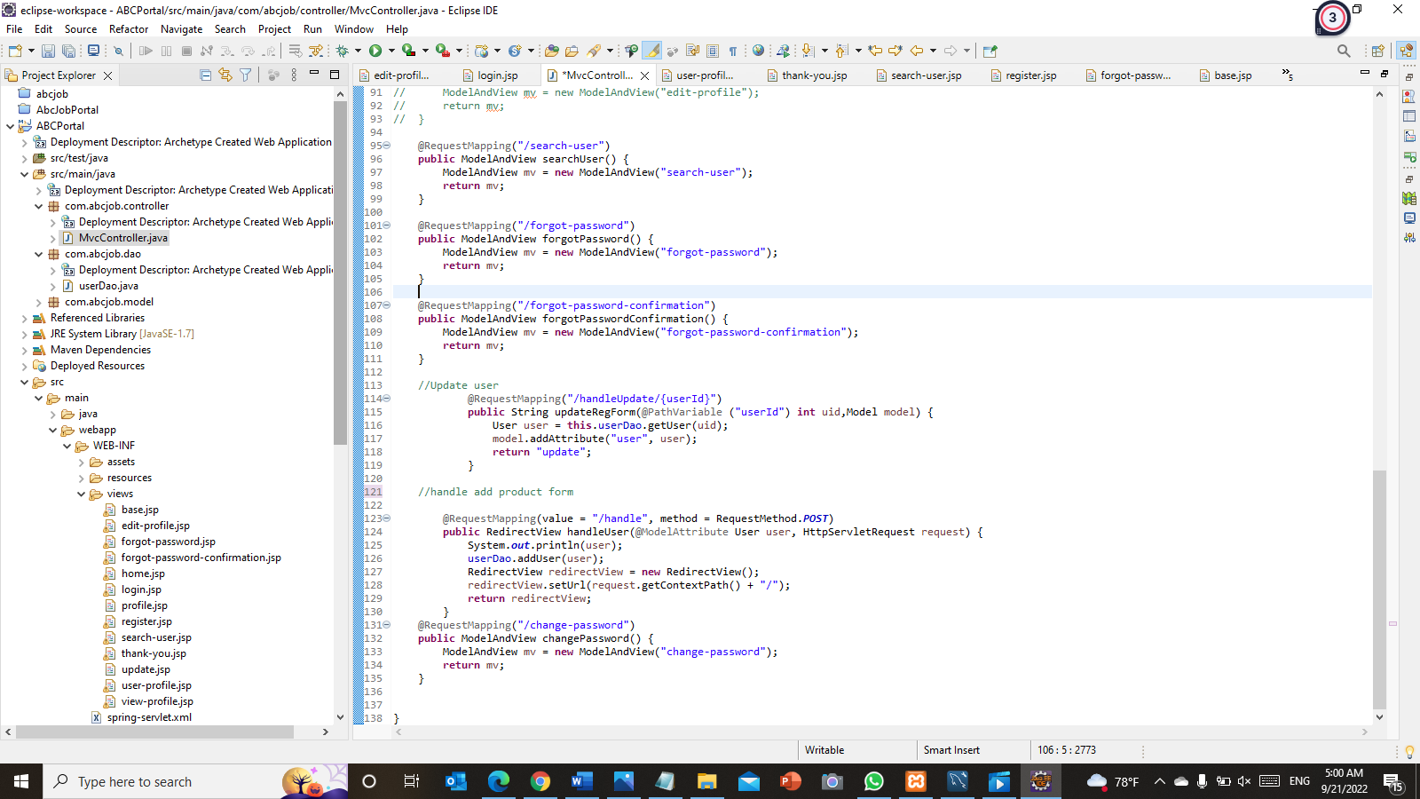comments are textual content notes added to the program to offer explanatory statistics about the supply code. they're utilized in a programming language to record the program and remind programmers of what difficult things they simply did with the code and additionally allows the later generation for know-how and upkeep of code.

Figure :Screenshot of coding & documentation Standards in eclipse (comments)

* 1. Naming Convention

Class Name - Class names should be nouns, in mixed case with the first letter of each internal word capitalized.

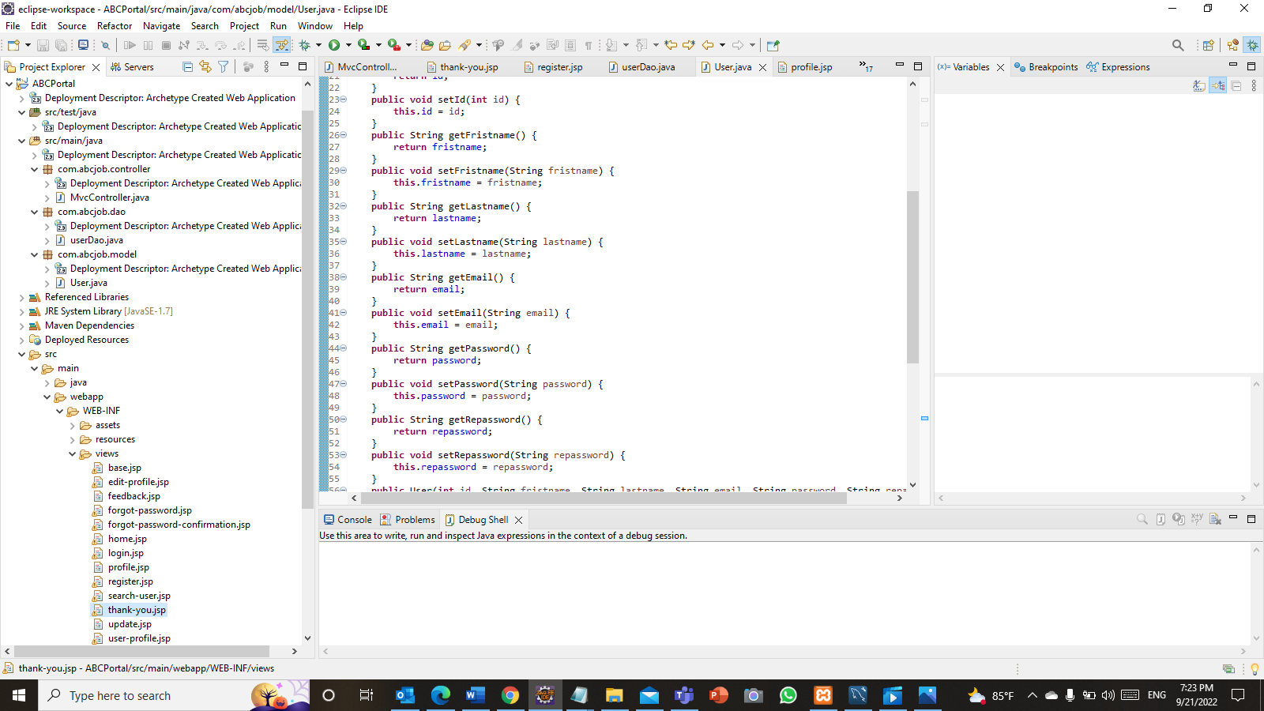

Figure :Screenshot of coding & documentation Standards in eclipse (Naming Conventions)

* 1. File and Folder Organization

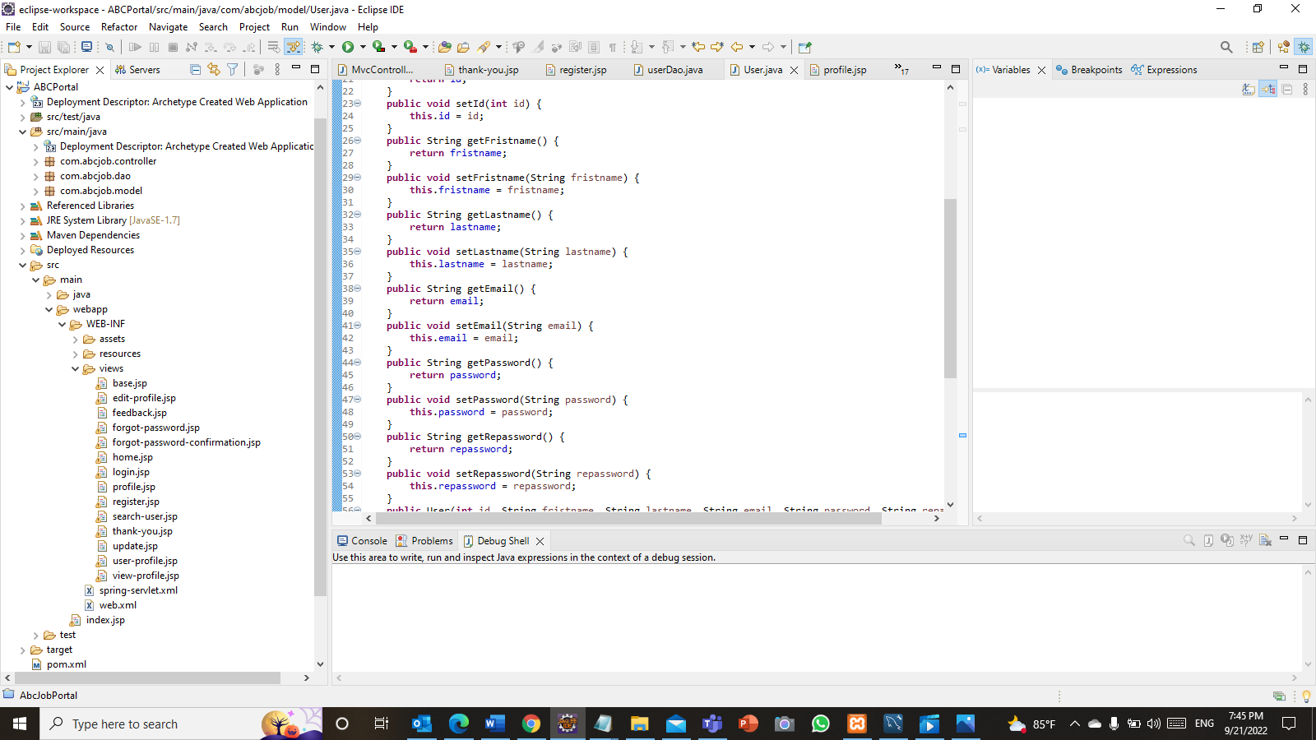By keeping files and folders in order, it is possible to get the necessary information quickly when using coding.

Figure :Screenshot of coding & documentation Standards in eclipse (File and Folder Organization)

1. Documentation tool and its configuration.

Step 1 - In Eclipse, go to ****File > Export****

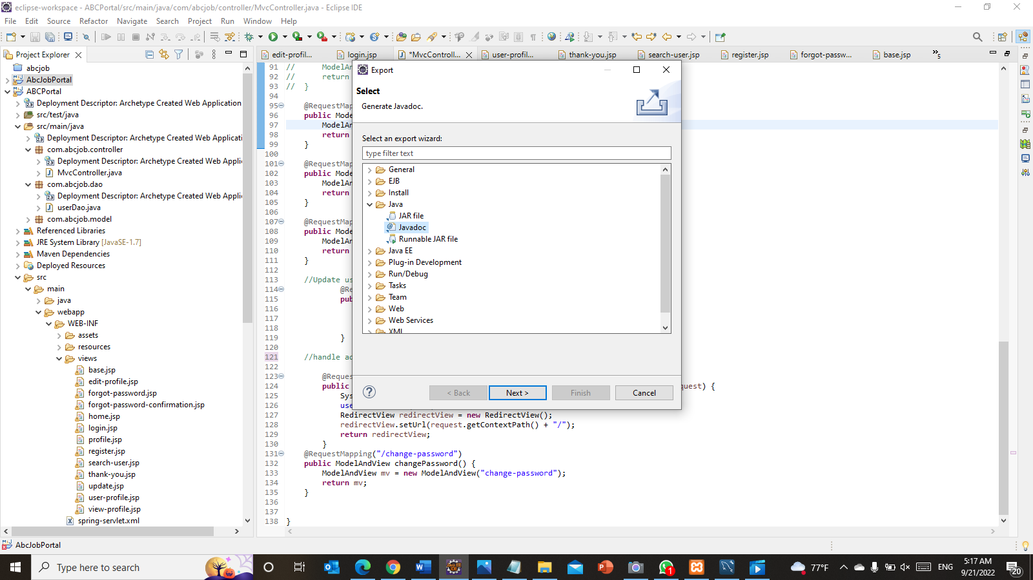 Step 2 - Expand **Java** and select **Javadoc and then click next**

Figure :Javadoc configuration step 2

Step 3 - Select your project and package. Then inside the right pane, select the classes you need to be included in the Javadoc

Step 4 - Select which visibility option you want: Private, Package, Protected, or Public.

Step 5 -Make sure the **Use standard doclet** radio button is selected

Step 6 -Click the Browse button and select the output location in which you want the Javadoc generated and click next

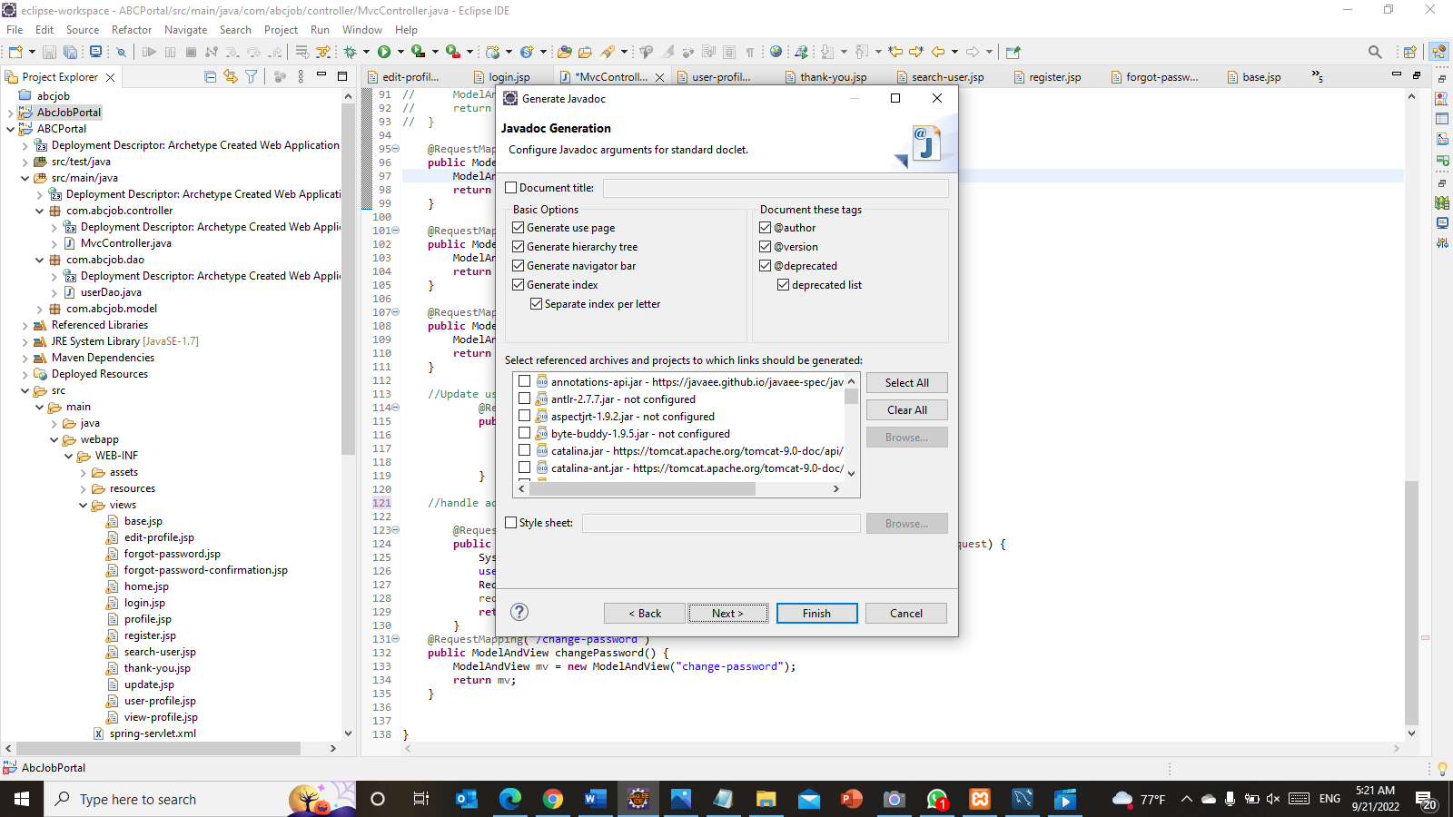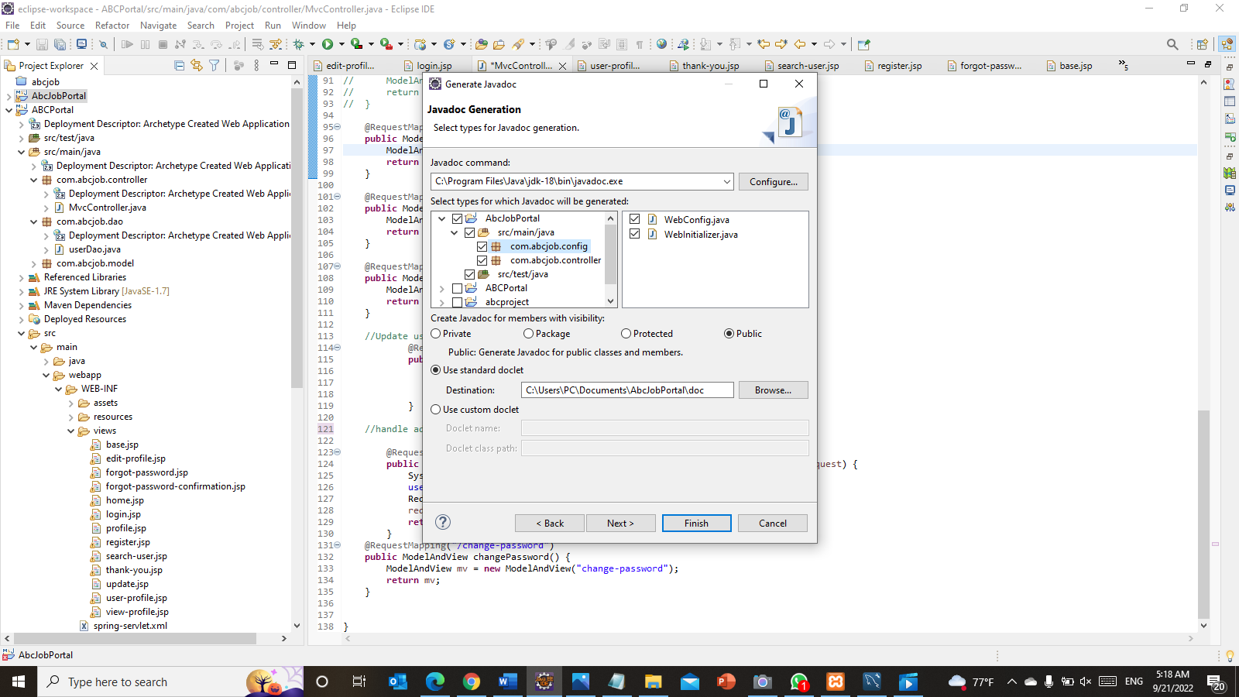Step 7 – Click Next

Figure :Screenshot of Javadoc configuration step 7

Figure :Screenshot of Javadoc configuration step 3,4,5,6

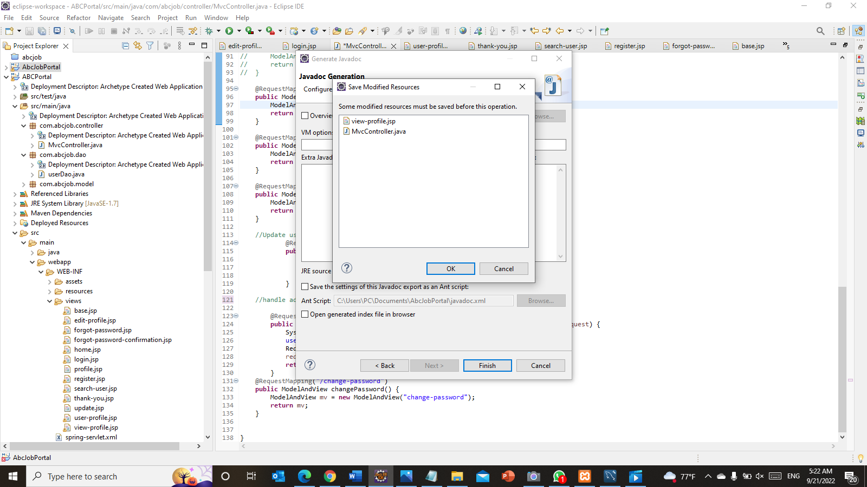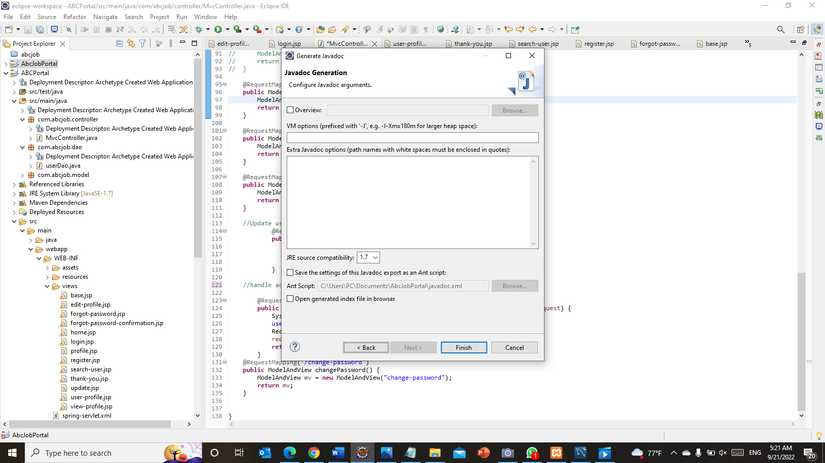Step 8 - Select an HTML page that you want to be your overview page in Javadoc and click finish

Figure :Javadoc configuration step 8

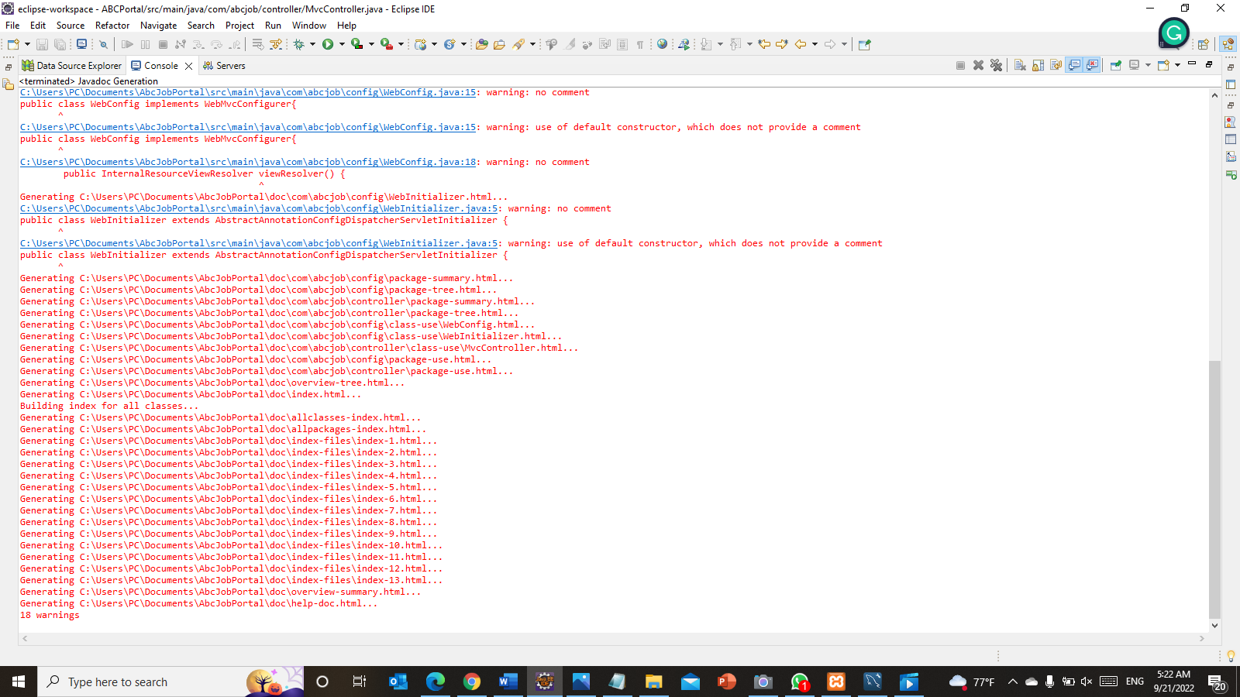Step 9 – Javadoc and error checking

Figure :Javadoc configuration step 9

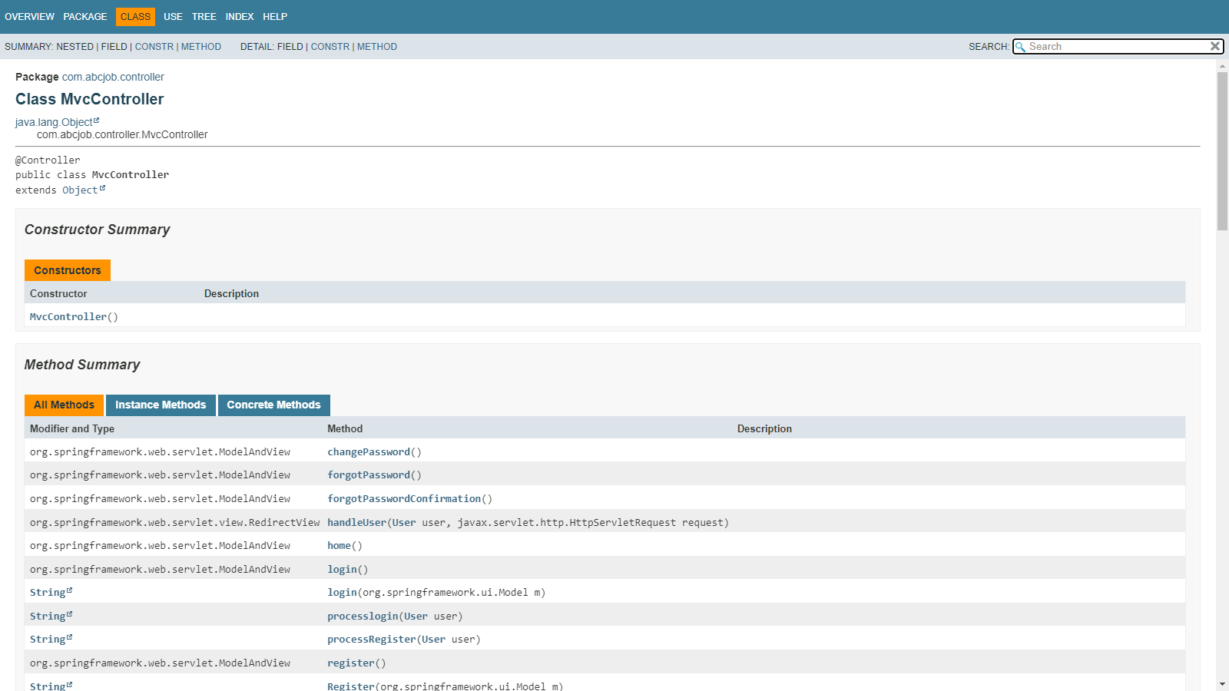

Figure :Screenshot of Javadoc

Task 5

1. HTML Pages Source Code
   1. 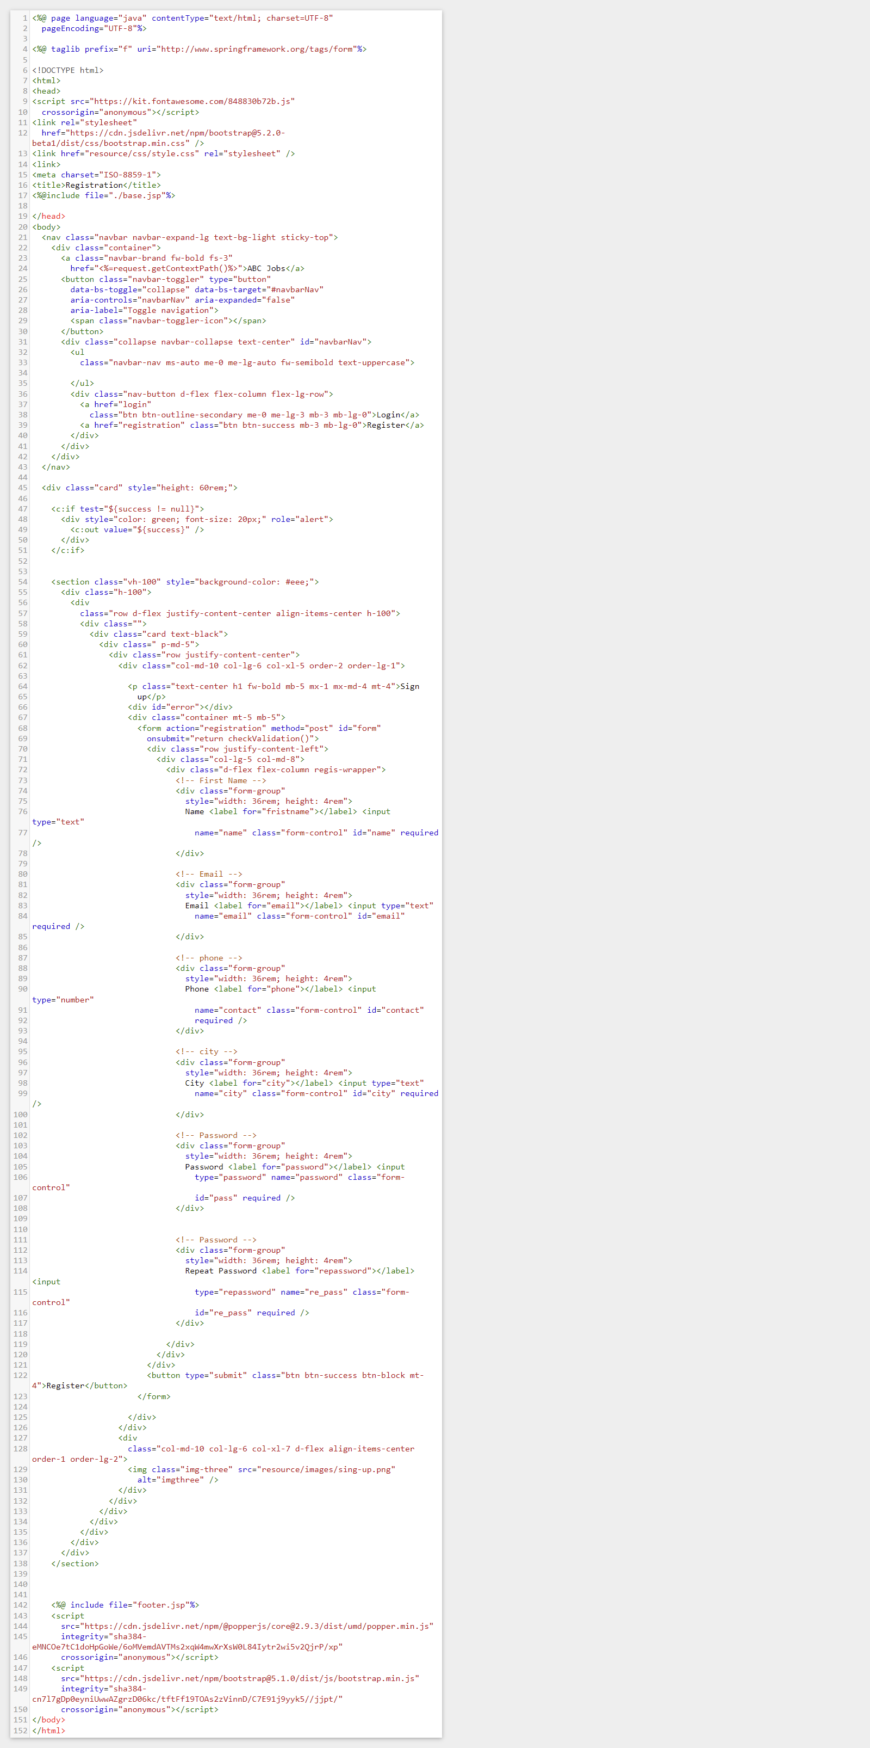Registration Page (register.jsp)



* 1. Login Page (login.js)

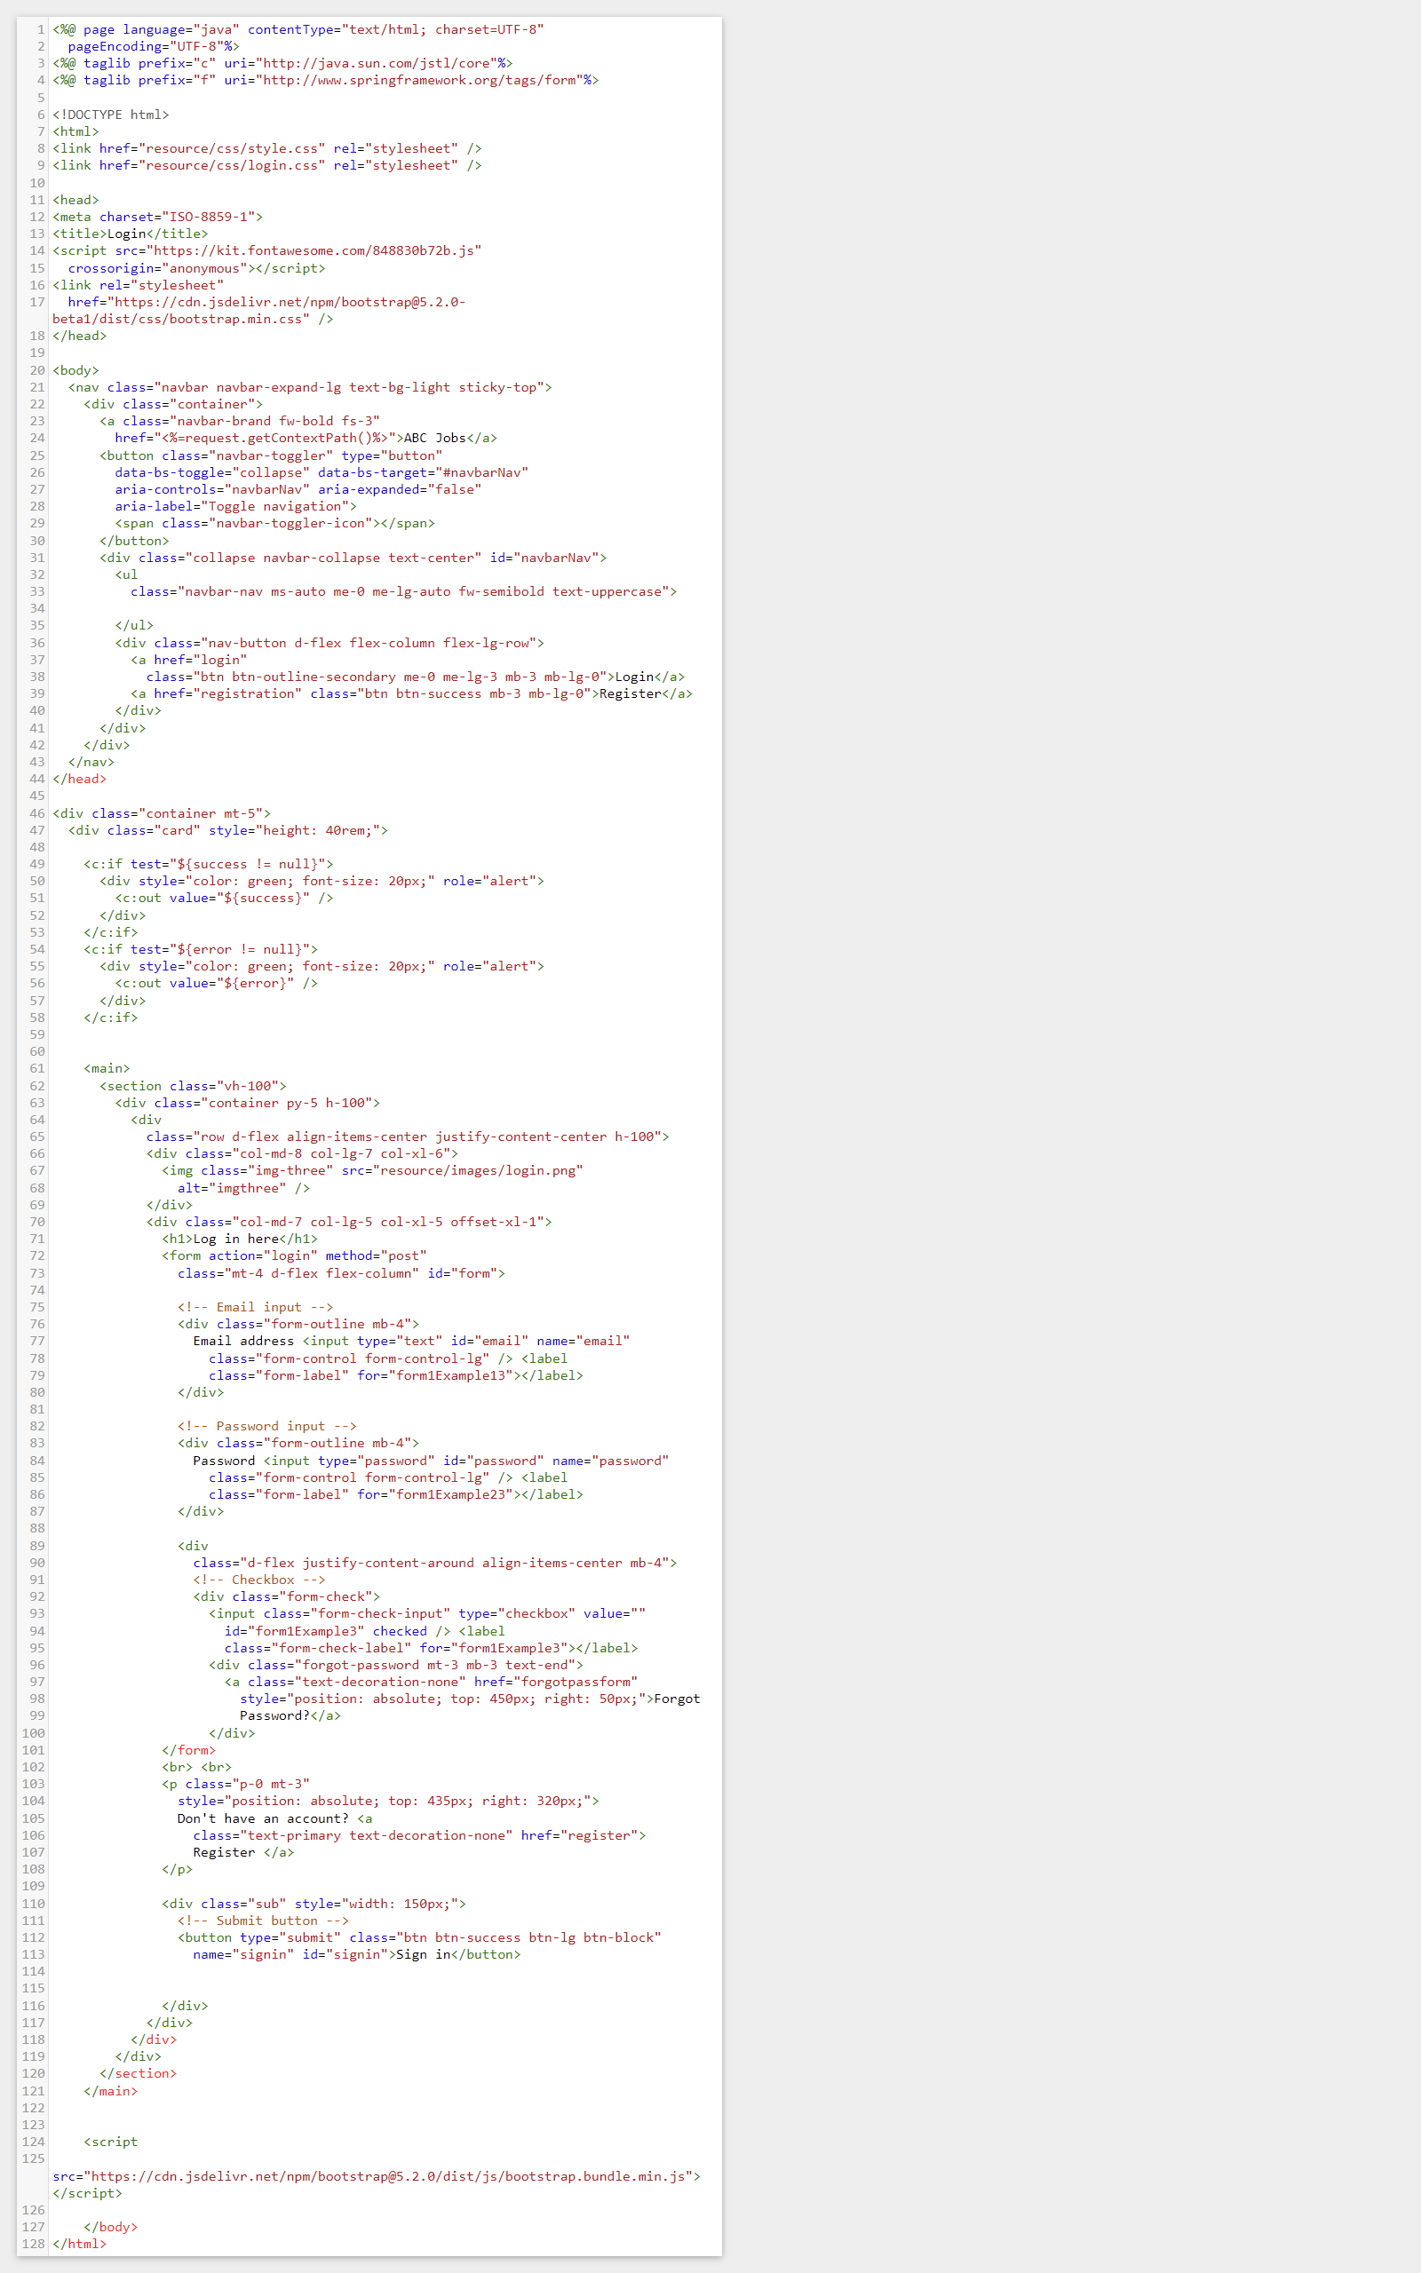



* 1. 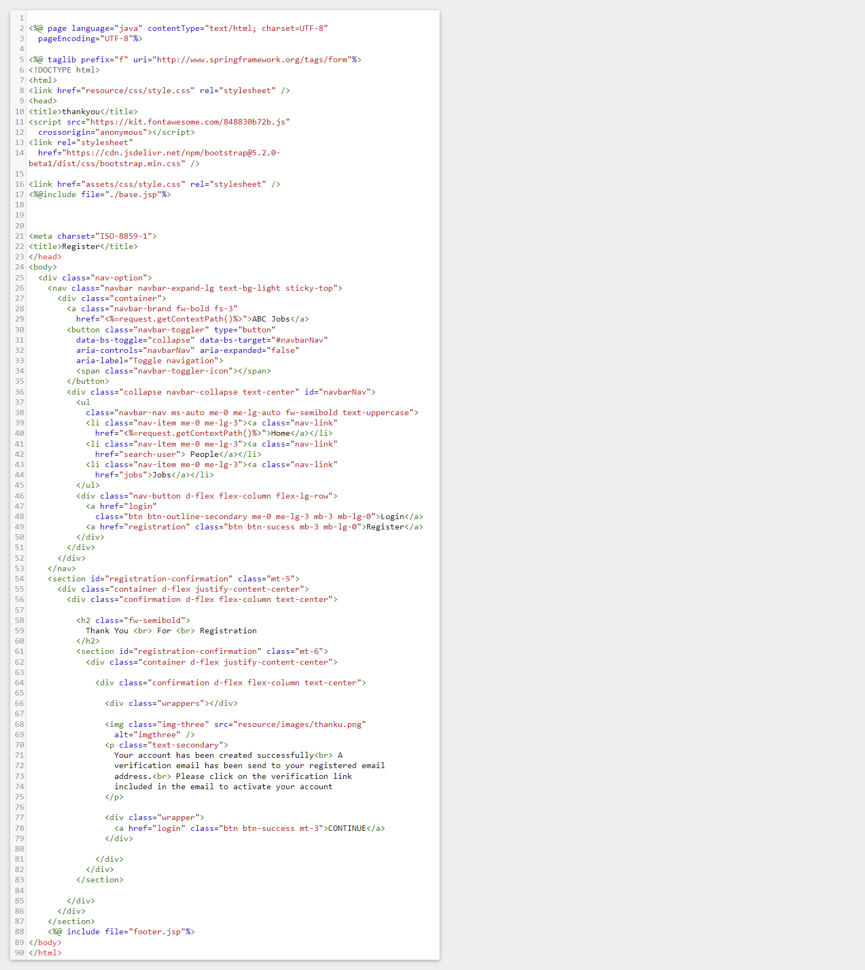Thank you Page(thank-you.jsp)
  2. Forgot Password Page (forgot-password.jsp)

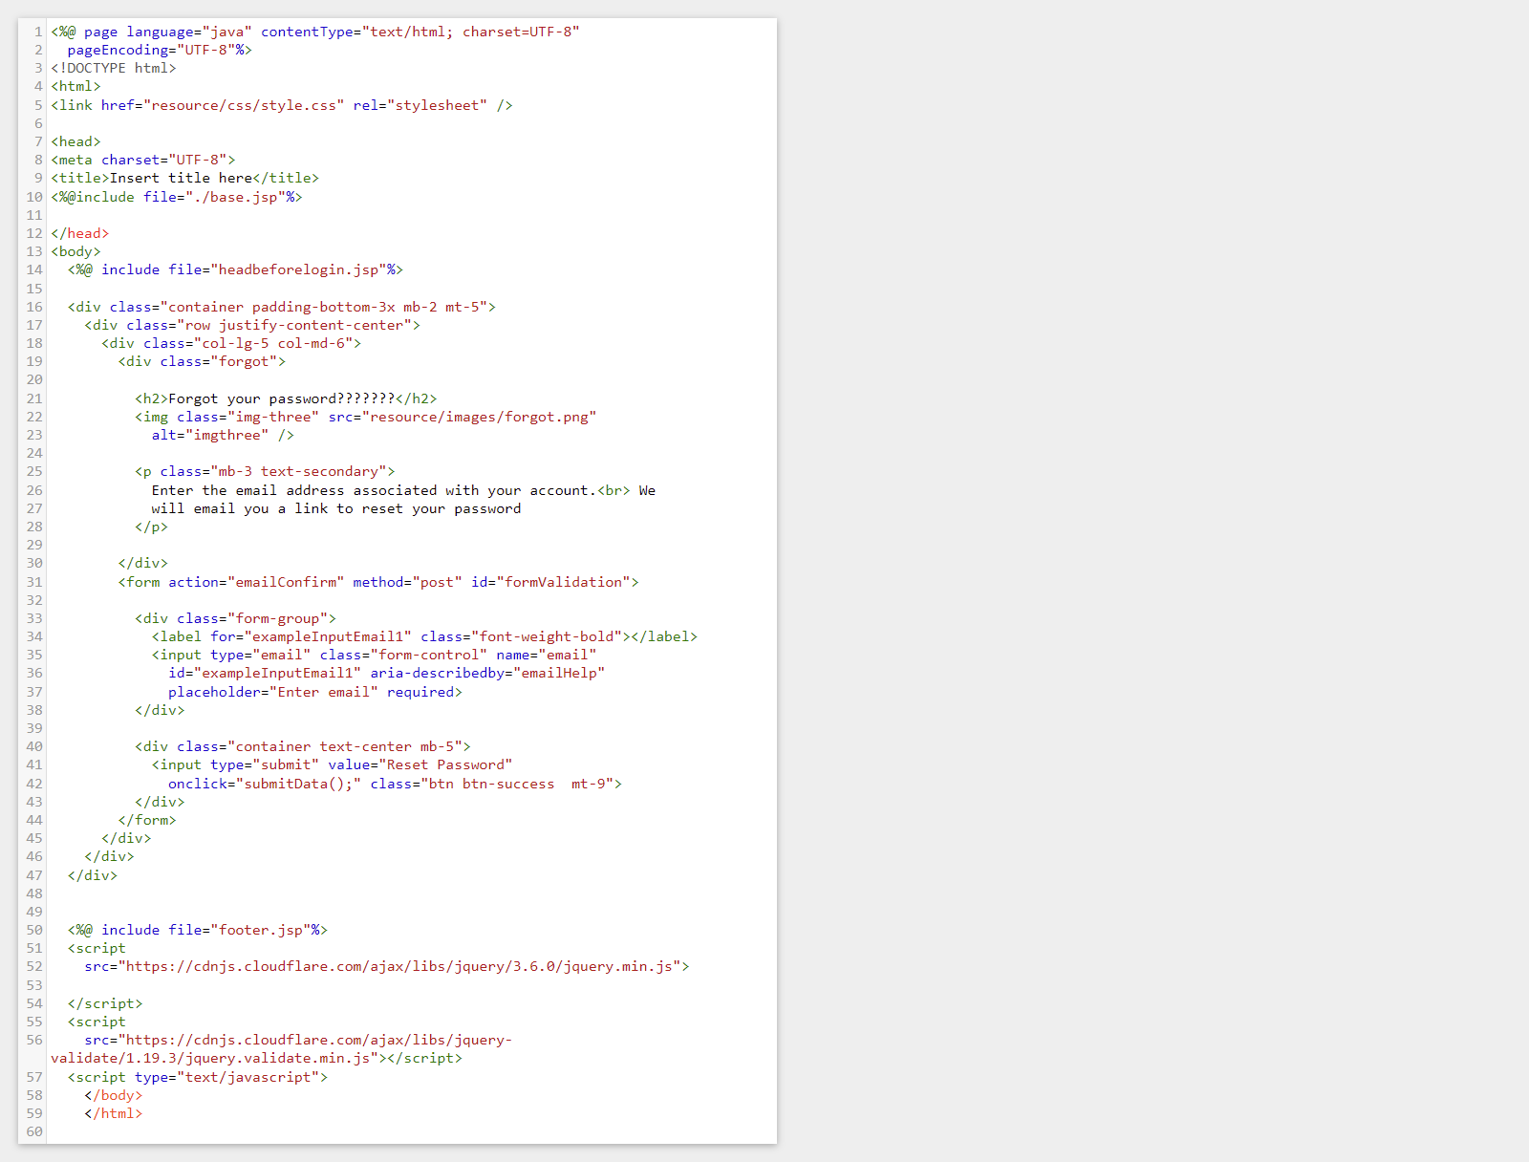

* 1. 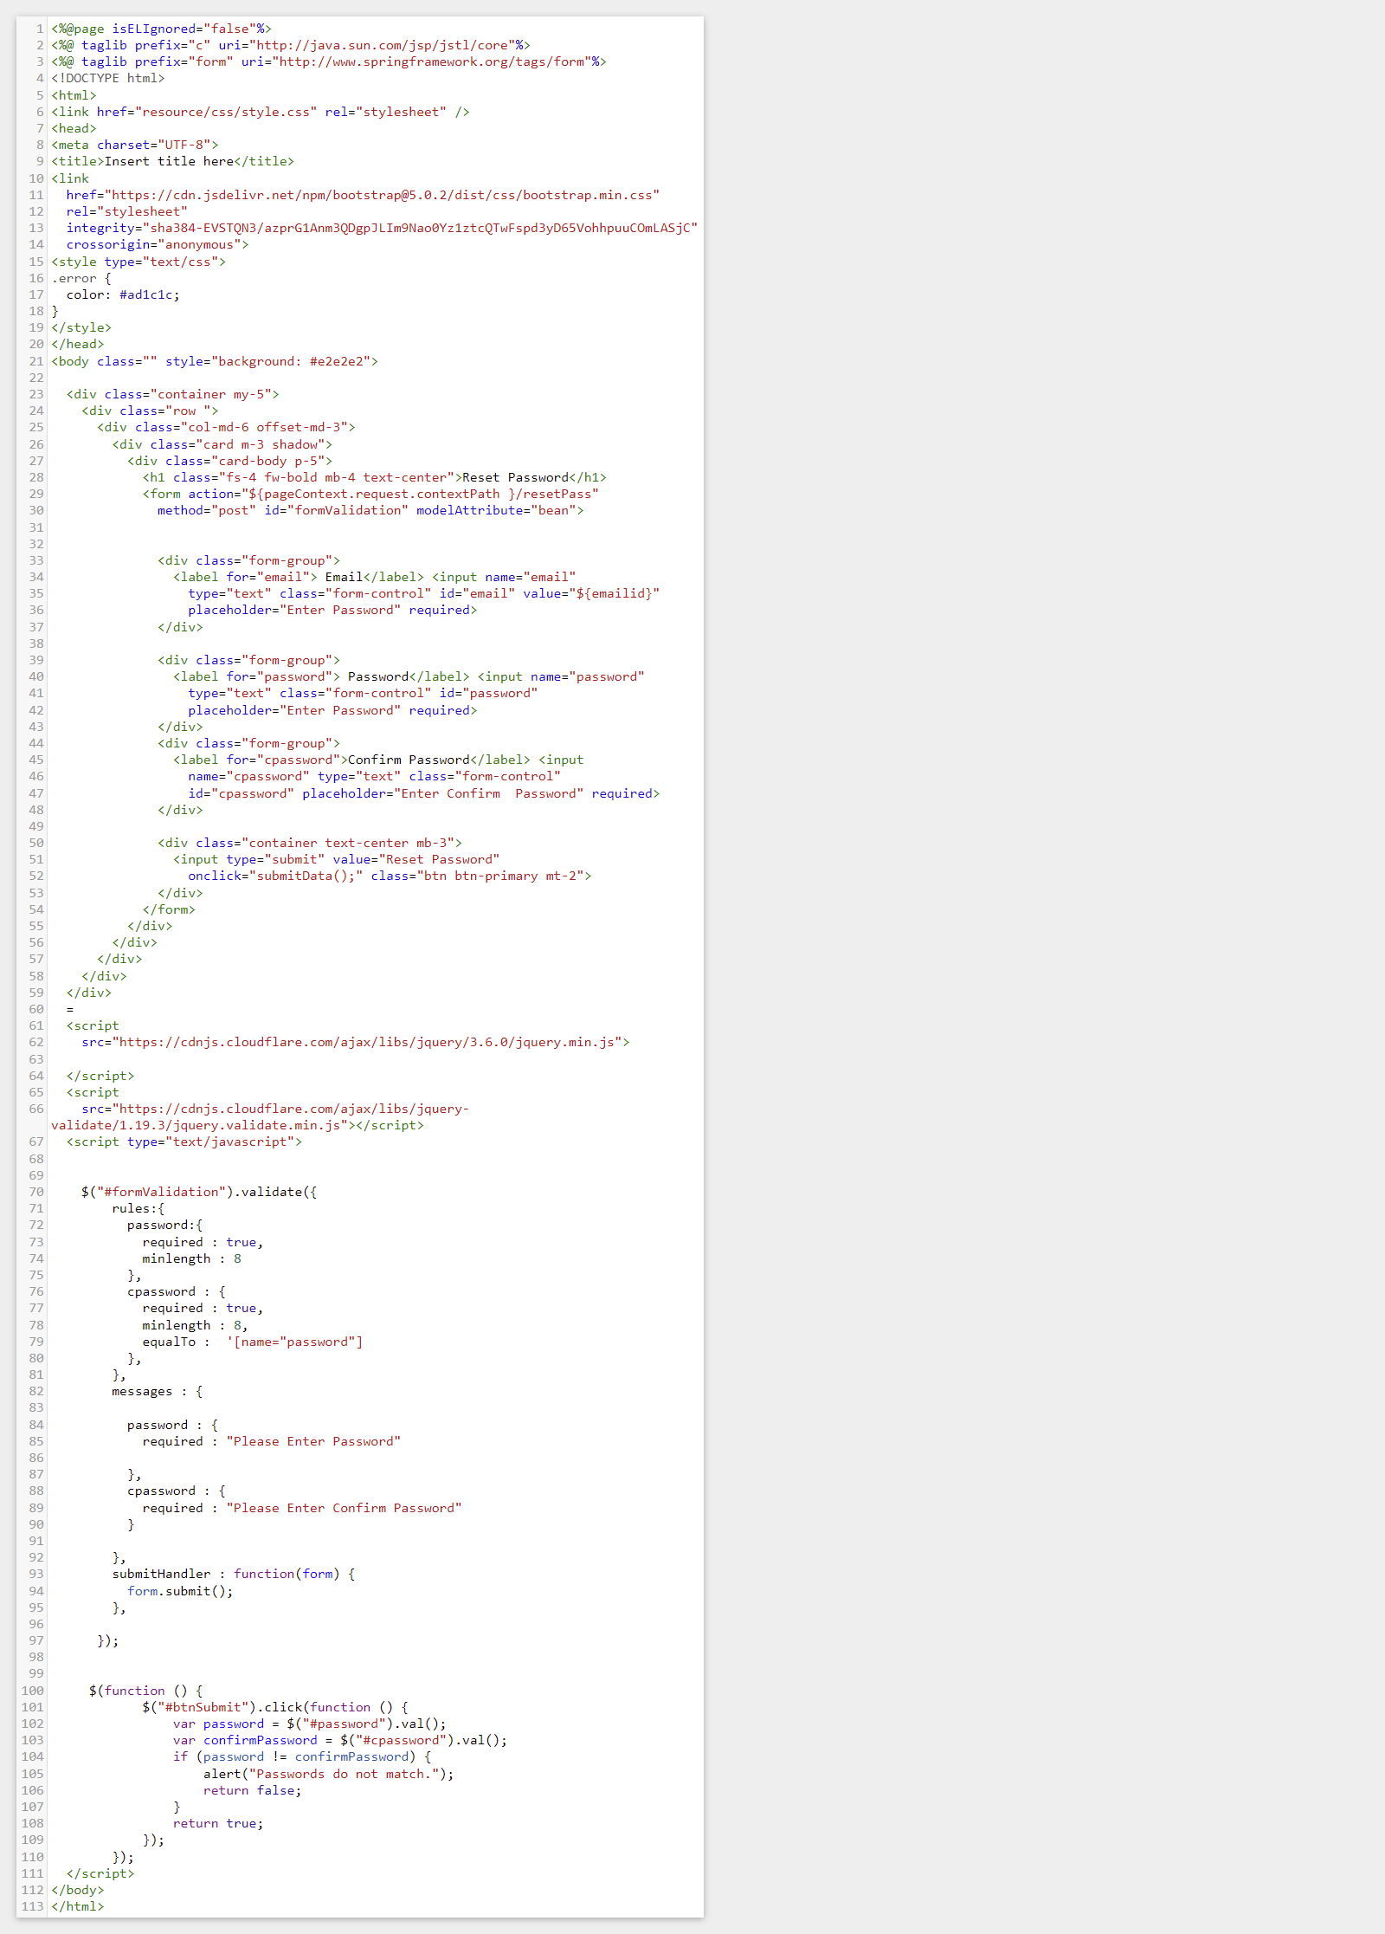Forgot Password Confirmation Page (Reset_password.jsp)
  2. 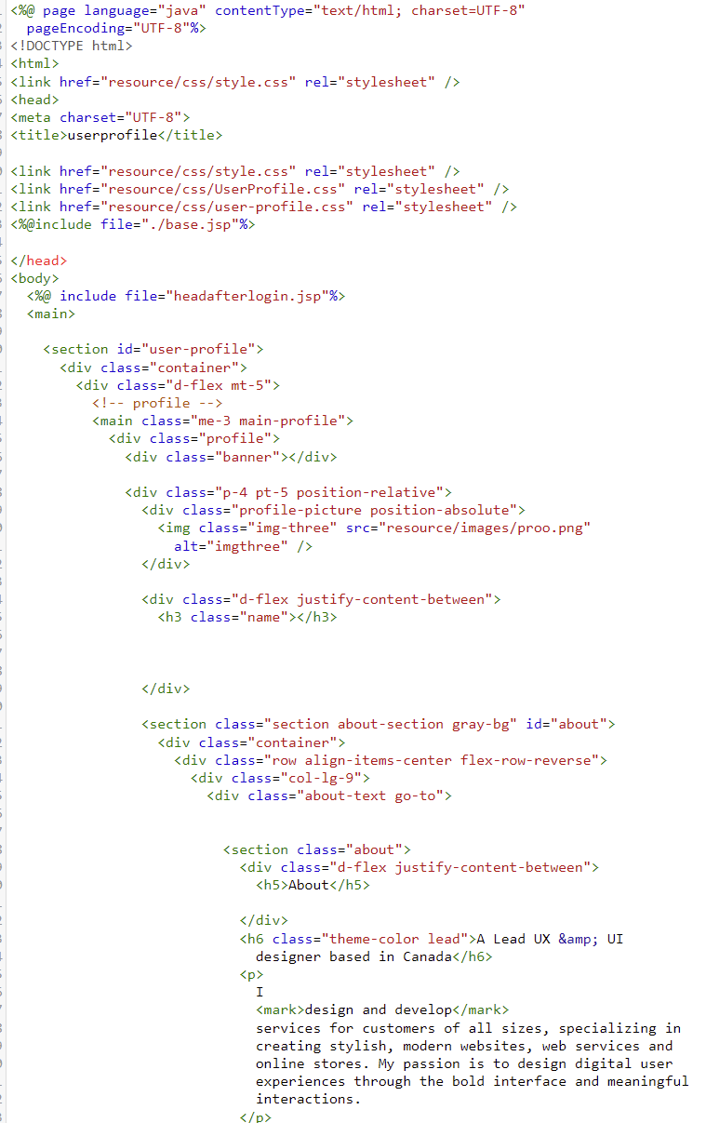User Profile (userProfile.jsp)

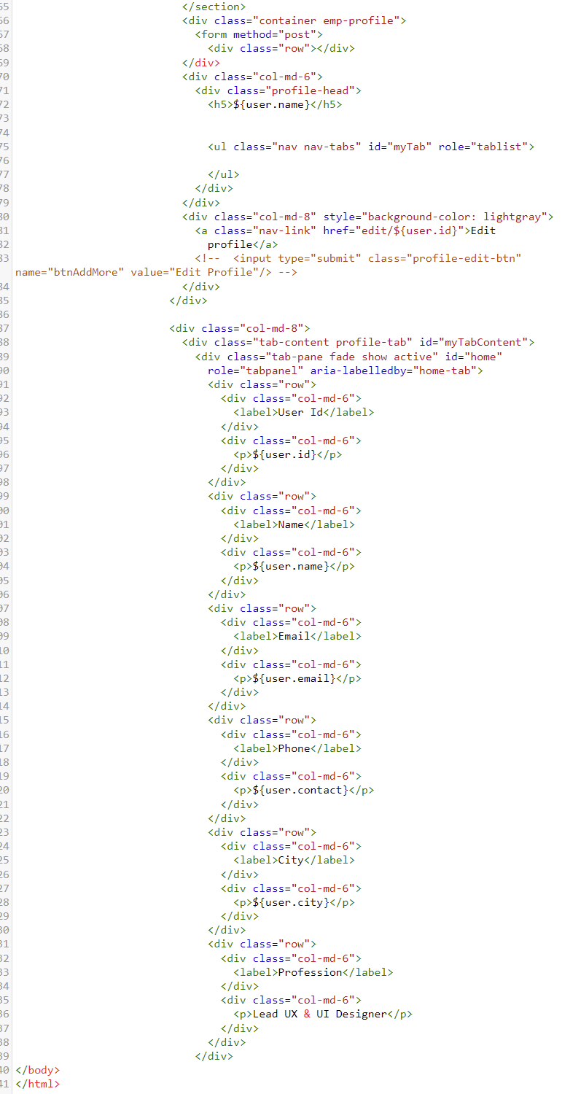

* 1. 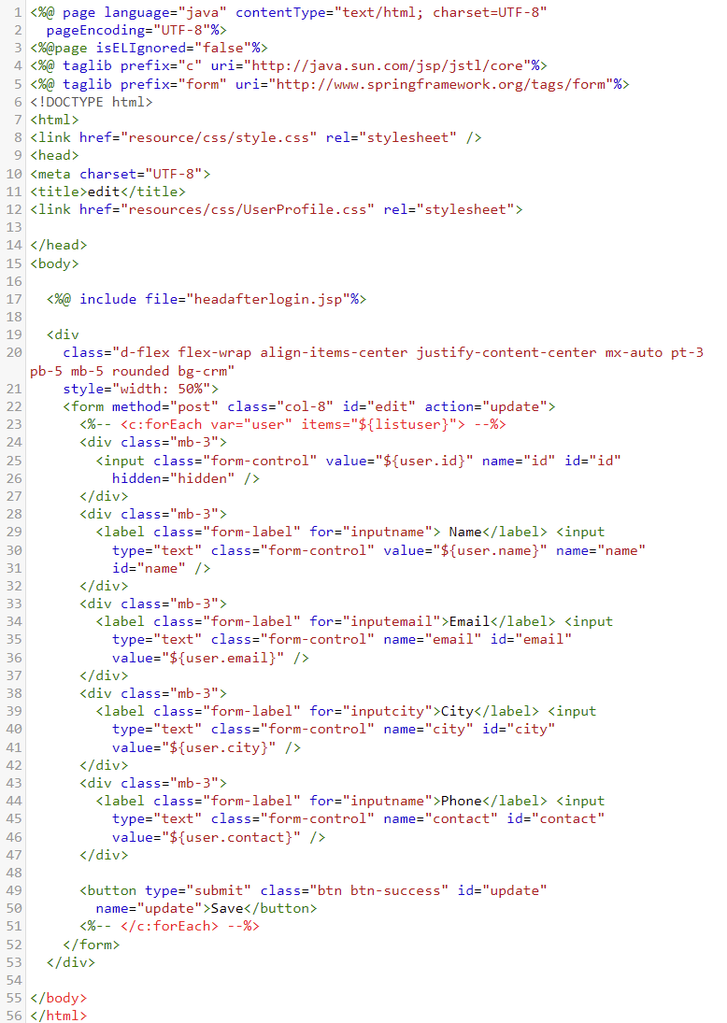Edit Profile (editprofile.jsp)
  2. Search User (searchUser.jsp)

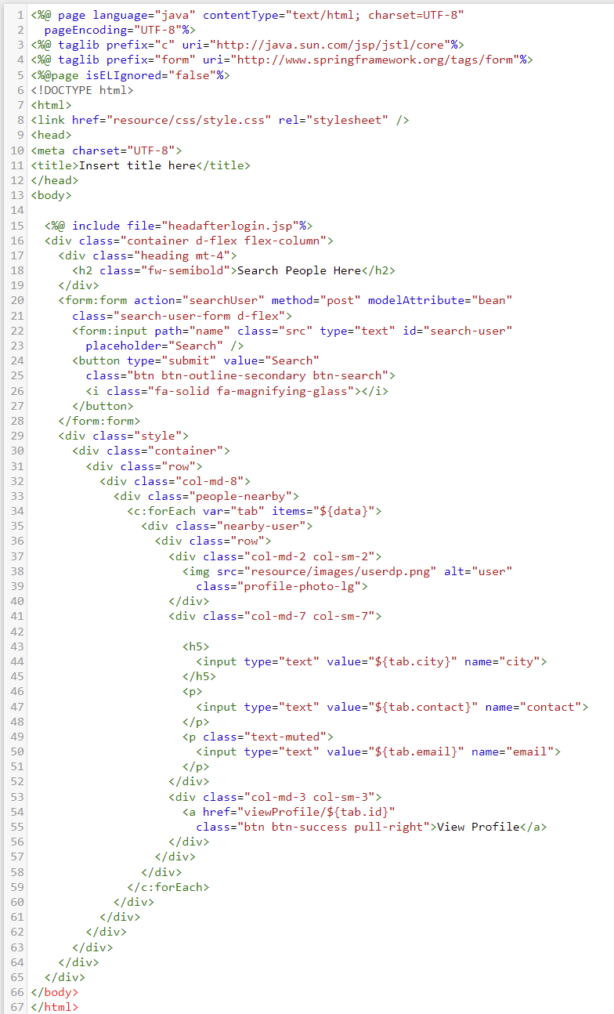

* 1. Check Mail (checkMail.jsp)

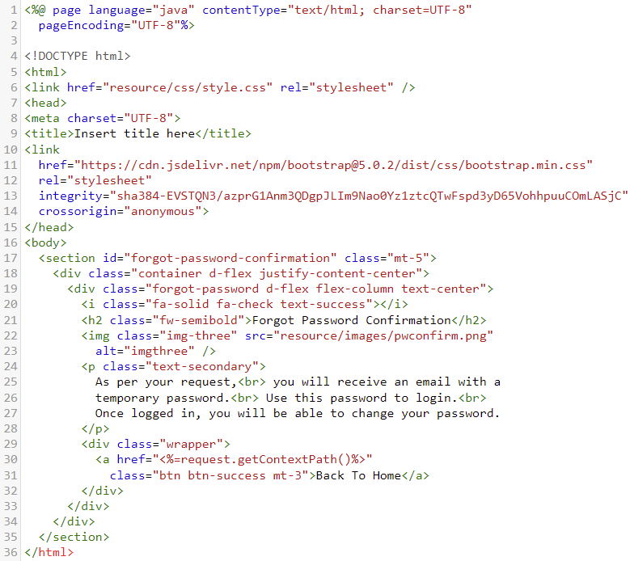

* 1. 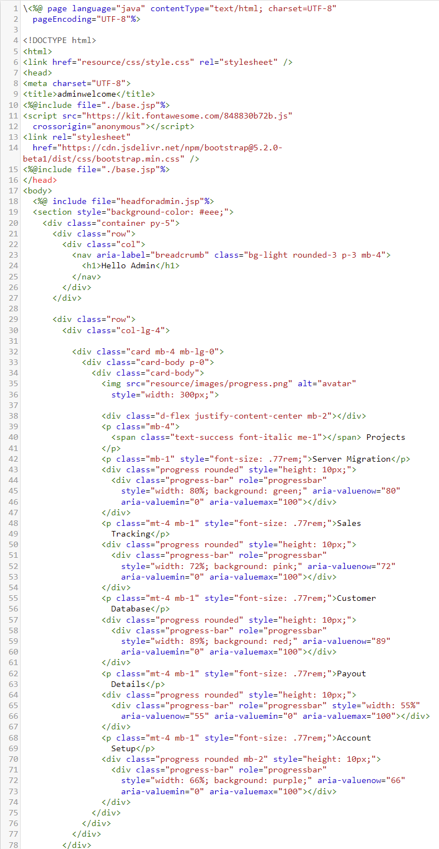Admin Profile(adminwelcome.jsp)

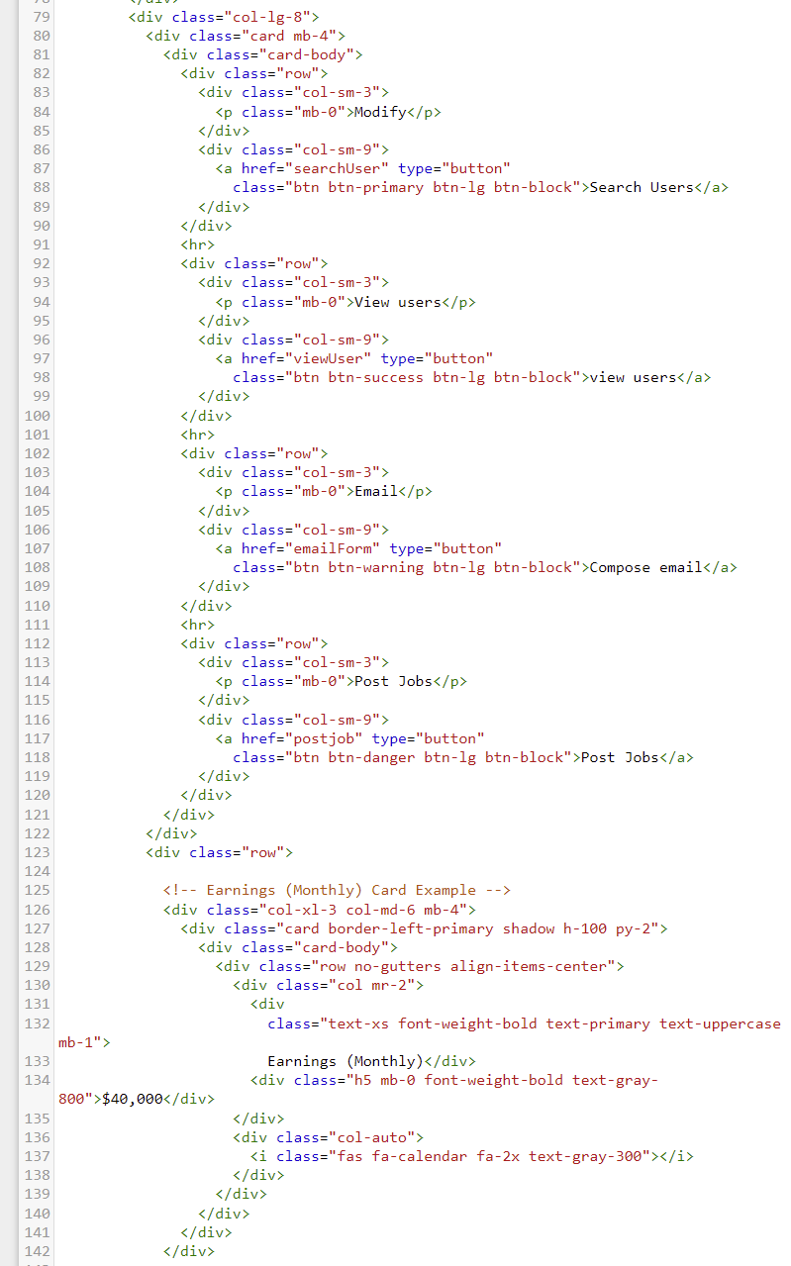

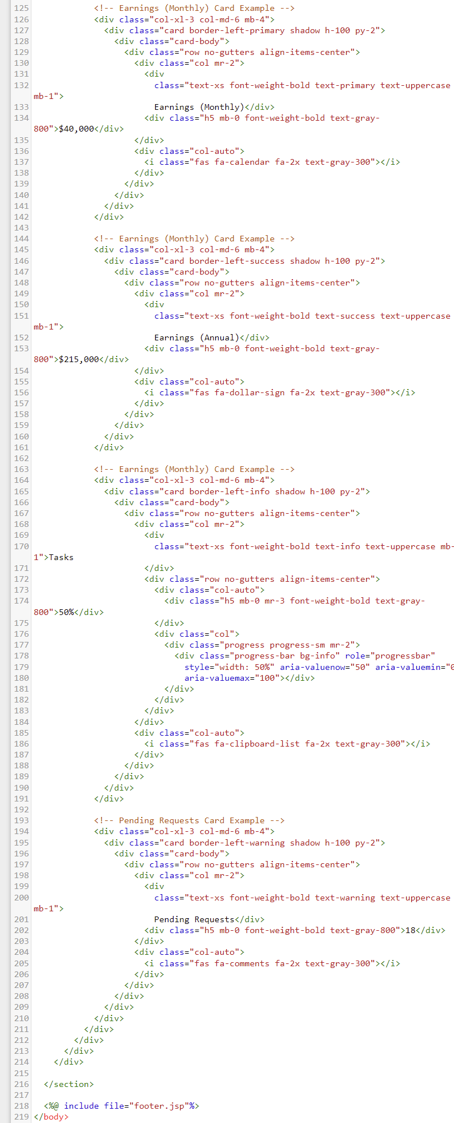

* 1. 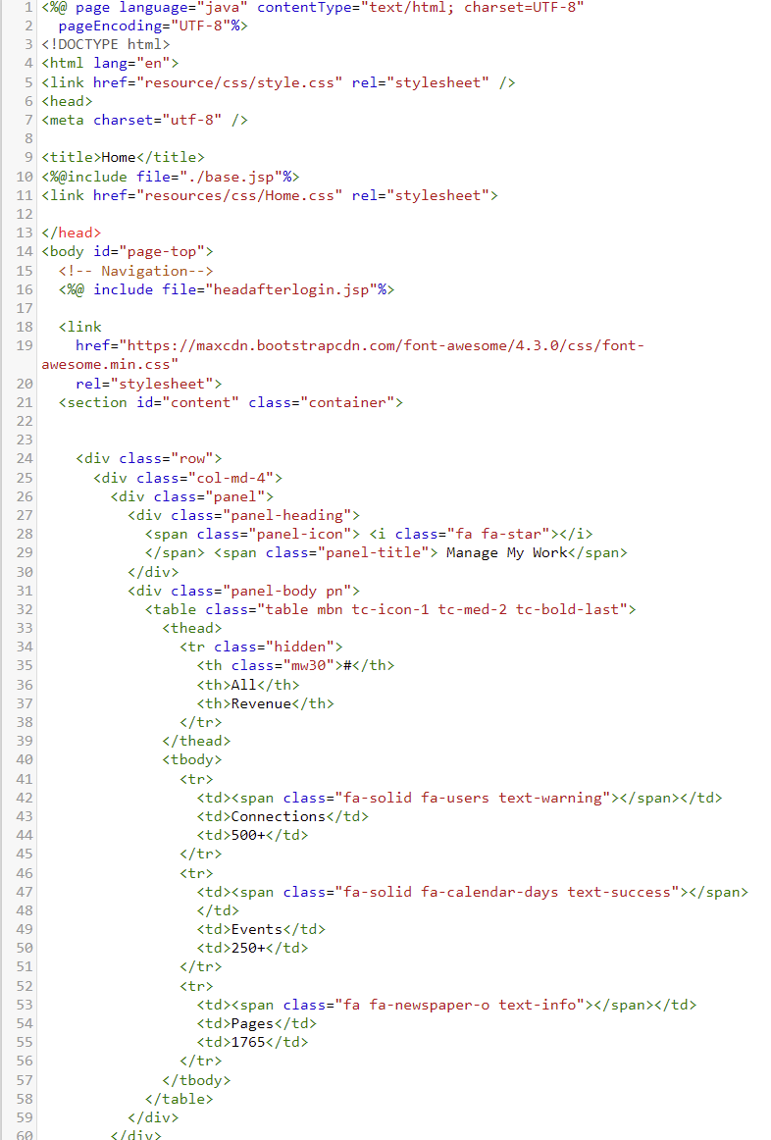Index Page (home.jsp)

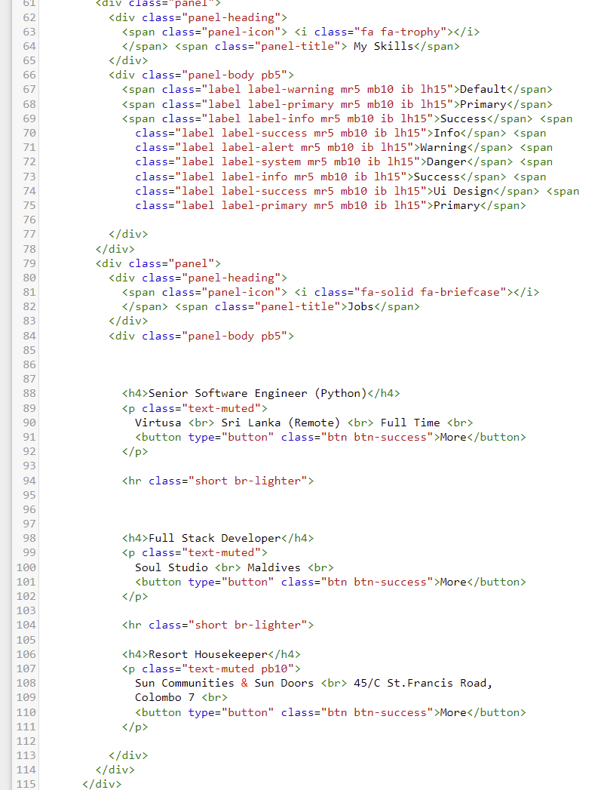

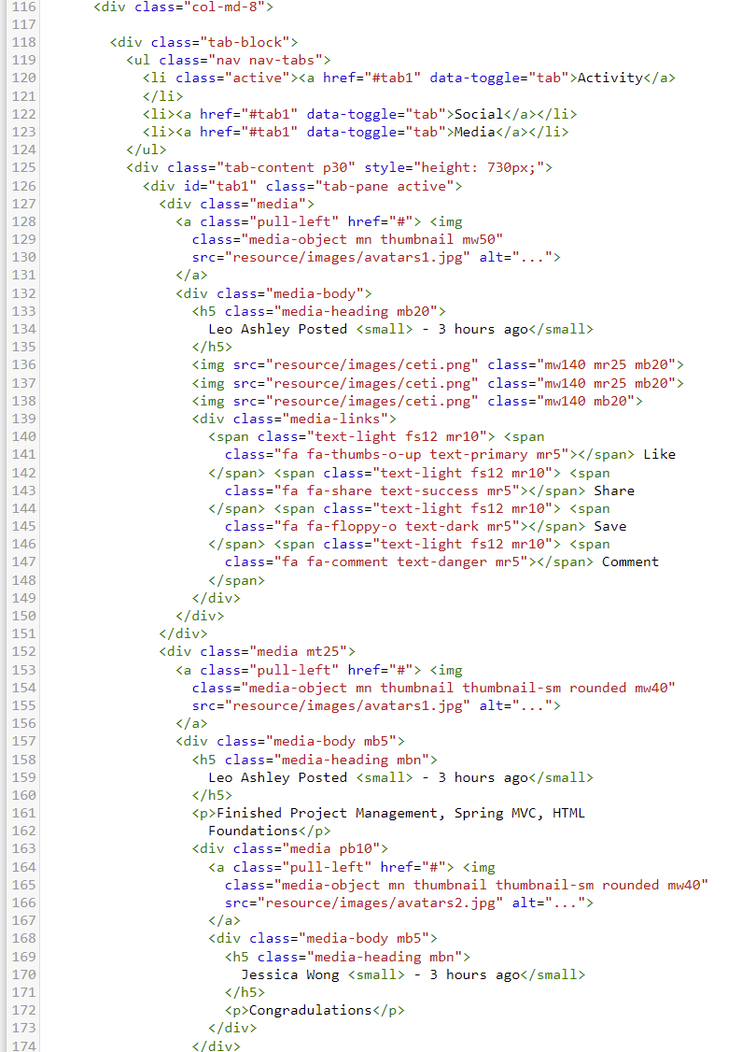

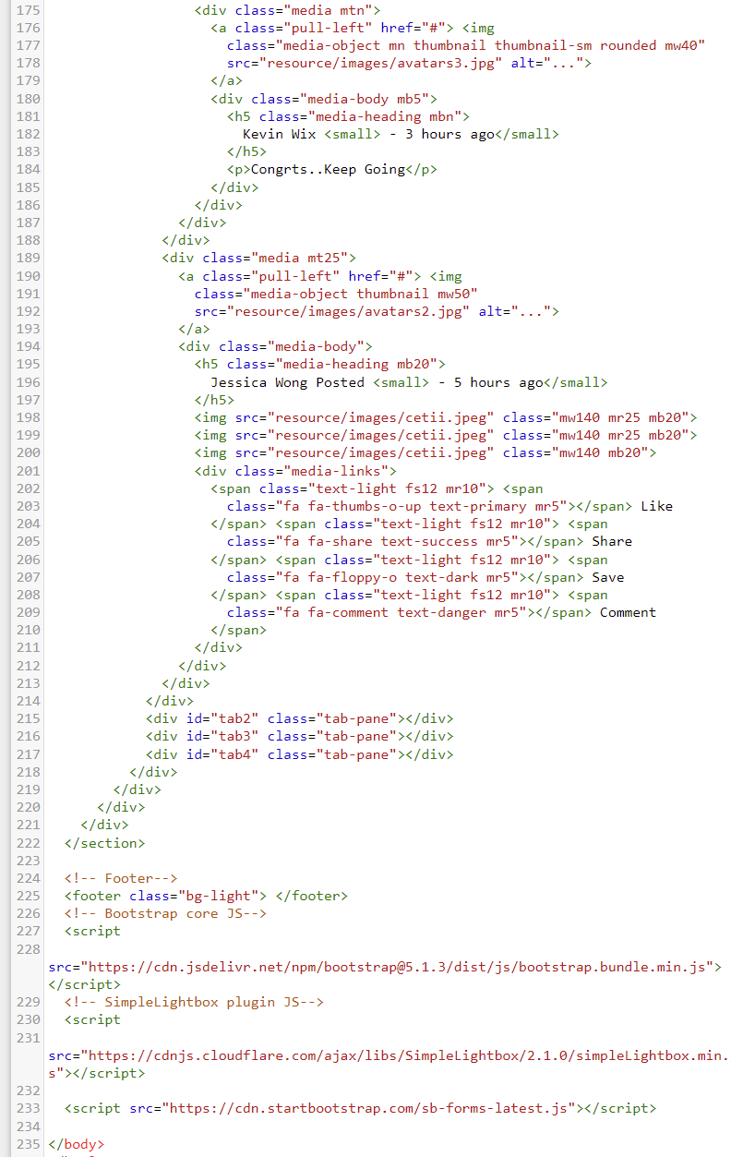Task 6

1. Java Classes
   1. com.spring.mvc.config

* ViewRes

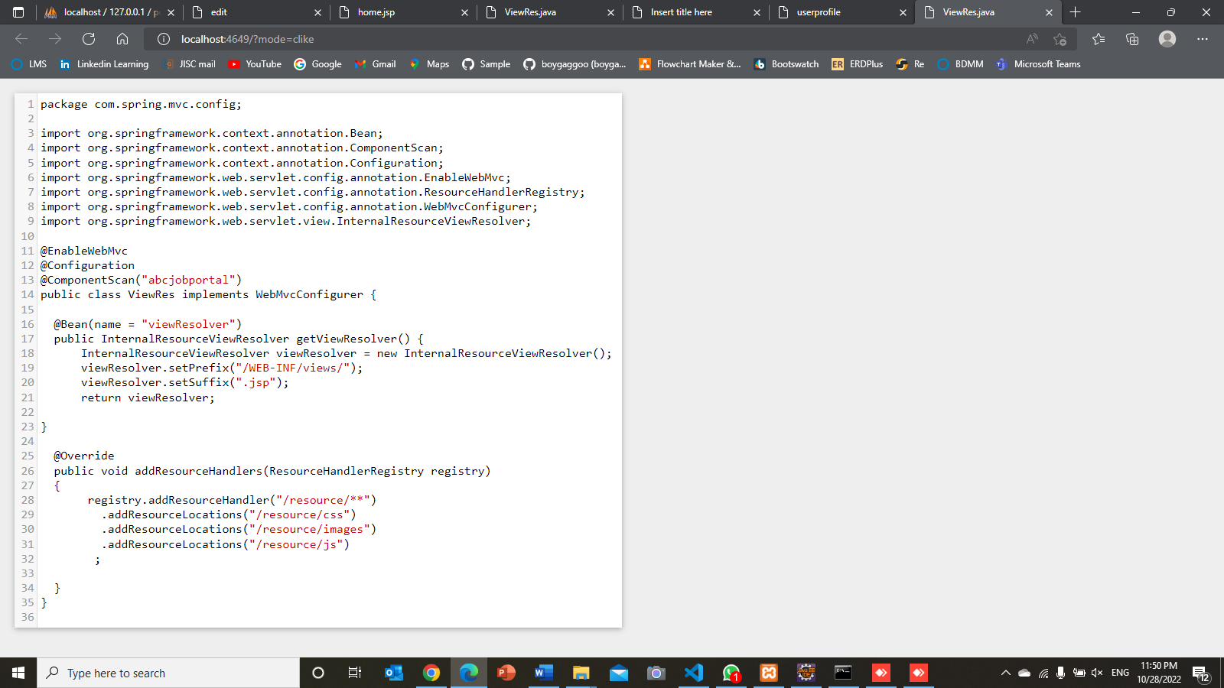

* 1. com.spring.mvc.controller
* ApplicationContoller.java

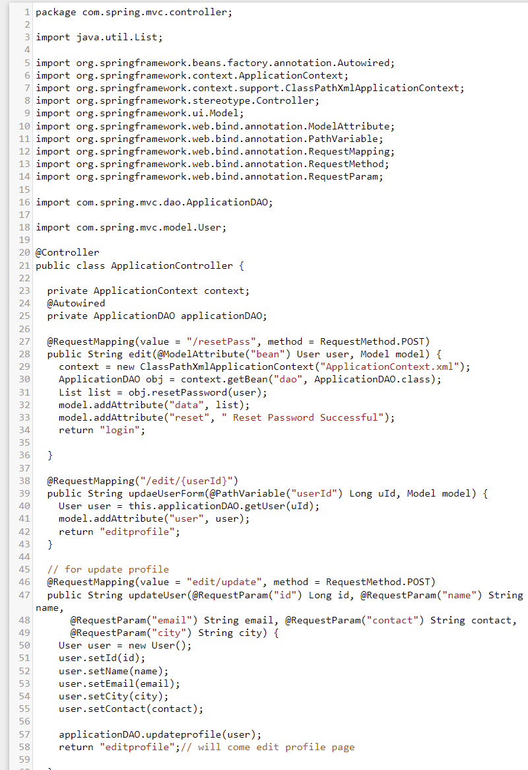

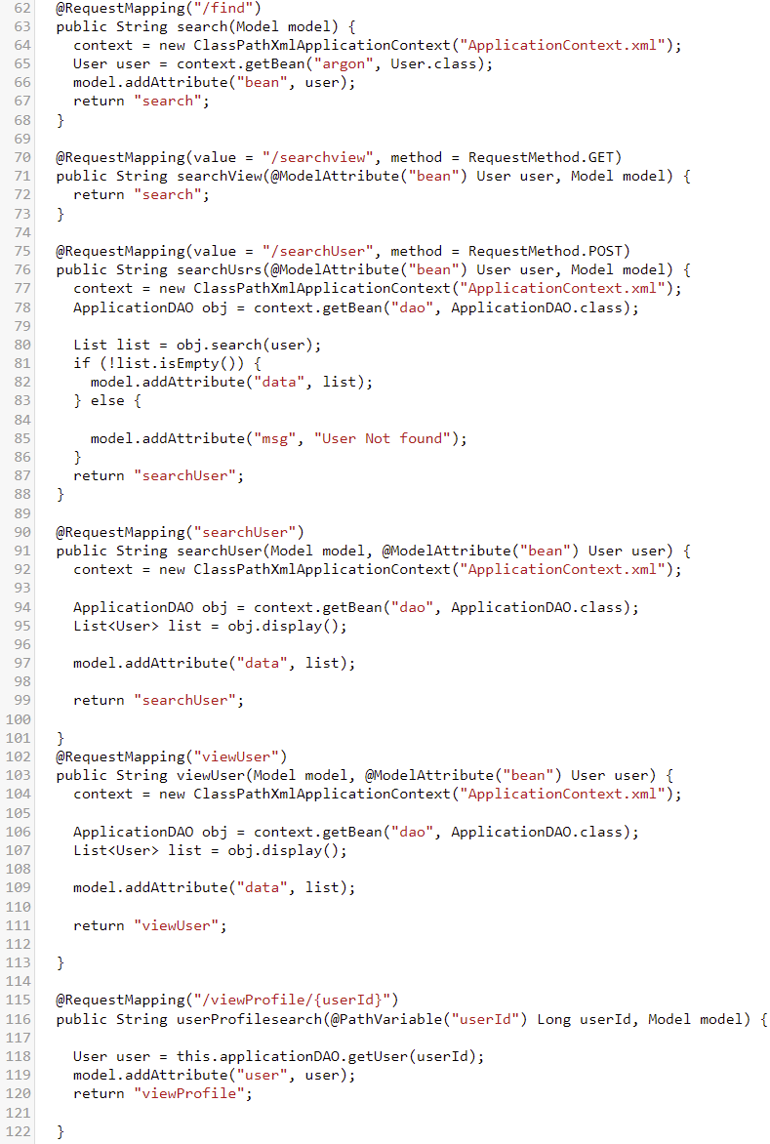

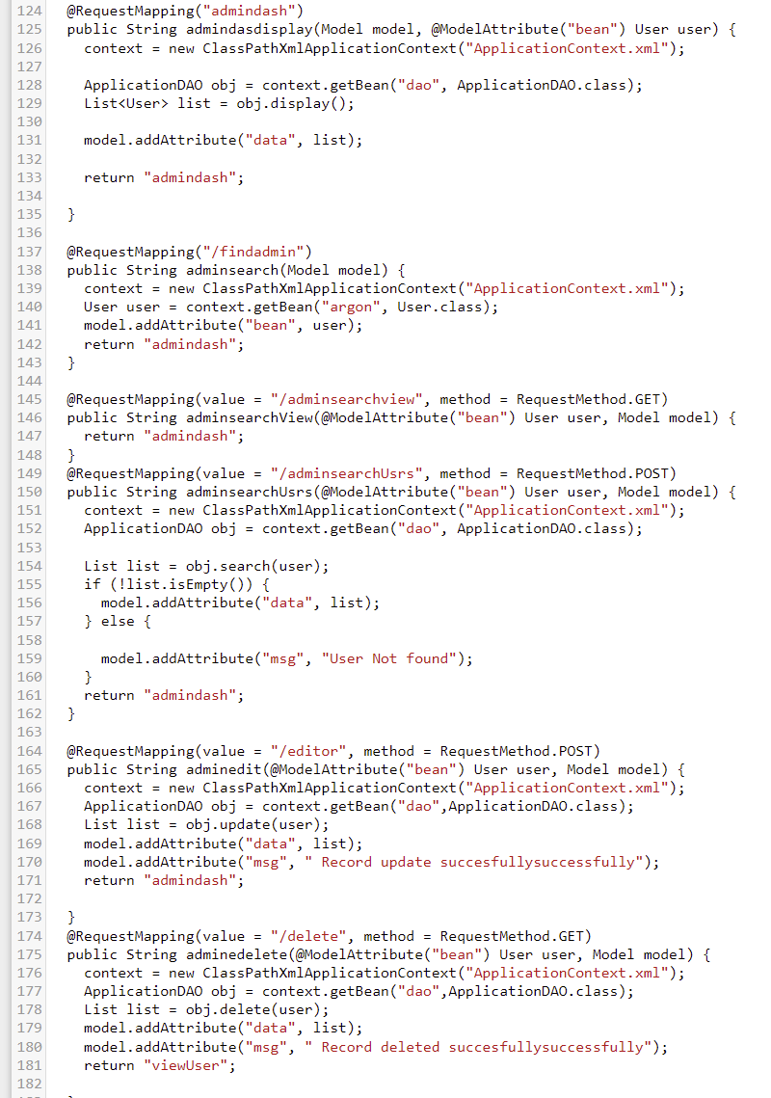

* 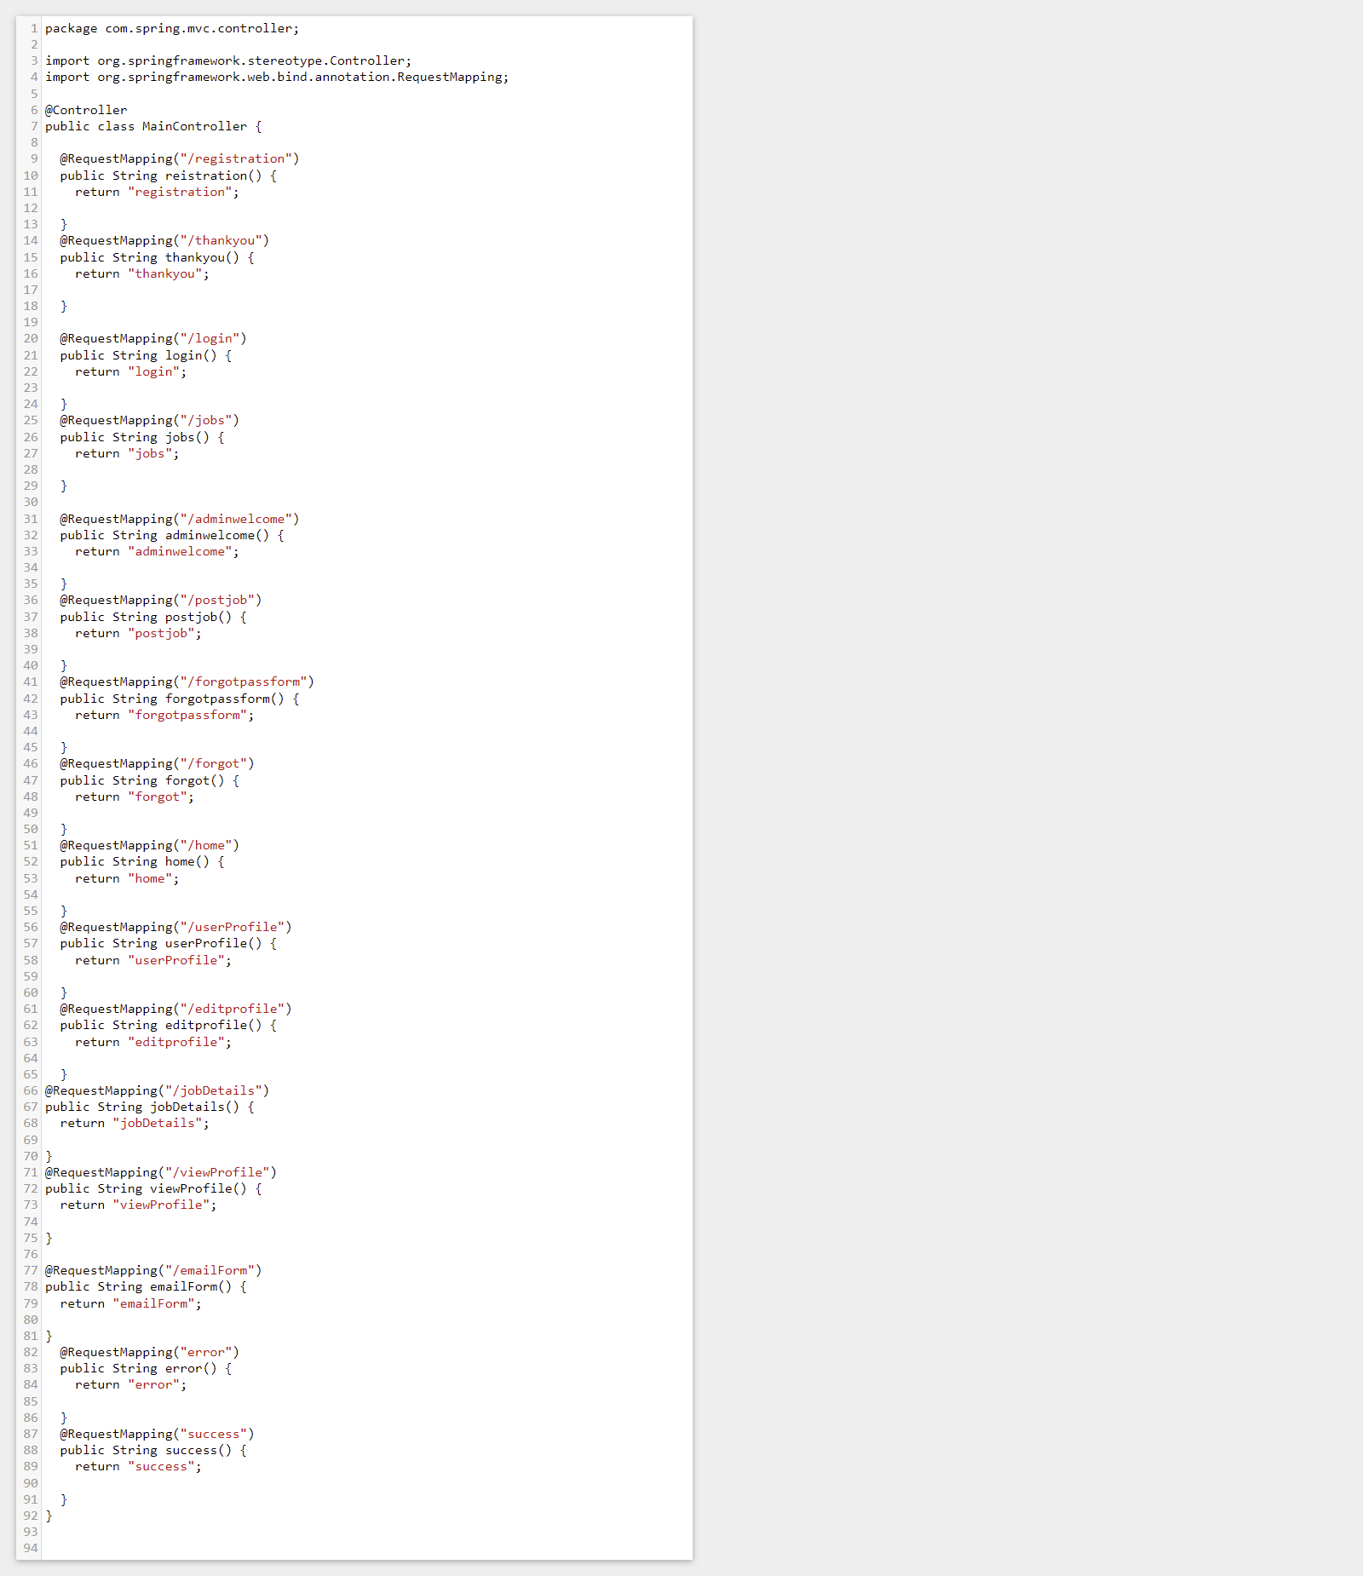MainController.java
* UserController.java

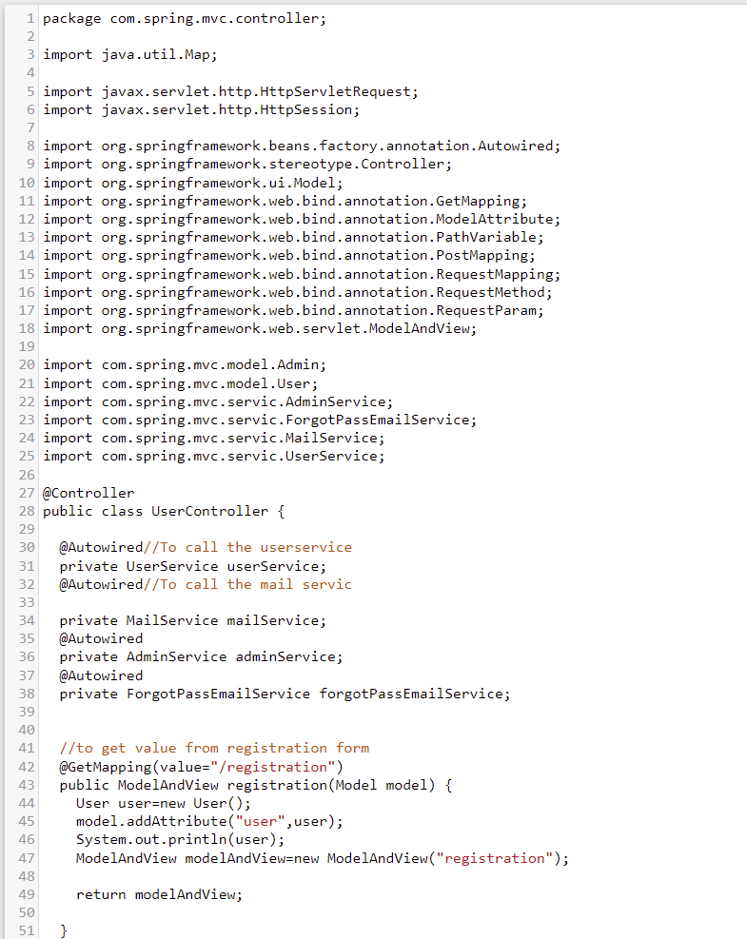

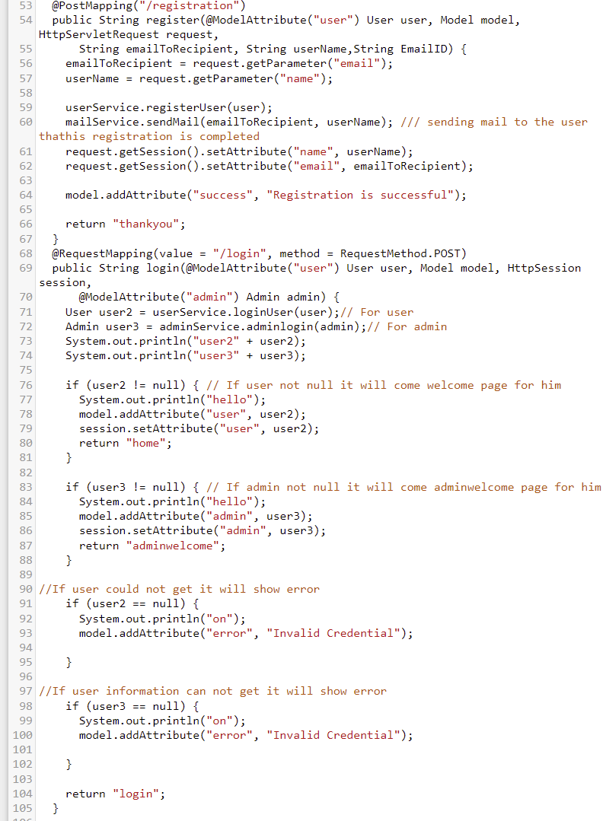

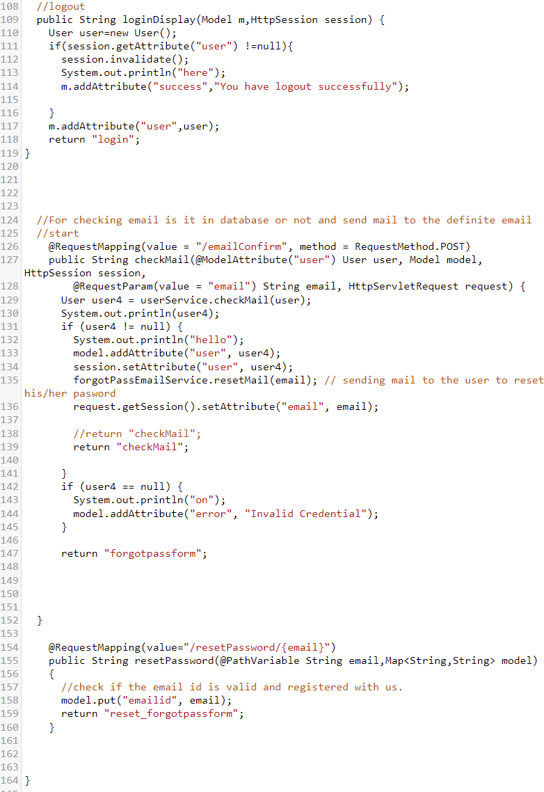

* 1. com.spring.mvc.dao
* 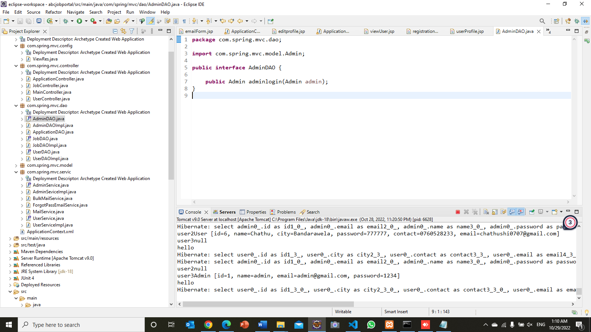Admindao.java
* 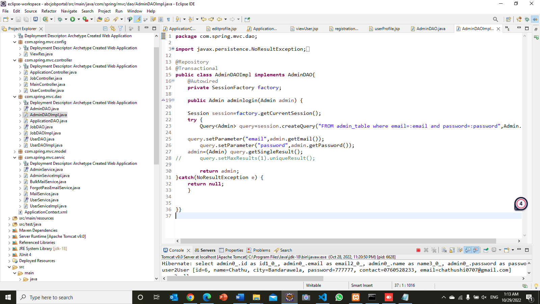AdminDaoImpl.java
* ApplicationDao.java

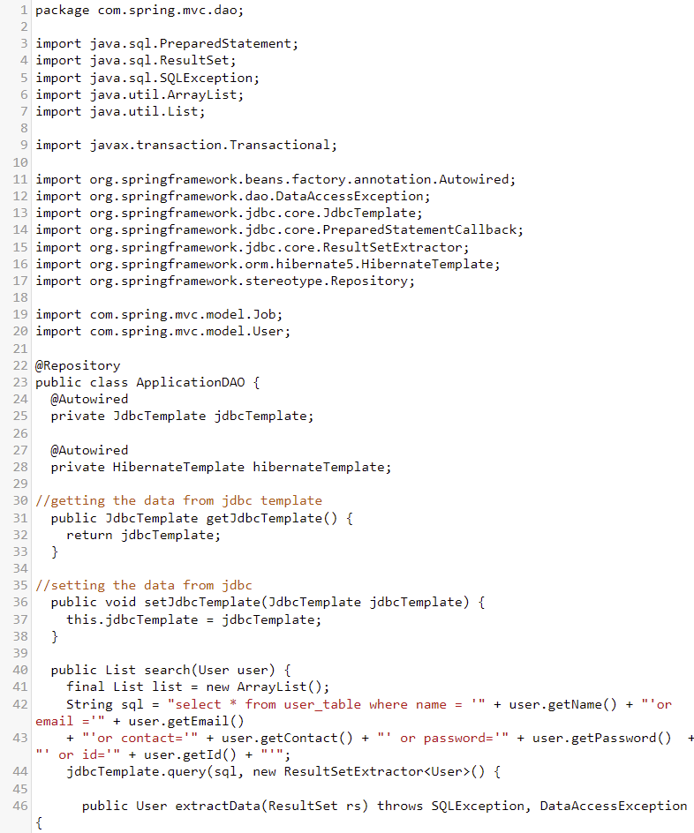

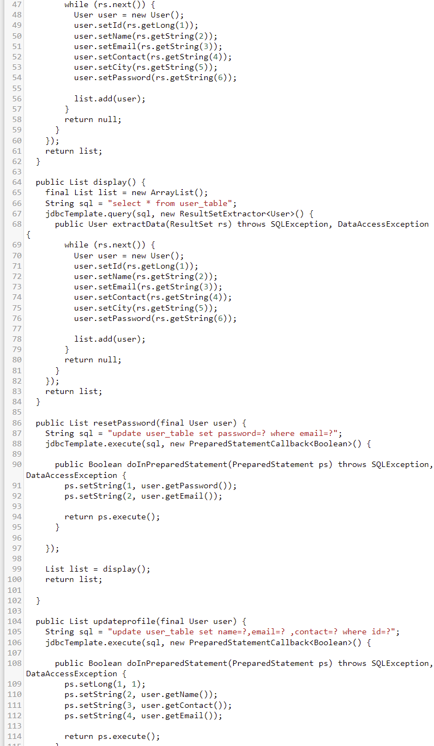

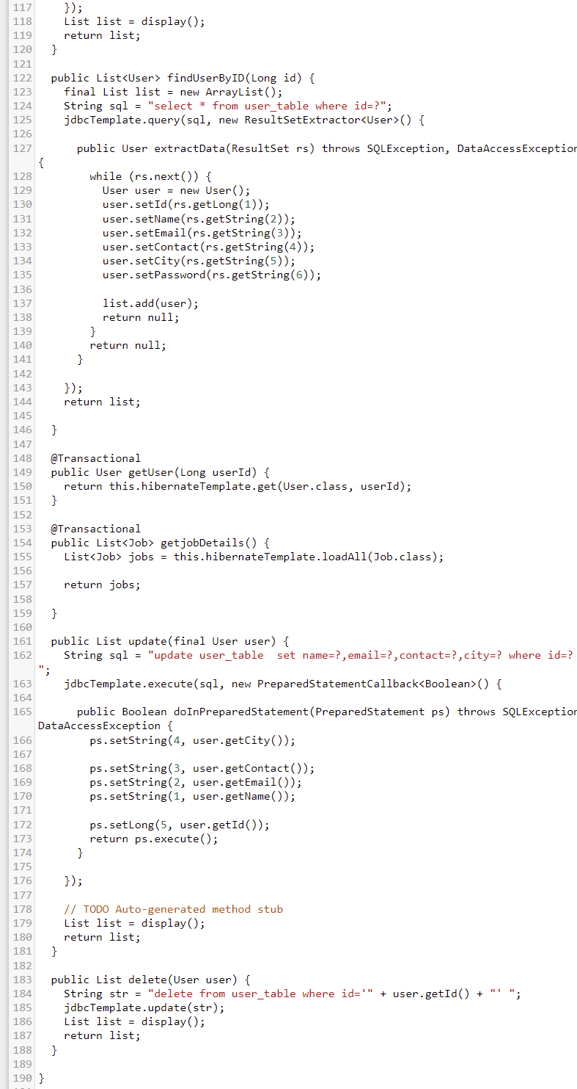

* 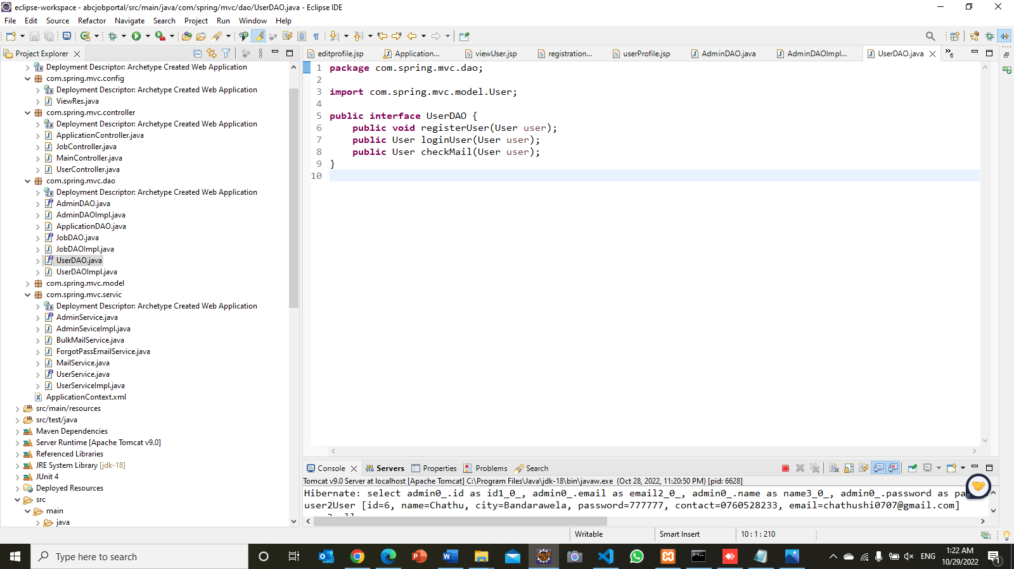UserDao.java
* 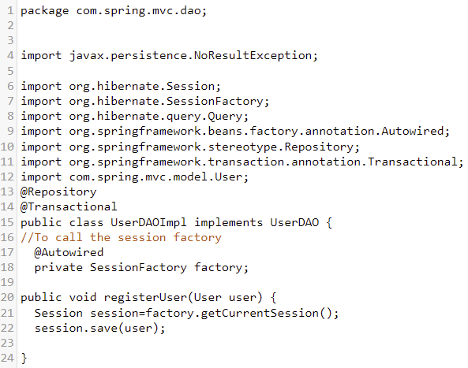UserDaoImplementation.java

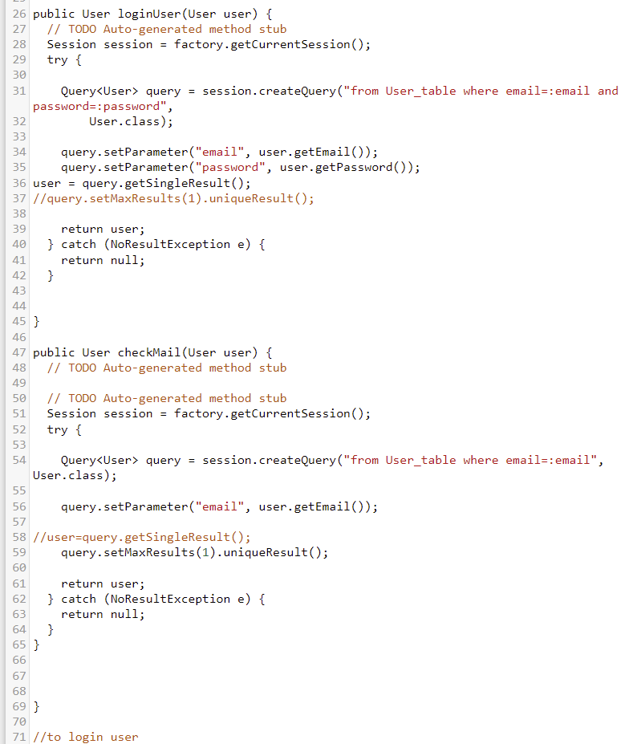

* 1. com.spring.mvc.model
* 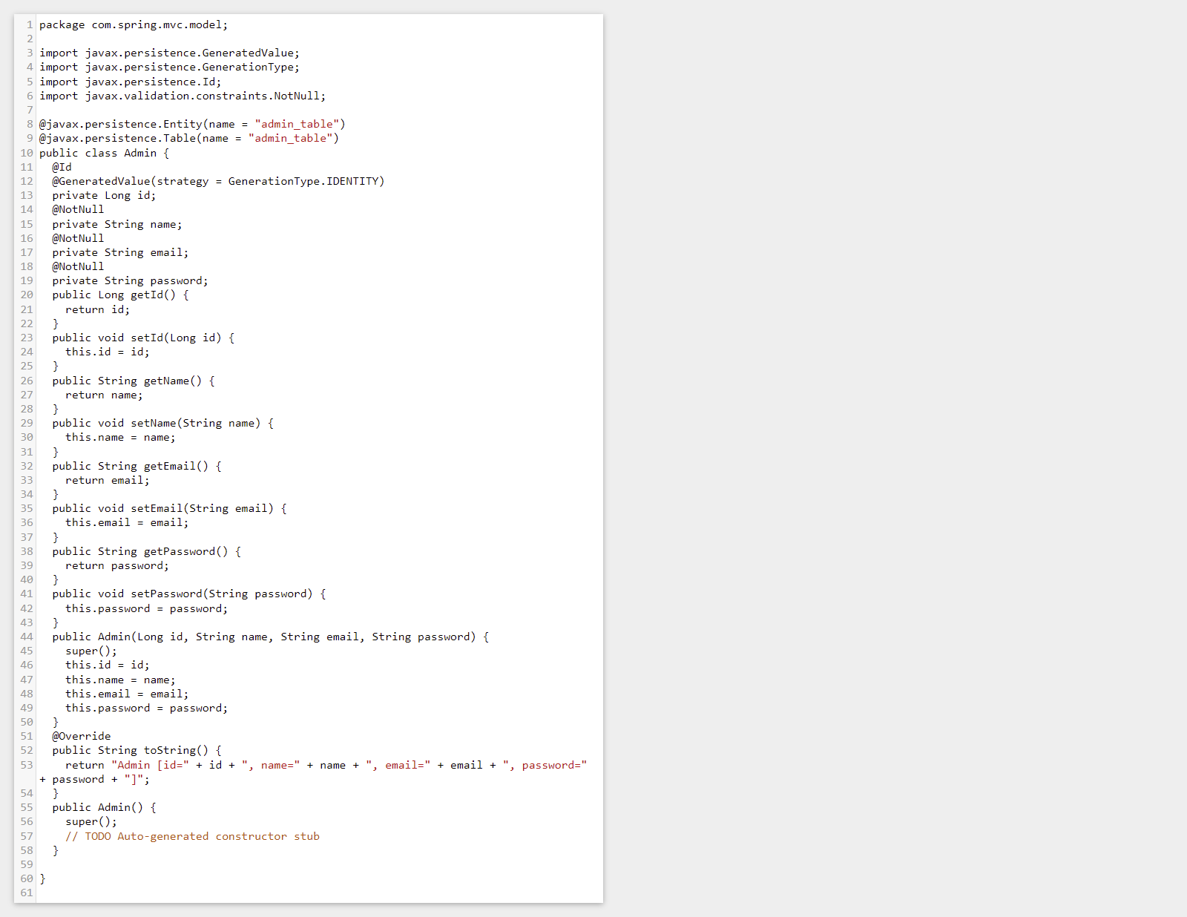admin.java
* User.java

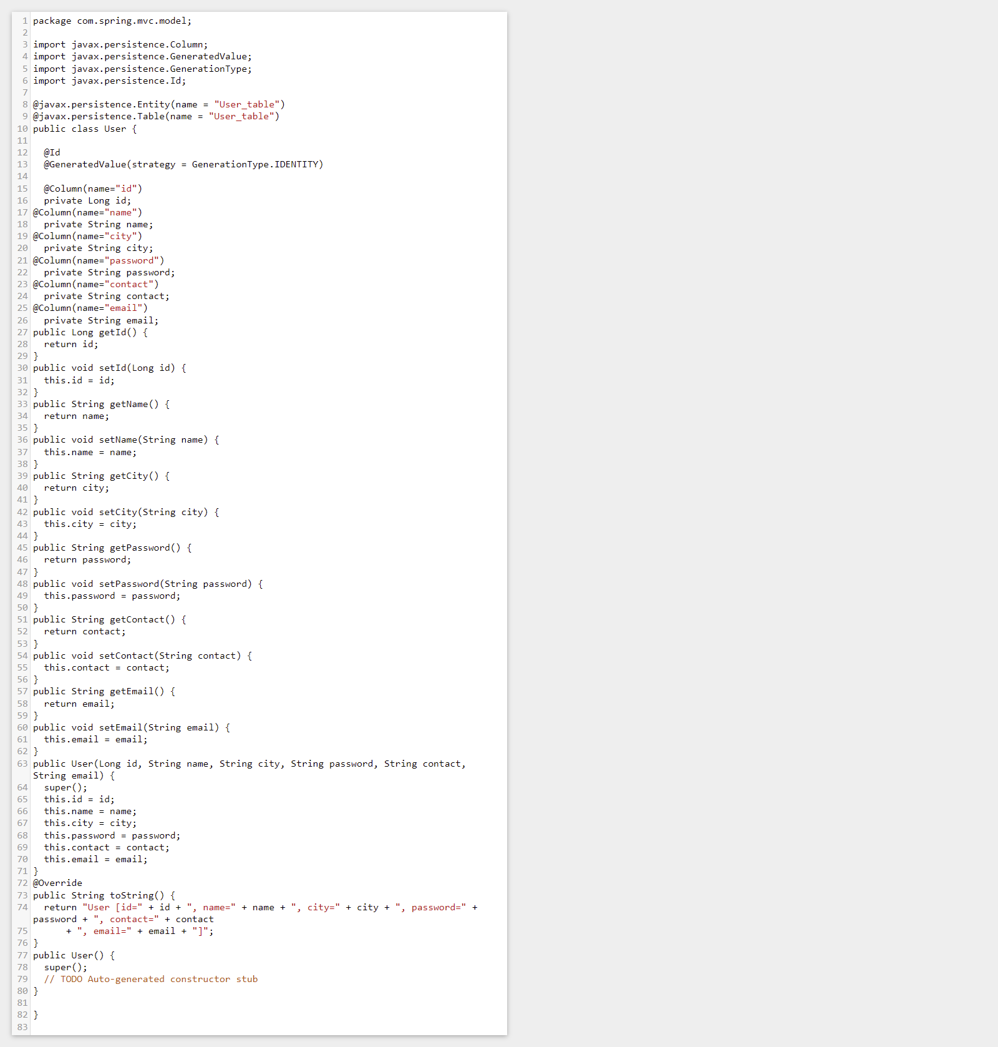

* 1. com.spring.mvc.service
* AdminService.java

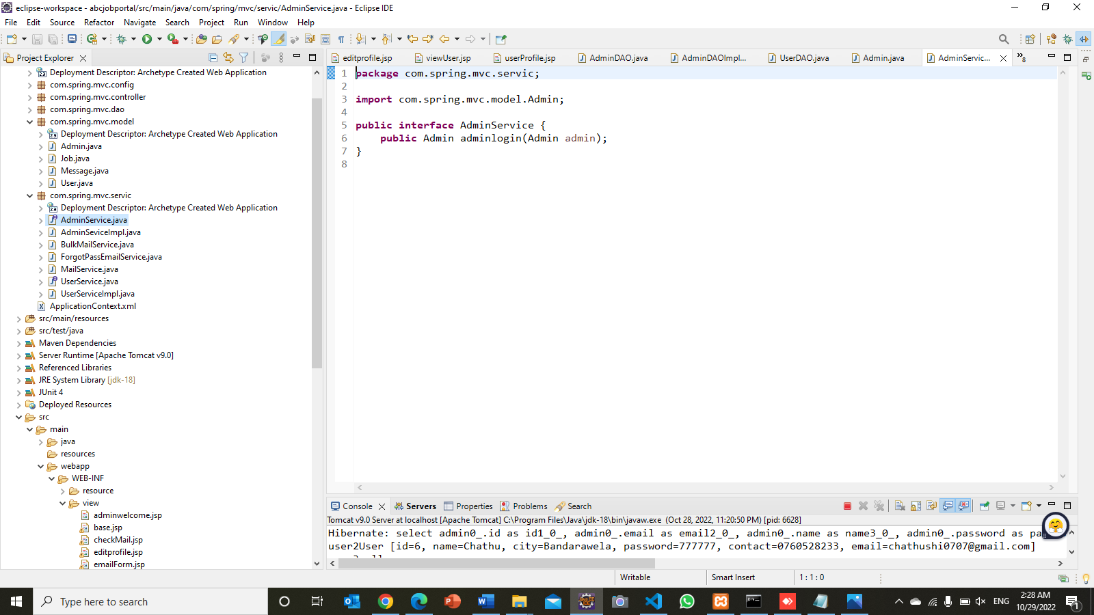

* 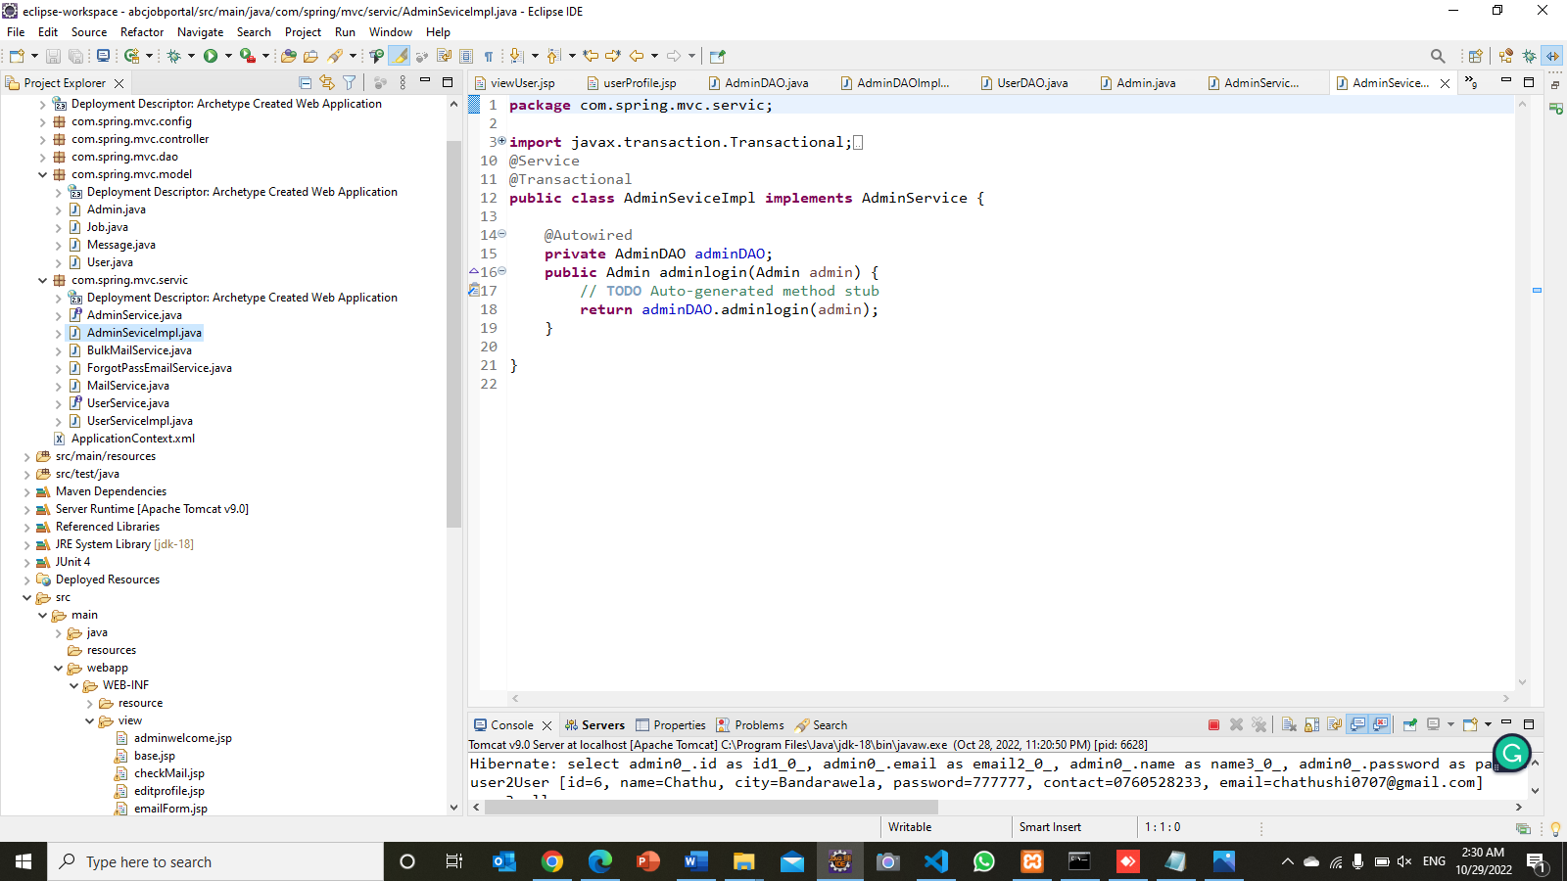AdminServiceImpl.java
* BulkMailService.java

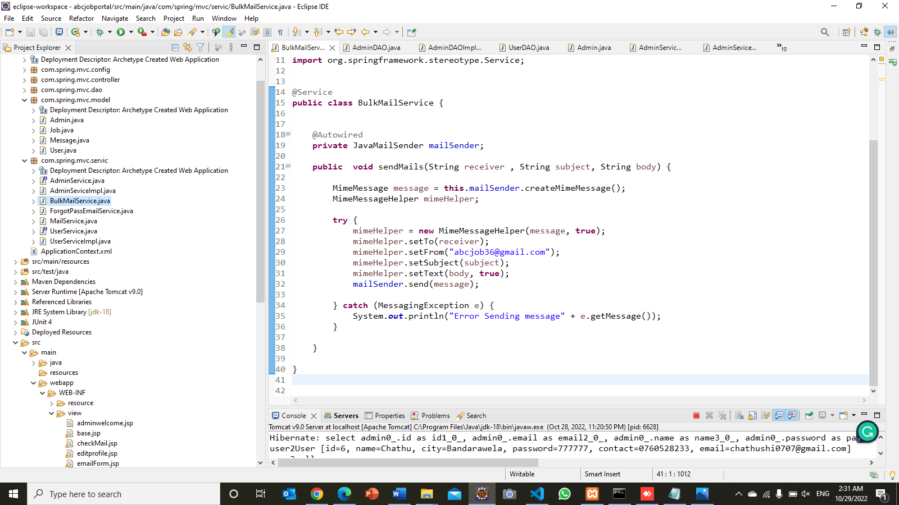

* 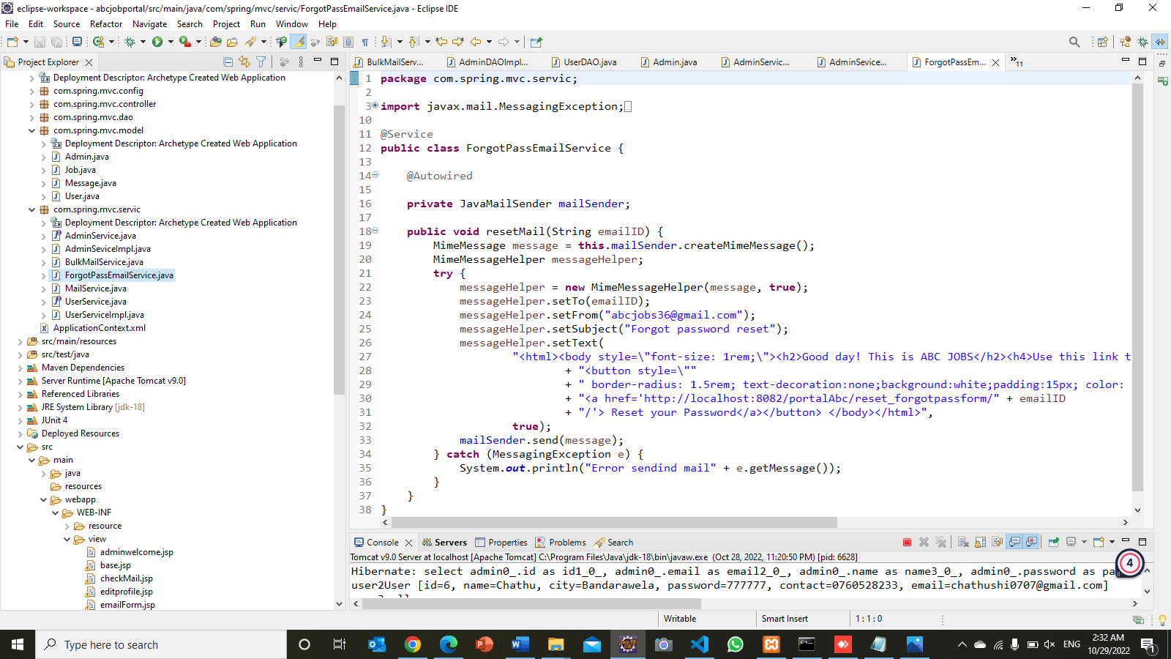ForgotPasswordMail.java
* 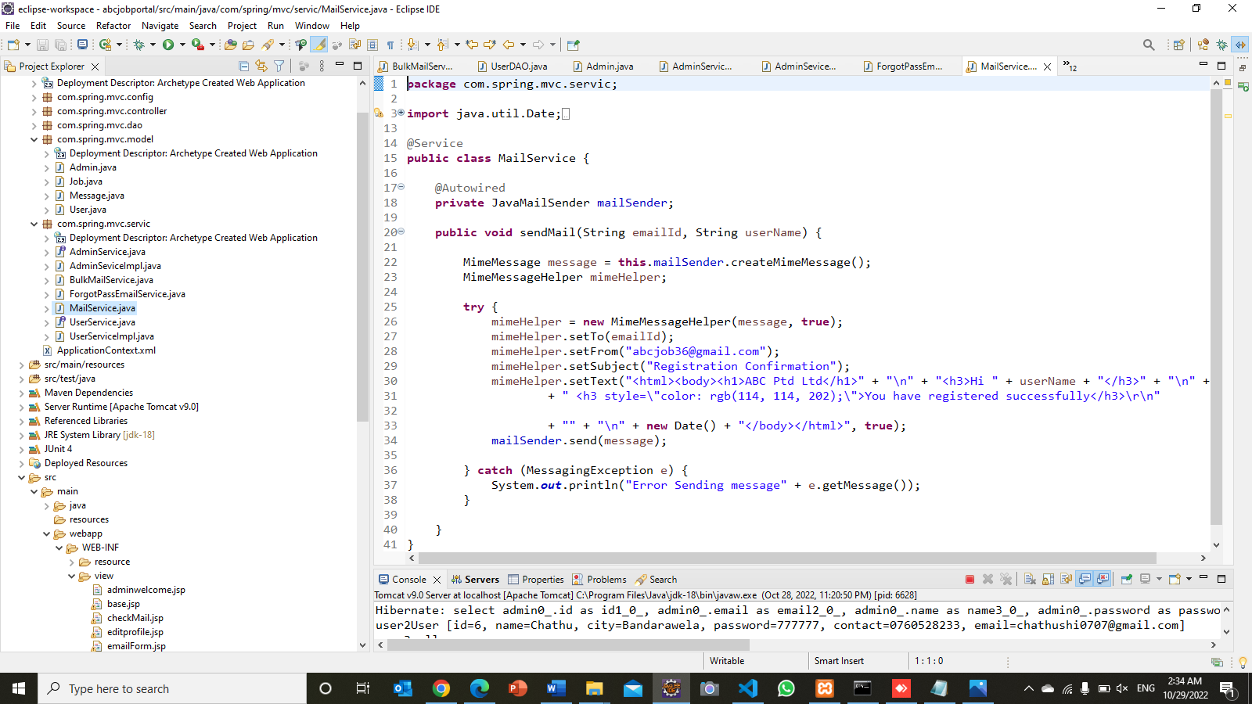MailService.java
* UserService.java

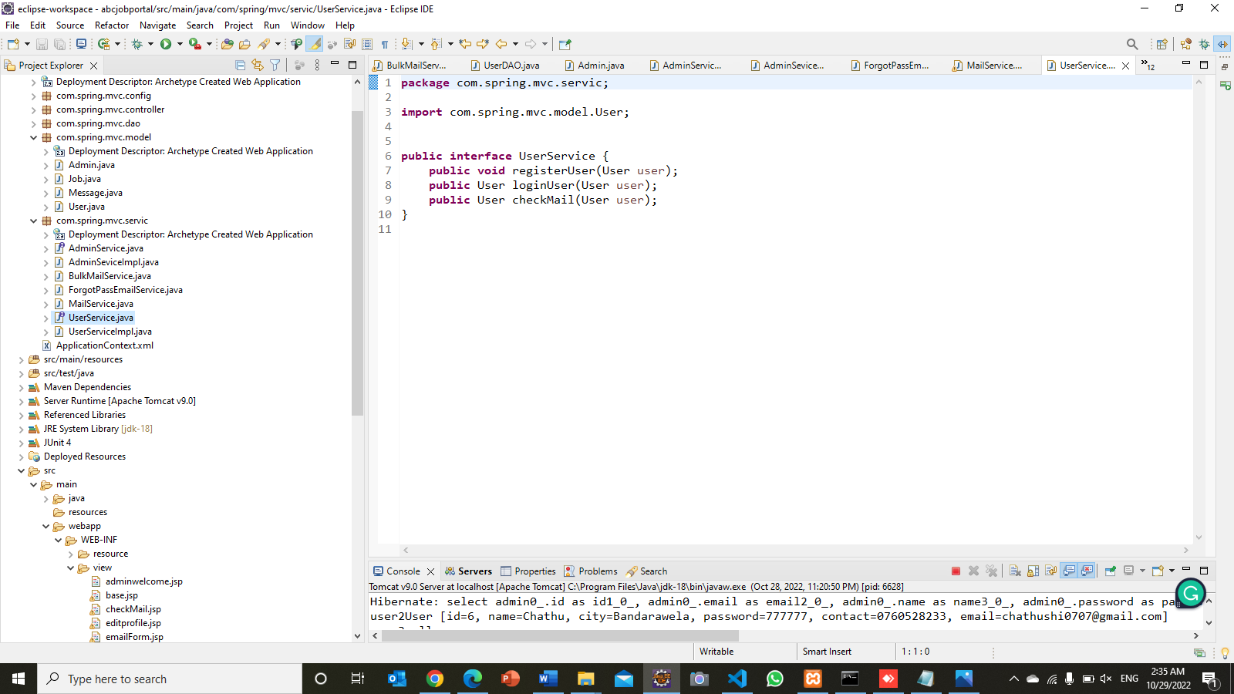

* UserServiceImplementation.java

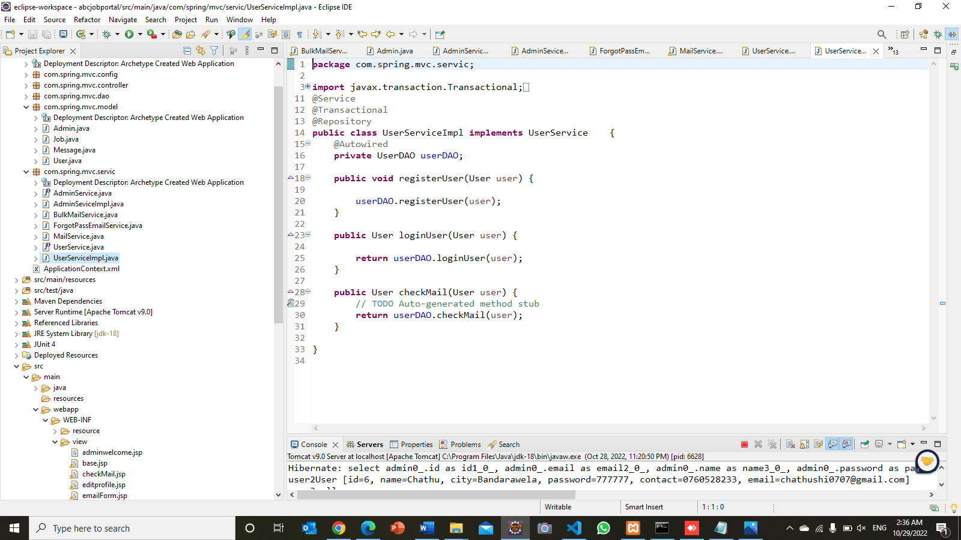

**Task 7**

1. Implemented pages

* 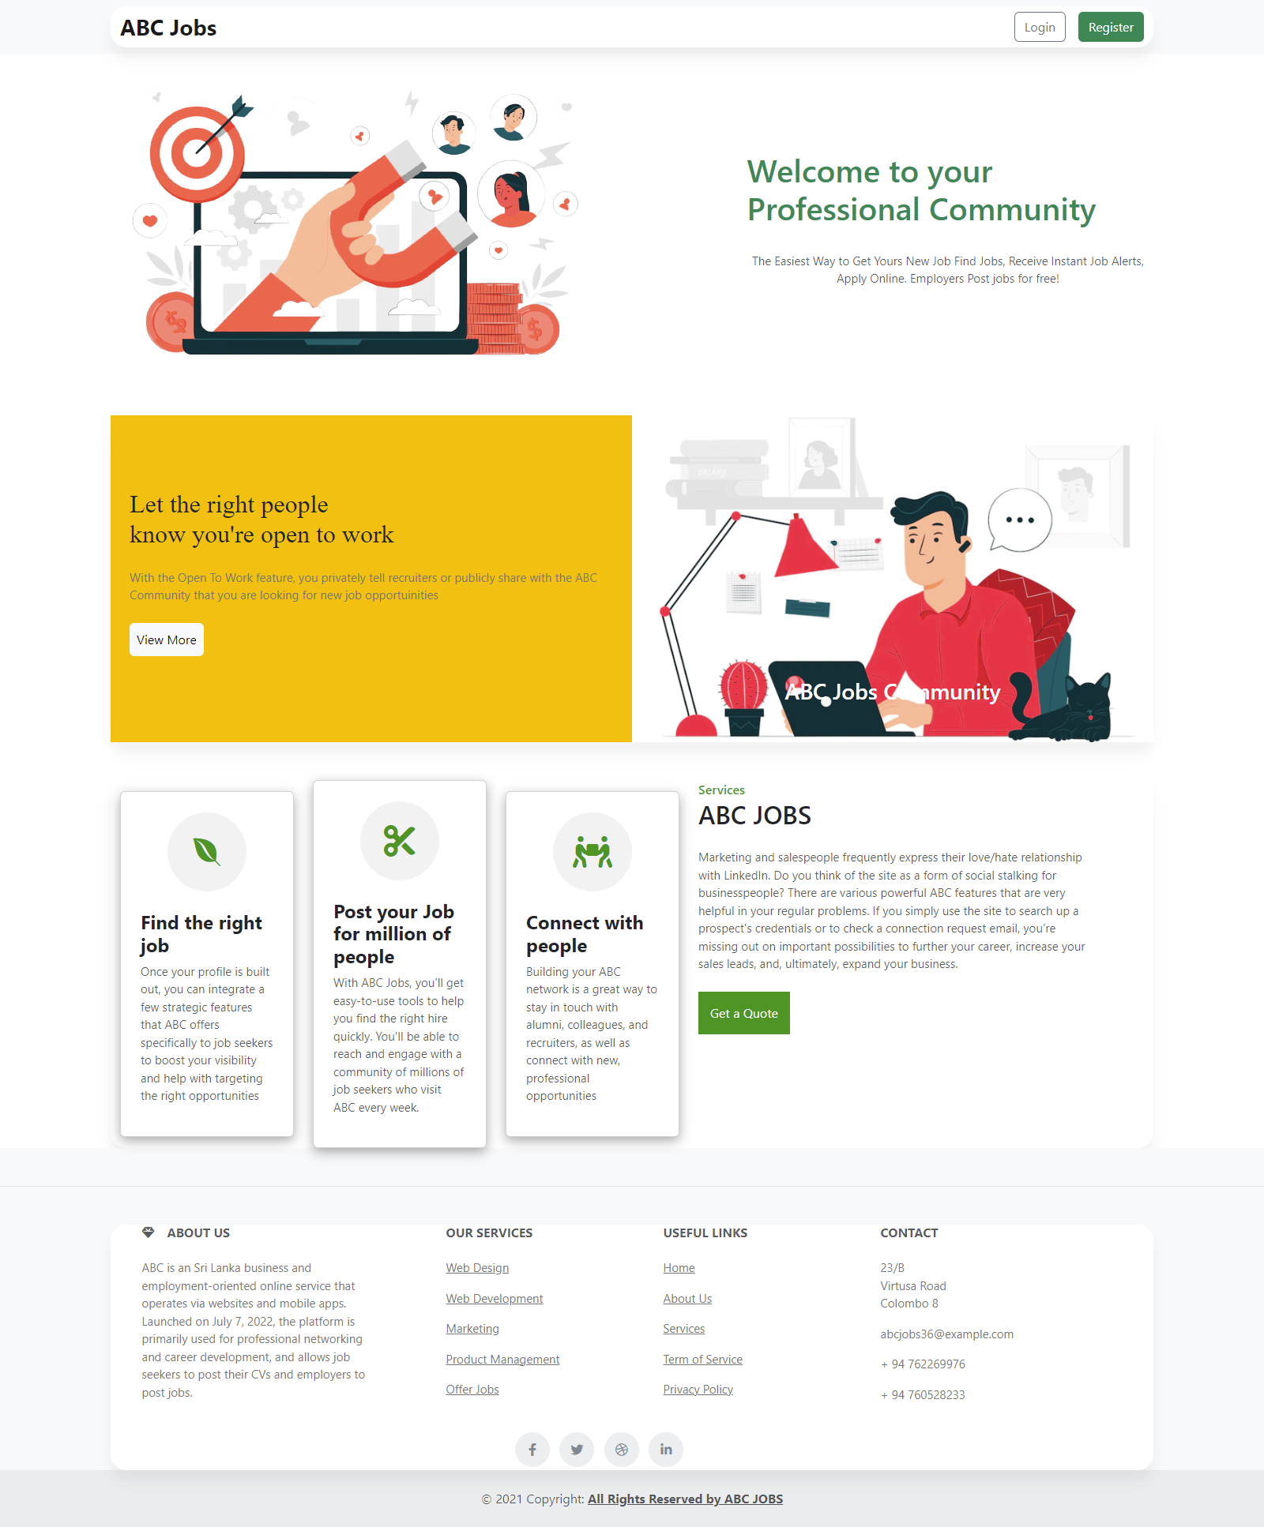Home Page

Figure :Screenshot of Home Page

* Registration Page

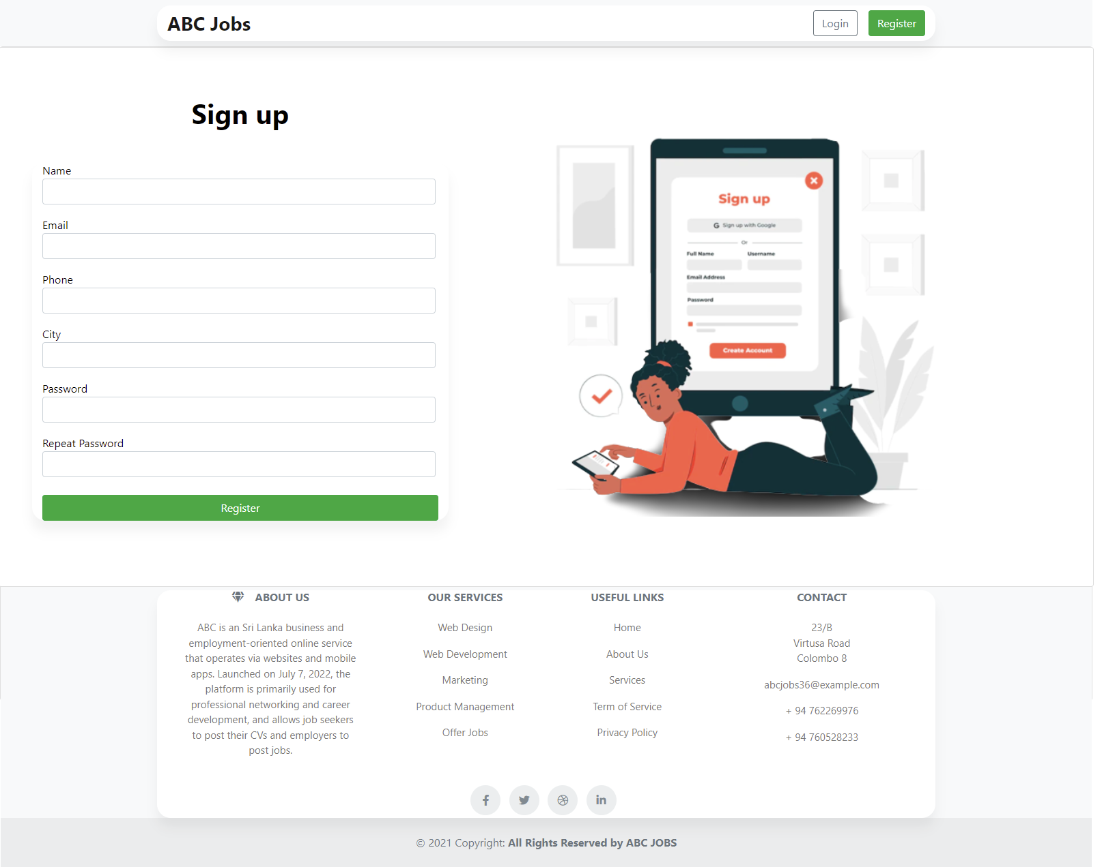

Figure :Screenshot of Registration Page

* Registration Thankyou page

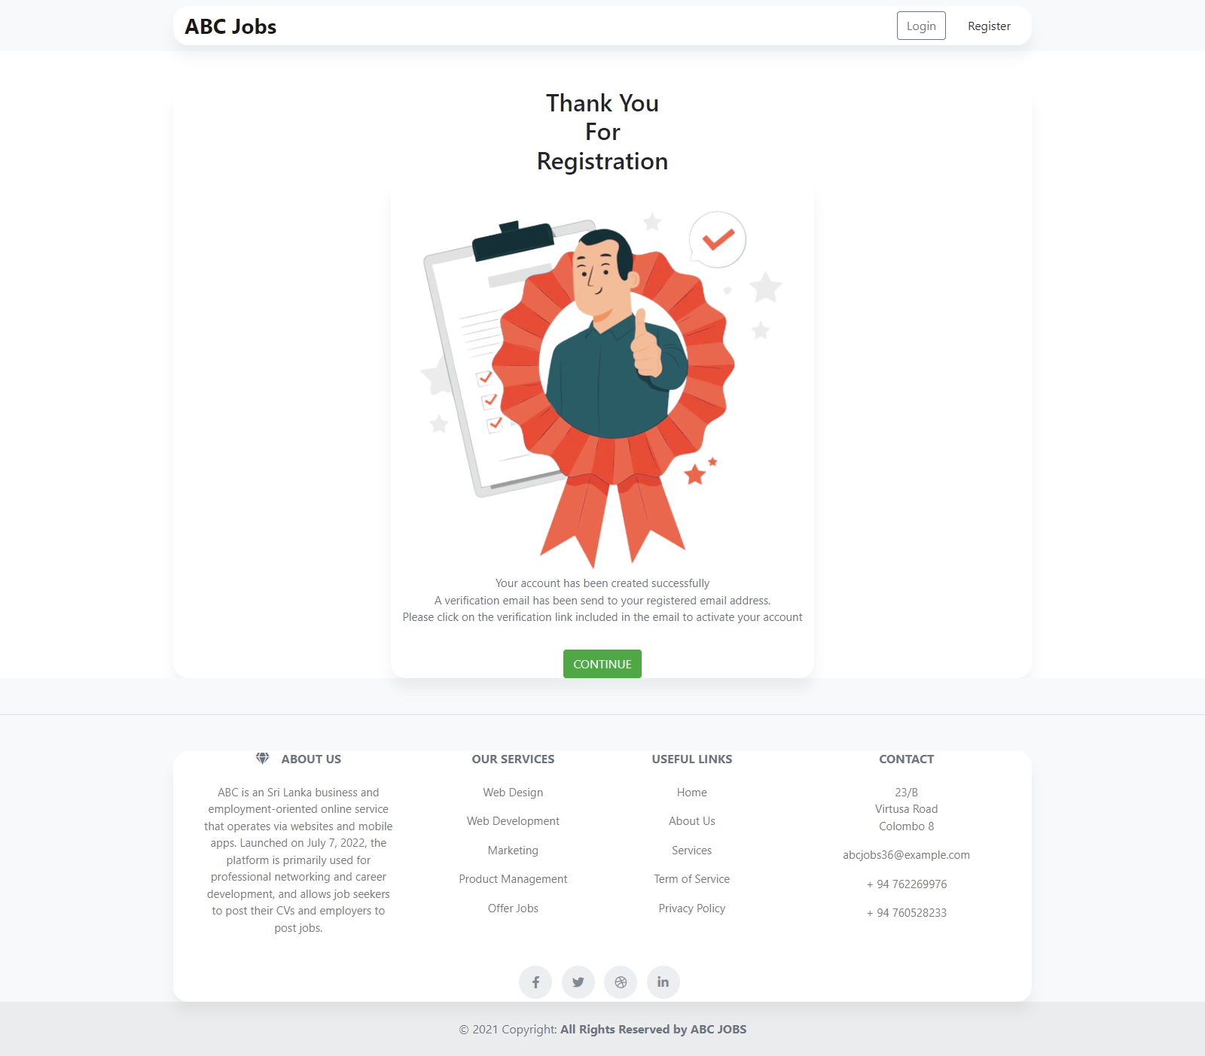

Figure :Screenshot of Registration Thank you Page

* Login Page

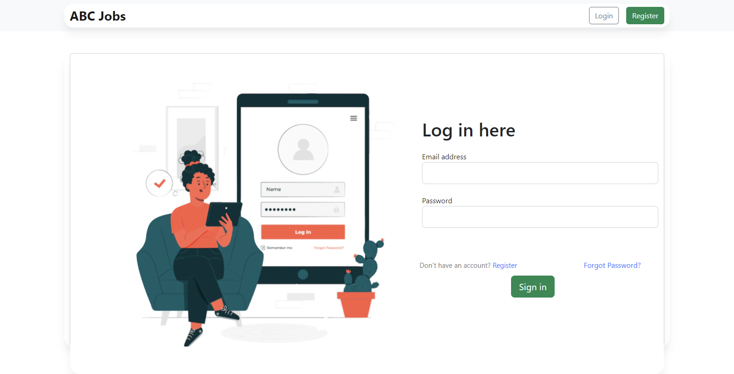

Figure :Screenshot of Login Page

* Forgot Password

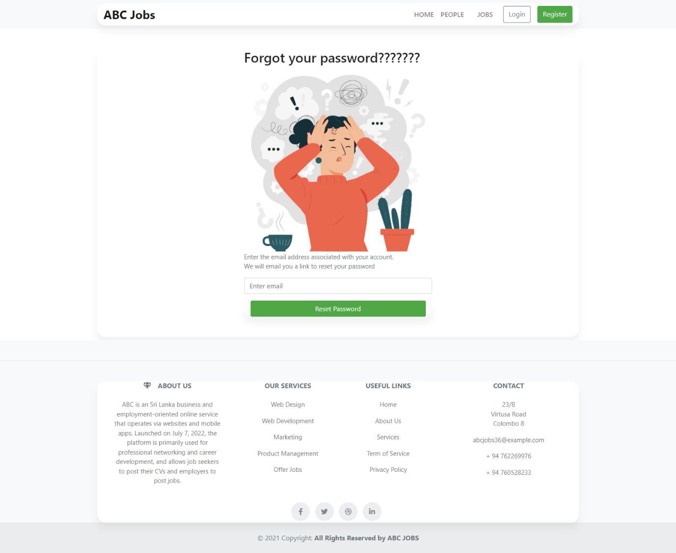

Figure :Screenshot of Forgot Password Page

* 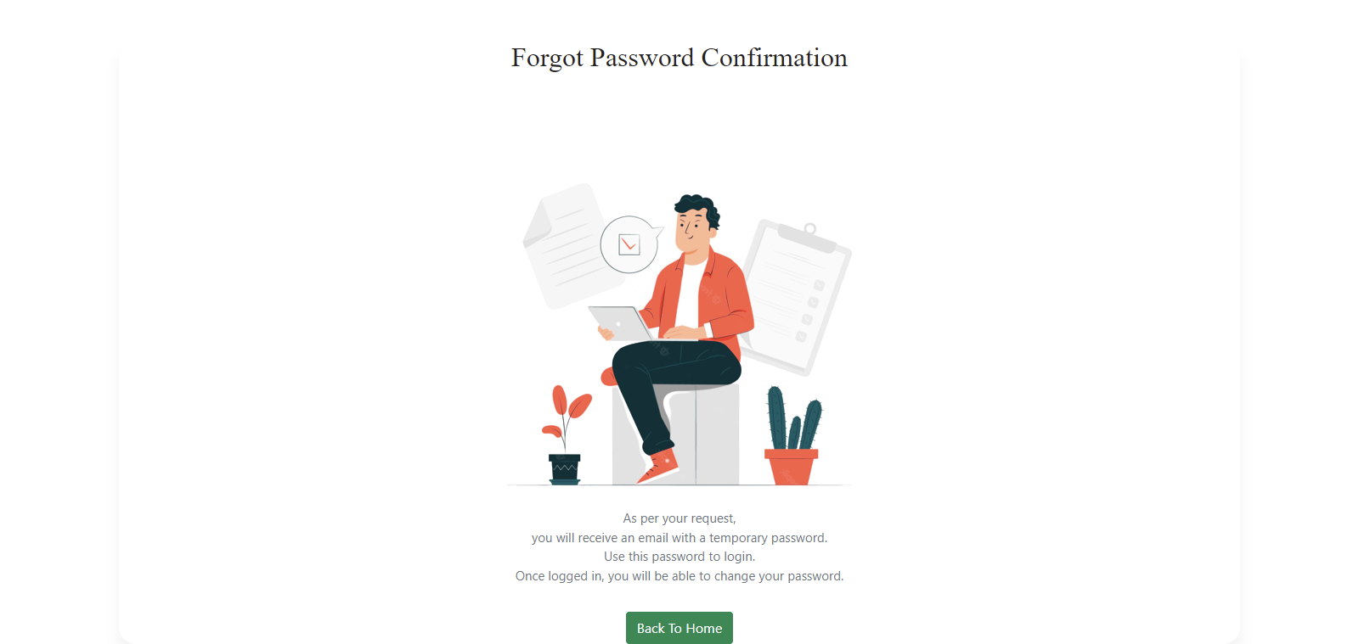Forgot Password Confirmation

Figure :Screenshot of Forgot Password Confirmation Page

* 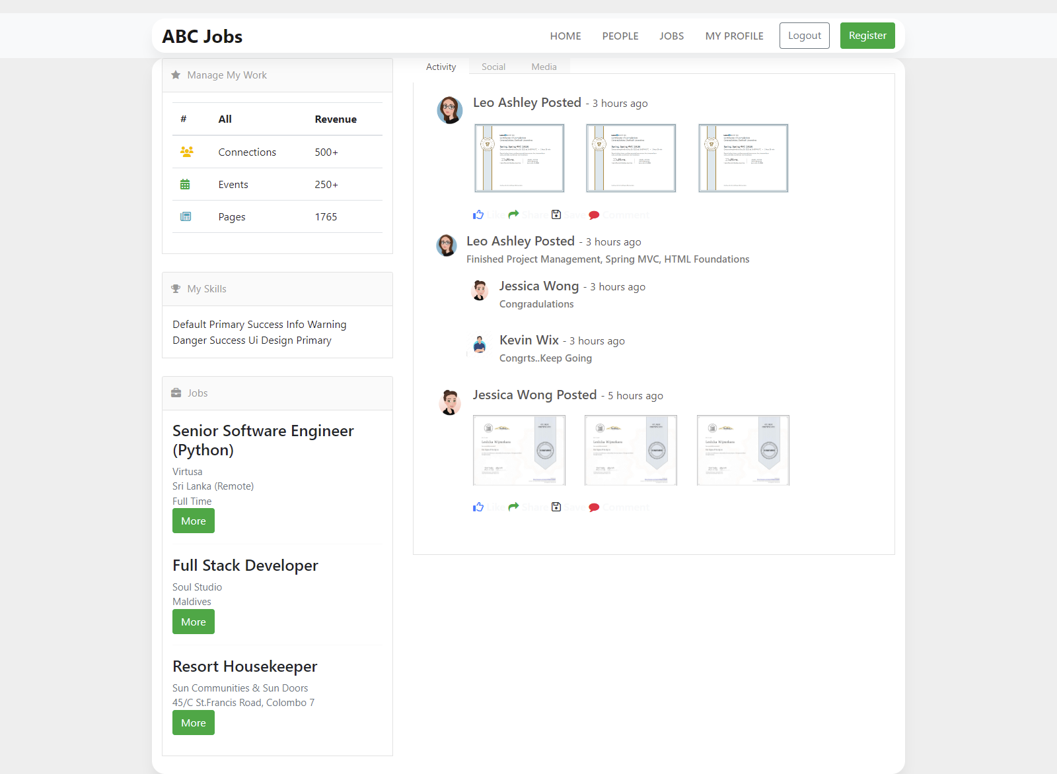User Home Page

Figure :Screenshot of User Home Page

* User Profile Page

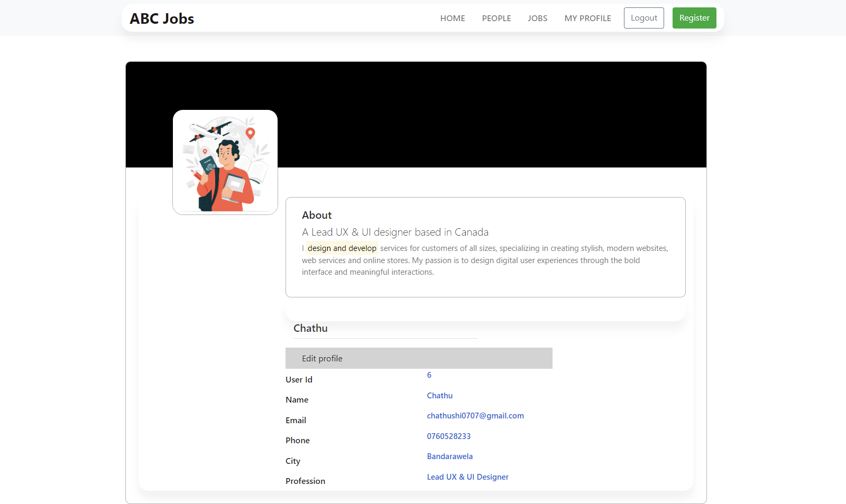

Figure :Screenshot of User Profile Page

* 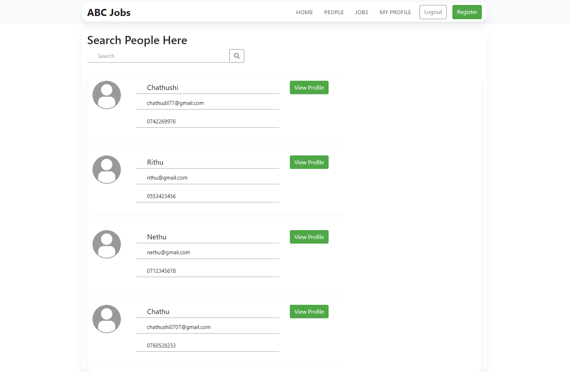Search User Page

Figure :Screenshot of Search User Page

* 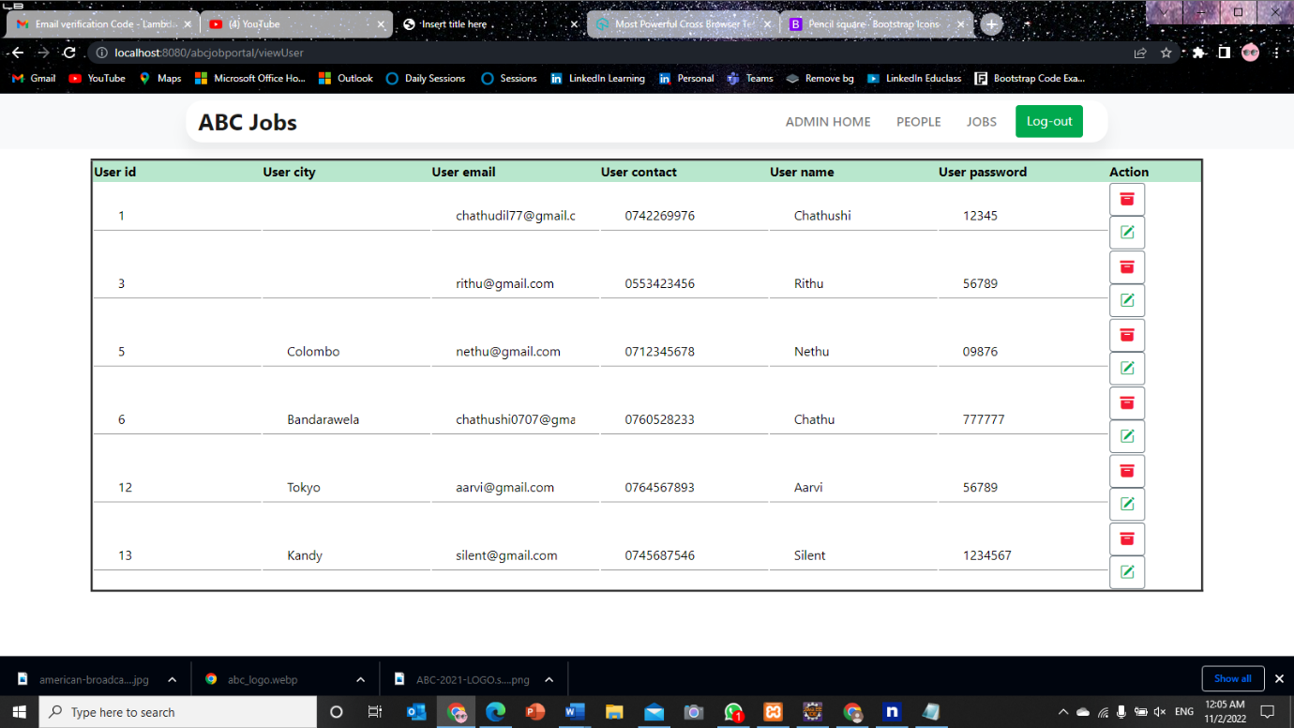Admin View/edit/delete User Page
* Admin Profile Page

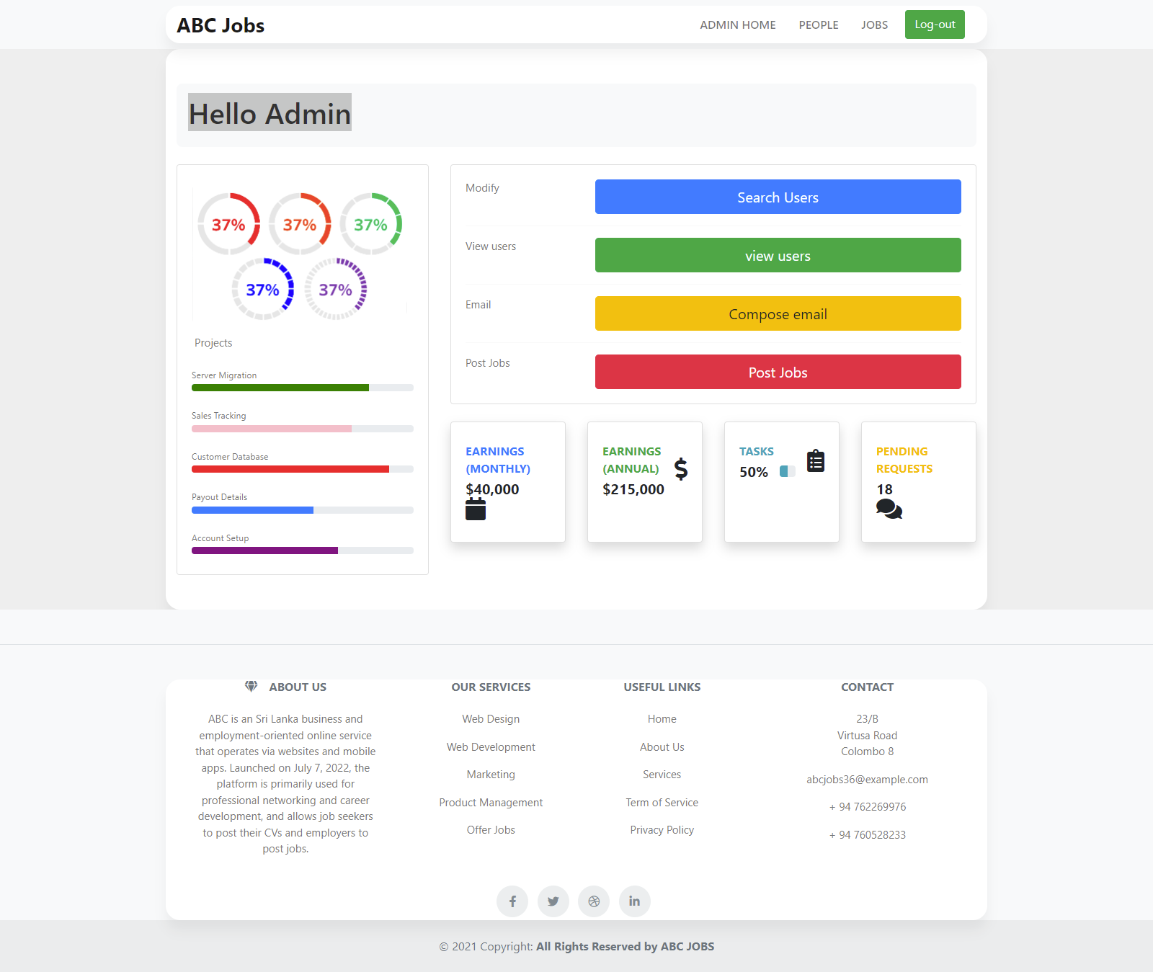

Figure :Screenshot of Admin Home Page

* 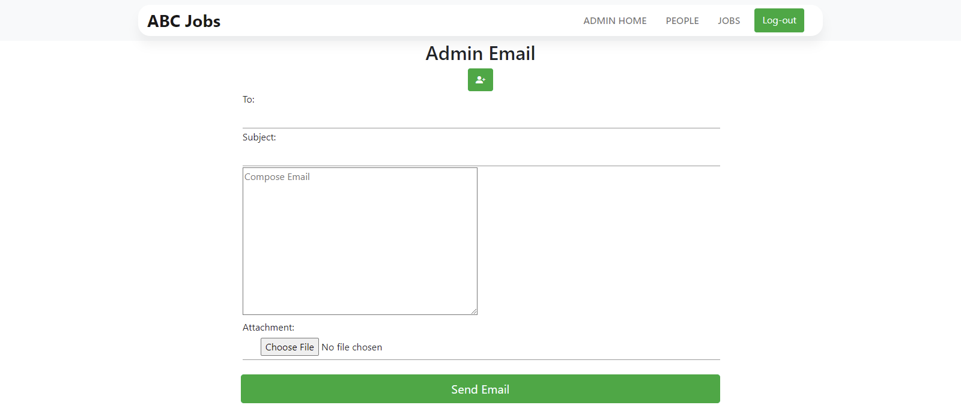Admin Compose Mail Page (Bulk Email)

Figure :Screenshot of Bulk Email Page

**Task 8**

1. **Debug the application in Eclipse**

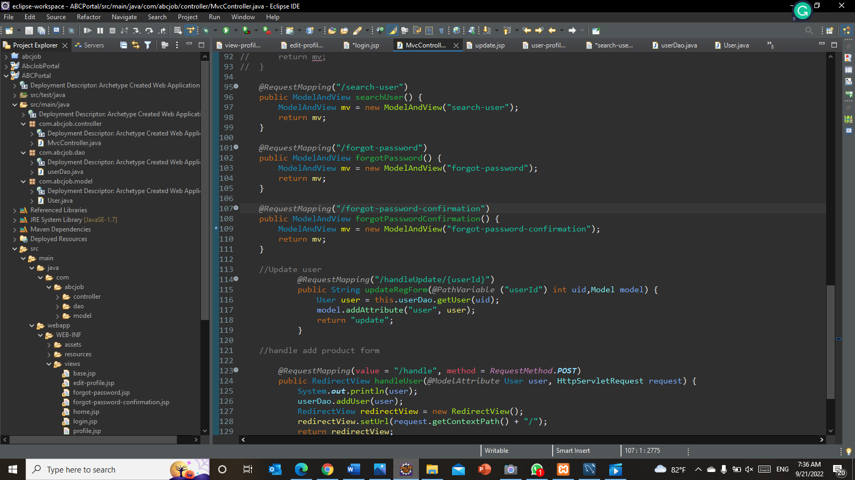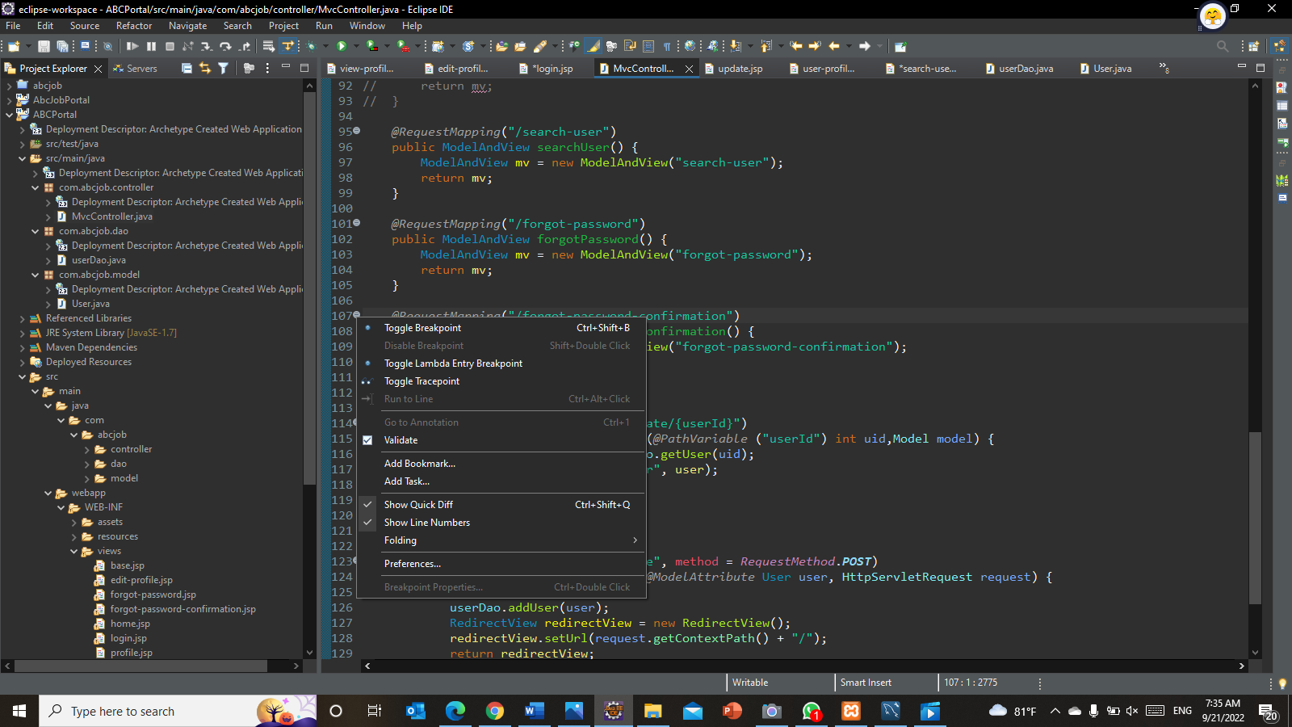**Step 1** – Set Breakpoints

Breakpoint: A blue circle should then appear next to the line:

Figure :Screenshot of debugging in eclipse step 1

**Step 2** – Start the program in Debug mode

(Right click on project🡪Debug as🡪Debug as server)

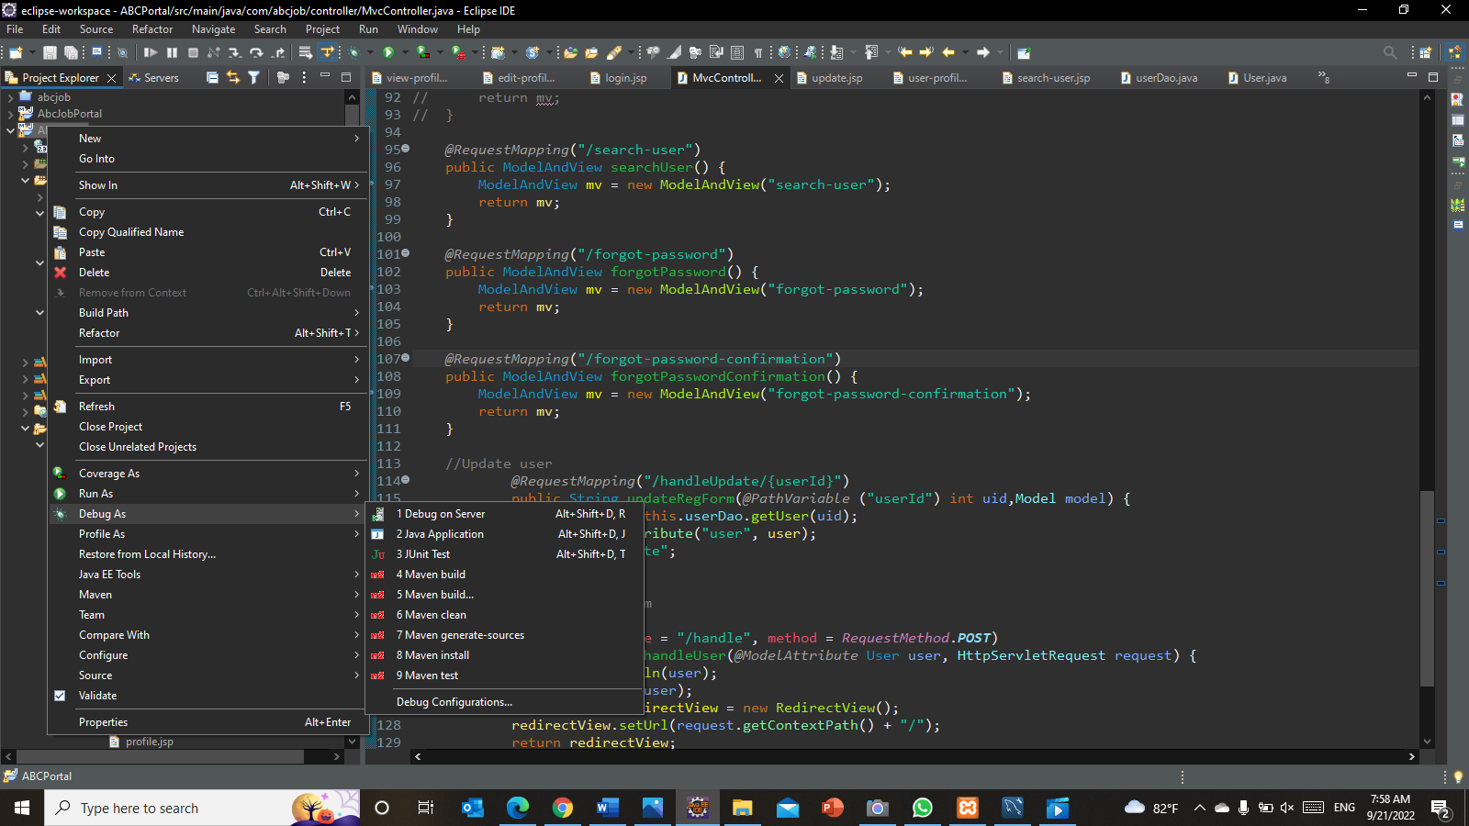

‘pppppppppppp’’’’Figure pp’000’0:Screenshot of debugging in eclipse step 2

**Step 3** – Showing debugger details in the console

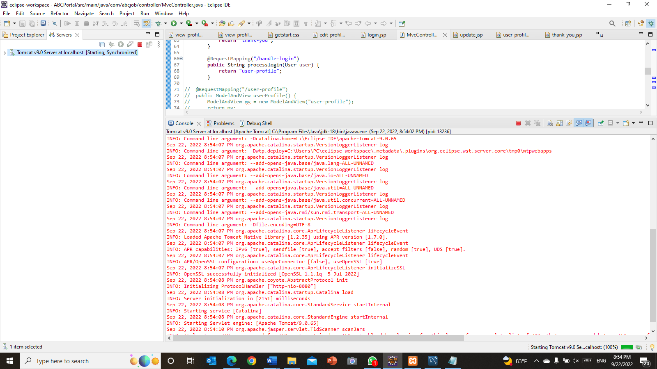

Figure :Screenshot of debugging in eclipse step 3

**Step 4** - Controlling the program execution

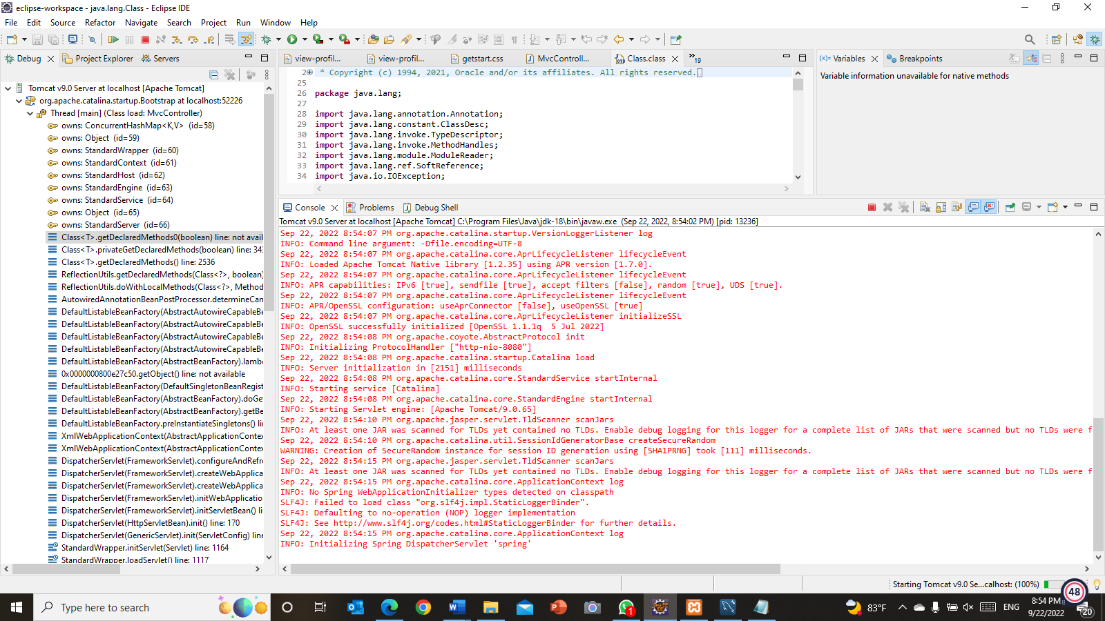The call stack indicates the parts of the program which can be currently executed and the way they relate to each other. The present-day stack is displayed inside the Debug view

Figure :Screenshot of debugging in eclipse step 4

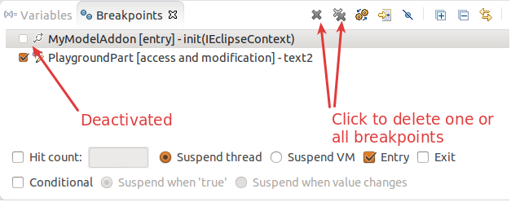Step 5 **- Breakpoints view and deactivating breakpoints**

Figure :Screenshot of debugging in eclipse step 5

Step 6 -Evaluating variables in the debugger

The variables view shows fields and nearby variables from the contemporary executing stack.

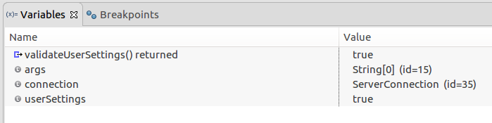

Figure :Screenshot of debugging in eclipse step 6

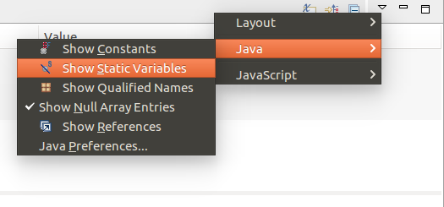Step 7 – Use the drop-down menu to display static variables

Figure :Screenshot of debugging in eclipse step 7

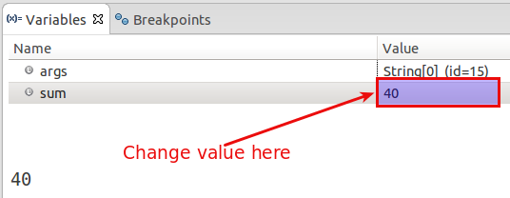Step 8 - Changing variable assignments in the debugger

Figure :Screenshot of debugging in eclipse step 8

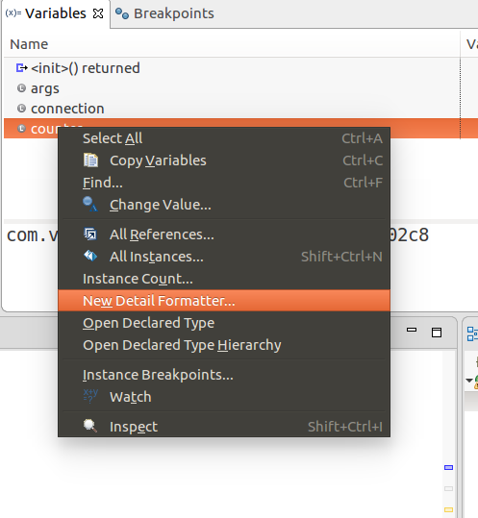Step 9 -Controlling the display of the variables with detail formatter

Figure :Screenshot of debugging in eclipse step 9

Task 9

1. **Errors you encountered while developing the application.**

|  |  |
| --- | --- |
| Error | Error handling (Solution) |
|  | - Look at HTTP Status  - Check out the Root Cause  - Look at the last sentence  - Unable to create requested service [org.hibernate.engine.jdbc.env.spi.JdbcEnvironment]  - Likely caused by JDBC or repository interfaces  - Check persistence.xml  - Fixed jdbc:mysql://localhost:5476 to jdbc:mysql://localhost:3306 |
|  | - Look at HTTP Status  - Check out the Root Cause  - Look at the description  -The origin server did not find a current representation for the target resource or is not willing to disclose that one exists.  - Check the MainController.java class  - Add request mapping for home.jsp |
|  | - Look at HTTP Status  - Check out the Root Cause  - Look at the message  - JSP file [/WEB-INF/views/searchUsers.jsp] not found  - Check the MainController.java class  - Add return page to search method |

Task 10

1. **New feature to the application**

I received feedback to add suggestions to the search user page. So I added account suggestions to the search user page

* 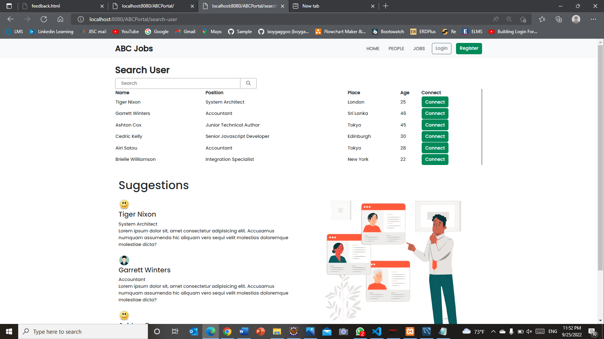**Before**

Figure :Search User Page before Implementation new feature

* 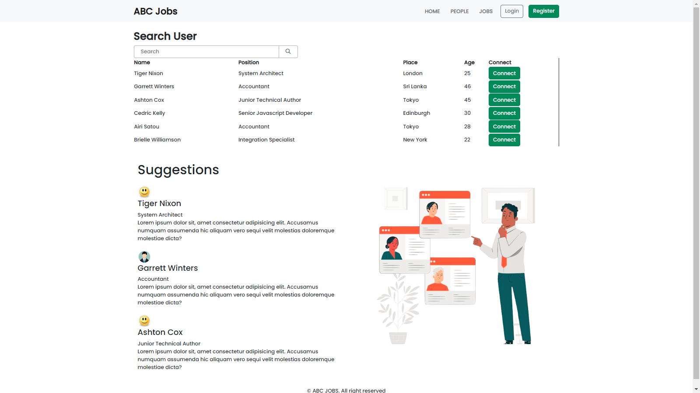**After**

Figure :Search User Page After Implementation new feature

Task 11

1. Unit Testing code

|  |  |  |  |  |  |  |  |
| --- | --- | --- | --- | --- | --- | --- | --- |
| Scenario ID | Test Case | Preconditions | Test Step | Test Data | Expected Results | Actual Results | Pass / Fail |
| TS001 | Check all the mandatory fields are entered | The website is configured to Google chrome by Apache Tomcat Server. | Go to Google chrome  Type <http://localhost:8080/ABCPortal/login>  Enter the fields.  Click “Sign in now”. | Email= “chathu@gmail.com”  Password= | It will Display error message “Password is required” | As expected, | Pass |
| TS002 | Check each hyperlink menu is loading the correct page | The website is configured to Google chrome by Apache Tomcat Server. | Go to Google chrome  Type <http://localhost:8080/ABCPortal/login> | Click on the profile link  Click on the search users link | Loaded profile page  Loaded Search users page | As expected, | Pass |
| TS002 | Check log out hyperlink is loading correct page | The website is configured to Google chrome by Apache Tomcat Server. | Go to Google chrome  Type <http://localhost:8080/ABCPortal/home> | Click on the log out link at the top nav bar | Loaded login page | As expected, | Pass |